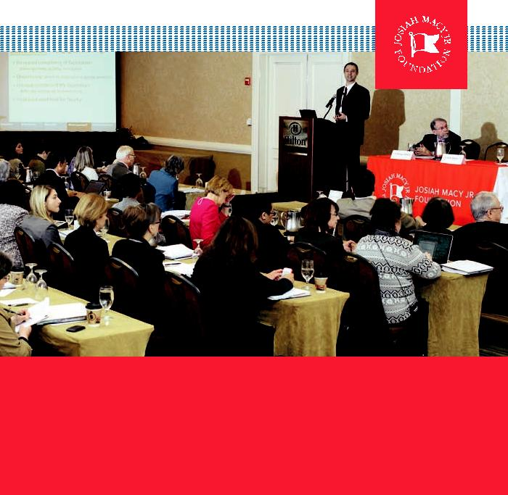

Conference on Interprofessional Education

April 1–3, 2012

Hilton Alexandria | Alexandria, Virginia

November 2012

This monograph is in the public domain and may be reproduced or copied without permission. Citation, however, is appreciated.

Conference on Interprofessional Education Sponsored by the Josiah Macy Jr. Foundation, held in Alexandria, VA, April 2012; New York: Josiah Macy Jr. Foundation; November 2012.

All Photos by Keith Weller

Accessible at www.macyfoundation.org

Conference on Interprofessional Education

April 1–3, 2012

Hilton Alexandria Alexandria, Virginia

Published by Josiah Macy Jr. Foundation 44 East 64th Street, New York, NY 10065 www.macyfoundation.org

1

C ON T E N T S

Preface. . . . . . . . . . . . . . . . . . . . . . . . . . . . . . . . . . . . . 5

Conference Participants . . . . . . . . . . . . . . . . . . . . . . . . . . . . . . . . . . . . . . . . . . . . . . . . . . . 10

Institution Participants . . . . . . . . . . . . . . . . . . . . . . . . . . . 17

Conference Agenda . . . . . . . . . . . . . . . . . . . . . . . . . . . . . 20

Opening Remarks

George E. Thibault, MD . . . . . . . . . . . . . . . . . . . . . . . . . 23

Why IPE Now and What Have We Learned

Scott Reeves, PhD, Msc, PGCE . . . . . . . . . . . . . . . . . . . . 29

Institutional Summaries of IPE Activities . . . . . . . . . . . . . . . . 41

Abstract Summaries. . . . . . . . . . . . . . . . . . . . . . . . . . . . . 99

Breakout Sessions. . . . . . . . . . . . . . . . . . . . . . . . . . . . . . . . . . . . . . . . . . . . . . . . . . . . . . . . . 111

Breakout Summaries by Topic. . . . . . . . . . . . . . . . . . . . . . 119

2

Panel Discussions on IPE in Clinical Practice

Introduction from Geraldine “Polly” Bednash,

PhD, RN, FAAN. . . . . . . . . . . . . . . . . . . . . . . . . . . . 147

IPE in the VA

Introduction and Moderated by Malcolm Cox, MD. . . . . . . 151

Education and Delivery System Links

Introduction and Moderated by George Bo-Linn, MD . . . . . . . . . . 159

Impressions Learned and Next Steps Panel

Introduction and Moderated by David Irby, PhD. . . . . . . . . 179

Summary Remarks

George E. Thibault, MD . . . . . . . . . . . . . . . . . . . . . . . . 199

Biographies of Speakers and Faculty. . . . . . . . . . . . . . . . . . . . . . . . . . . . . . . . . . 203

3

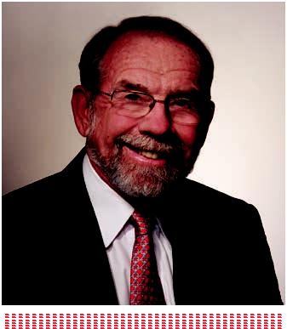

4

PREFACE

GEORGE E. THIBAULT, MD

In April 2012 we convened all Macy grantees and participants in Macy-funded activities in interprofessional education (IPE). This was the first time in recent history that we have had a critical mass of sponsored work within one area that could occupy an entire conference.

Joining the grantees was a distinguished, interprofessional group of faculty who served as speakers, moderators, and facilitators. The goals of the meeting were:

- To provide an opportunity for each participating team to present its work.

- To provide a safe environment for the critique of that work and identify opportunities for collaboration.

- To inspire, mentor, guide, and validate our grantees.

- To summarize the lessons learned to date and to define directions for future work in IPE.

In preparation for the meeting each of the invited teams was asked to submit a one-page institutional summary of their IPE work, structured abstracts of the projects to be discussed in the assigned breakout groups, and a poster presentation of IPE work they are doing that could be generalized.

The meeting was designed to be participatory with a mixture of interactive plenary sessions and breakout groups. The meeting began with two framing presentations. The first was by Scott Reeves, PhD, a social scientist and educator who is the founding Director of the Center for Interprofessional Health Education at the University of California San Francisco (UCSF). He provided a systematic review of the state of IPE and documented much progress that has been made. He identified the need for more rigorous assessment of learners and for theory-based evaluation of the long-term impact of programs. Don Berwick, MD, founding President of

5

the Institute of Healthcare Improvement and former Administrator of CMS, spoke compellingly of the moral framework within which we should evaluate IPE. He reminded us that we are in challenging times with great urgency about steps that need to be taken to preserve health care as a human right. He gave examples of the kinds of changes we need in the health care system, and he called on us to demonstrate that IPE is an effective tool to accomplish the Triple Aim of better care, better health, lower costs.

A series of breakout sessions were organized thematically to go into depth in discussing both content and pedagogy in IPE. Each breakout group began with two brief presentations by Macy grantees to give examples, and the discussions were moderated by two invited faculty members. The projects of Macy grantees were also presented in a poster session designed for interaction and discussion.

The remaining plenary sessions were devoted to panel discussions to exemplify real-world successes and problems in IPE. Polly Bednash, PhD, RN, FAAN, and the CEO of the American Association of Colleges of Nursing presided over two panels. The first was moderated by Malcolm Cox, MD, Chief Academic Affiliations Officer of the Department of Veterans Affairs. This panel included faculty and learners working in the VA’s new Interprofessional Center of Excellence in Primary Care. The second panel, moderated by George Bo-Linn, MD, Chief Program Officer at the Gordon

& Betty Moore Foundation, invited leaders from health care systems to discuss the challenges in integrating education and health care delivery. David Irby, PhD, former Vice Dean for Medical Education at UCSF presided over the final session. He led

a panel of senior medical and nursing educators to give their impressions of the meeting, lessons they have learned in IPE, and thoughts about future directions.

The meeting afforded us the opportunity to reflect on “the case” for IPE, the accomplishments to date, and some thoughts about future directions.

As for “the case” for IPE, the discussions re-enforced the following logic tree. We have a large and growing body of evidence that patients benefit from well-

coordinated care delivered by well-functioning teams of health professionals. Yet we continue to educate and train health professionals separately, and do not teach them team skills or mutual understanding of different professional roles and contributions. In the practice world we have too many examples of poorly functioning teams

with poor communications resulting from cultural and linguistic differences, lack of specific team competencies, or the perpetuation of stereotypes. The adverse consequences of this lack of effective teamwork grows greater with an increasingly

6

diverse patient population, an increasing burden of chronic illness, and a heightened sense of the need for greater efficiency in our health care system. Therefore, this is the time to change the educational paradigm so that team work and team-based competencies become core educational goals. To accomplish this, some portion of health professional education should include rigorous, structured interprofessional educational experiences.

This logic (expressed in a variety of ways) is embraced by our grantees and others working in the interprofessional arena, acknowledging that we still must ultimately prove the link between these educational interventions and better patient care.

The enthusiasm that these interprofessional educators bring to this work derives in large part from this commitment to improve patient care, and it is reinforced by the very positive response of the learners who are exposed to well-designed, rigorous interprofessional experiences.

Some of the notable accomplishments that were highlighted at the meeting included:

- The most meaningful and sustainable IPE experiences involve learning content and skills that lead to meaningful work together. The most developed example of this to date is teaching quality and patient safety interprofessionally. At least eight teams at the conference presented outstanding examples of curricula and problem-solving exercises in this area involving learners from medicine, nursing, and sometimes other health professions. Geisinger and the University of Missouri presented particularly exciting examples. Other areas in which this strategy has been successfully used are end-of-life care (Penn State) and geriatric care (Pittsburgh).

- Another outstanding set of examples has been in teaching initial clinical skills (physical examination, history taking, communication, social awareness) to interprofessional novice students. The parallel development of skills

as they move together from novice to more advanced learner creates opportunity for bonding and interdependence and emphasizes the commonality of many professional skills. Case Western Reserve, Colorado, Vanderbilt and Hunter/Cornell all have developed such programs, each with unique features.

- Technology can aid interprofessional education when used as part of a well thought-out educational plan. High-fidelity simulation provides an

7

opportunity to train and evaluate advanced students in an interprofessional environment. This has been done very successfully by teams at Texas Women’s College/Baylor and the University of Washington. At the University of Washington this has become the “capstone” experience for all senior health professional students. Teams at New York University and Duke have taken advantage of on-line, interactive learning tools to create virtual environments for interprofessional education.

- Robust interprofessional faculty development programs have been developed at the University of Washington and University of Missouri, and with our support they are being disseminated to six more institutions.

- University of Virginia and Case Western Reserve have developed four-year curricular maps for their medical and nursing schools to identify and plan the opportunities for the most productive intersection.

- Several institutions are consciously working to create a “Health Professions Culture” that starts on the first day of the educational experience and exists side by side with the developing individual professional identity. Colorado and Minnesota are the best examples of this culture shift.

From all the participants we learned about the importance of leadership to overcome obstacles to IPE, the necessity of careful rigorous planning for each of the innovations, and the need for a major investment in faculty development.

The unanimous conclusions were that we must now bring these successful projects to scale so that all students can benefit, that we must be clearer that the goal of IPE is to improve patient care and that we must more clearly link these educational reform efforts with ongoing practice reform efforts.

The response to the meeting was overwhelmingly positive. The buzz in all the meeting rooms, hallways and dining rooms was very strong; the evaluations were among the best I have seen for any meeting. People left energized and validated, and all returned home with a renewed commitment to take their work to a new level.

We were all moved by Don Berwick’s call to arms that IPE and the collaborative practice it leads to can and must be tools to accomplish the Triple Aim. That is a challenge we must meet going forward.

8

I want to thank the planning committee* for their insight and commitment that made this such a successful meeting. I want to thank the invited speakers and faculty who contributed so much to the discourse and intellectual excitement at the meeting. And, of course, I want to thank all the Macy grantees for making us proud of the investment we have made in you to improve health professions education for the nation. Finally, I want to thank Nick Romano of the Macy Foundation for his great efforts before, during and after the meeting that assured its success.

George E. Thibault, MD

President, Josiah Macy Jr. Foundation

*Planning Committee
Geraldine “Polly” Bednash, PhD, RN, FAAN

David Irby, PhD

Stephen Schoenbaum, MD

George E. Thibault, MD

Marc M. Triola, MD

Brenda Zierler, PhD, RN, RVT

9

CO N F ER ENC E PA R T IC IPAN T S

Hanan J. Aboumatar, MD, MPH

Education & Research Associate Armstrong Institute for Safety and Quality

Johns Hopkins Medicine Assistant Professor Department of Medicine

Johns Hopkins University

Cynthia Arndell, MD

School of Medicine

University of New Mexico

Myra A. Aud, PhD, RN, LNHA

Associate Professor

Sinclair School of Nursing

University of Missouri

Amy Barton, RN, PhD

Associate Professor

Associate Dean, Clinical Affairs

College of Nursing

Anschutz Medical Campus

University of Colorado Denver

Geraldine “Polly” Bednash,

PhD, RN, FAAN

Chief Executive Officer and

Executive Director

American Association of Colleges of Nursing

Marge Benham-Hutchins, RN, PhD

Assistant Professor

Texas Woman’s University,

College of Nursing

Patricia Benner, RN, PhD, FAAN

Professor Emerita

School of Nursing

University of California, San Francisco

Donald M. Berwick, MD, MPP, FRCP

Senior Fellow, Center for American Progress Former Administrator of the Centers for Medicare and Medicaid Services

John R. Boker, PhD, BS, MEd, MS

Vice President, Faculty and Curriculum

Development

Academic Affairs

Geisinger Health System

George W. Bo-Linn, MD, MHA, FACP

Chief Program Officer

Gordon & Betty Moore Foundation

Robin P. Bonifas, MSW, PhD

John A. Hartford Geriatric Social Work

Faculty Scholar

Assistant Professor

School of Social Work

College of Public Programs

Arizona State University

Judith L. Bowen, MD, FACP

Physician Consultant

VA Centers of Excellence in

Primary Care Education

Professor of Medicine

Oregon Health & Science University

Barbara Brandt, PhD

Associate Vice President for Education Academic Health Center

University of Minnesota

Valentina Brashers, MD

Professor of Nursing

University of Virginia

10

Rebecca Brienza, MD, MPH | Molly Cooke, MD, FACP
Director, Center of Excellence in | Academy of Medical Educators
Primary Care Education | School of Medicine
VA Connecticut Health Care System | University of California, San Francisco
Assistant Professor of Medicine
Yale University School of Medicine | Malcolm Cox, MD
Assistant Professor | Chief Academic Affiliations Officer
Fairfield School of Nursing | Veterans Health Administration
Frank B. Cerra, MD | Heather Davidson, PhD
Professor of Surgery | Assistant Professor
McKnight Presidential Leadership Chair | Office for Teaching & Learning in Medicine
University of Minnesota | Vanderbilt University
Rita Charon, MD, PhD | Hollis D. Day, MD
Professor of Clinical Medicine | Director, Advanced Clinical Education Center
Director, Program in Narrative Medicine | Associate Professor
Columbia University | University of Pittsburgh School of Medicine
Frederick Chen, MD, MPH | Lisa Day, PhD, RN, CNS, CNRN
Senior Advisor | Assistant Professor
Bureau of Health Professions | School of Nursing
Health Resources and Services Administration | Duke University
Marilyn Chow, RN, DNSc, FAAN | Maja Djukic, PhD, RN
Vice President | Assistant Professor
Kaiser Permanente | New York University College of Nursing
Mary Beth Clark, RN, EdD | Alan Dow, MD, MSHA
Assistant Professor of Nursing and Hershey | Associate Professor of Internal Medicine
Campus Coordinator | Assistant Dean of Medical Education
Penn State School of Nursing | Virginia Commonwealth University
P. Ann Coleman, EdD, RN, MSN, PMP | Carla Dyer, MD
Department of School of Nursing | Assistant Professor of Clinical Medicine
University of St. Thomas | University of Missouri Columbia
Eve Colson, MD | Mark Earnest, MD, PhD
Associate Professor | Director of Interprofessional Education
Department of Pediatrics | Professor, General Internal Medicine
Yale School of Medicine | University of Colorado Denver Anschutz
 | Medical Campus
 | University of Colorado Denver

11

Jill Edwards, MSN, APRN BC

Nursing Director, Ambulatory Care,

VA Connecticut Health Care System

Co-Director, Center of Excellence in Primary

Care Education

Veterans Affairs Connecticut

Health Care System

Assistant Professor, Fairfield School of

Nursing

Assistant Professor, Yale University

School of Nursing

Robert Elgie, RN, MSN, BC

Clinical Educator

College of Nursing

University of New Mexico

Sandra Engberg, PhD, RN, CRNP, FAAN

Associate Dean for Clinical Education University of Pittsburgh School of Nursing

Jeanne M. Erickson, PhD, RN, AOCN

Assistant Professor of Nursing

University of Virginia

Linda M. Famiglio, MD

Academic Affairs, Chief Academic Officer

Geisinger Health System

Stuart D. Flynn, MD

Dean

University of Arizona-Phoenix

Aaron Friedman, MD

Vice President for Health Sciences Dean of the Medical School University of Minnesota

Gail B. Gall, APRN, BC

Clinical Assistant Professor, Nursing

Massachusetts General Hospital
Clara M. Gona, PhD, FNP-BC

Assistant Professor of Nursing

Massachusetts General Hospital Institute of

Health Professions

Alexander Green, MD, MPH

Associate Director, The Disparities Solutions Center

Senior Scientist, Mongan Institute for Health Policy

Massachusetts General Hospital

Joyce P. Griffin-Sobel,

PhD, RN, CNE, ANEF

Hunter-Bellevue School of Nursing

Colleen O’Connor Grochowski, PhD

Associate Dean, Curricular Affairs

Assistant Professor of the Practice

of Medical Education

Duke University School of Medicine

Paul Haidet, MD, MPH

Director, Medical Education Research

Penn State College of Medicine

Leslie W. Hall, MD, FACP

Senior Associate Dean for Clinical Affairs Chief Medical Officer

University of Missouri Health Care

Dena Hassouneh,

PhD, RN, ANP, PMHNP

Associate Professor

School of Nursing

Oregon Health & Science University

Linda Headrick, MD, MS, FACP

Senior Associate Dean for Education Helen Mae Spiese Distinguished Faculty Scholar

University of Missouri

12

Susan Immelt, PhD, RN, CNS

Assistant Professor

Department of Acute and Chronic Care

School of Nursing

Johns Hopkins University

David M. Irby, PhD

Professor of Medicine

University of California, San Francisco

School of Medicine

Barbara Krainovich-Miller,

EdD, PMHCNS-BC ANEF, FAAN

Associate Dean Academic and Clinical

Affairs and Clinical Professor

New York University College of Nursing

Maryjoan D. Ladden, PhD, RN, FAAN

Senior Program Officer

Robert Wood Johnson Foundation

Gerri Lamb, PhD, RN, FAAN

Professor

College of Nursing and Health Innovation

Arizona State University

Christopher A. Langston, PhD

Program Director

The John A. Hartford Foundation, Inc.

Sabrina Lee

Assistant Director, Division of Educational

Informatics

New York University School of Medicine

Deborah Lindell

DNP, PHCNS-BC, CNE

Frances Payne Bolton School of Nursing

Case Western Reserve University
Theodore Long, MD

Internal Medicine Resident

Yale University School of Medicine

Veterans Affairs Connecticut Health

Care System

Michele Lundy, MD

Clinical Associate Professor

University of Arizona,

College of Medicine-Phoenix

Director, Intersession Curriculum Director

Faculty Development Fellowship Program

Susan M. Meyer, PhD

Co-PI, Macy-funded Project

Associate Dean for Education and Professor University of Pittsburgh School of Pharmacy

Bonnie M. Miller, MD

Senior Associate Dean for Health Sciences Education

Vanderbilt University School of Medicine

Paula Milone-Nuzzo

RN, PhD, FHHC, FAAN

Dean and Professor

Penn State School of Nursing

Jeanette Mladenovic, MD, MBA, MACP

Provost and Vice President for Academic Affairs

Oregon Health & Science University

Letty Moss-Salentijn, DDS, PhD

Vice Dean for Academic Affairs

Edwin S. Robinson Professor of Dentistry

(in Anatomy and Cell Biology) Columbia University

13

Nanci Murphy, PharmD

Associate Dean

University of Washington School of

Pharmacy

Joseph Murray, MD

Associate Professor of Clinical Psychiatry Weill Cornell Medical College

Deborah D. Navedo, PhD, CPNP, CNE

Director, Health Professions Education Program

Center for Interprofessional Studies and Innovation (CIPSI)

Assistant Professor in Nursing Massachusetts General Hospital Institute of Health Professions

Elizabeth Nelson, MD

Senior Associate Dean of Medical Education Office of Undergraduate Medical Education Service Chief, Section of General Internal Medicine

Director, Women’s Center for Comprehensive Care

Baylor Clinic

Associate Professor, Department of Medicine

Baylor College of Medicine

Kathleen Nokes, PhD, RN, FAAN

Professor & Director of Graduate

Nursing Programs

Hunter-Bellevue School of Nursing

Linda D. Norman, DSN, RN

Professor of Nursing

Vanderbilt Nursing School

John A. Owen, EdD, MSc

School of Medicine Faculty Continuing

Medical Education Coordinator

School of Nursing Faculty

University of Virginia
Wally B. Patawaran, MPH

Program Officer

The John A. Hartford Foundation, Inc.

Jan E. Patterson, MD, MS

Associate Dean for Quality & Lifelong Learning

University of Texas Health Science Center San Antonio

Christine M. Peterson, MD

Associate Professor of Obstetrics and Gynecology

Assistant Dean for Medical Education and Student Affairs

School of Medicine Director of Gynecology

Department of Student Health University of Virginia

Christine Raup, RN CPN

Macy Project Coordinator

In & Out Surgery

Geisinger Health System

Scott Reeves, PhD, MSc, PGCE

Founding Director

Center for Innovation in Interprofessional Healthcare Education

University of California at San Francisco

John Rogers, MD, MPH, MEd

Professor and Executive Vice Chair

Department of Family and Community

Medicine

Baylor College of Medicine

Brian Ross, PhD, MD

Professor, Anesthesiology

Director, Institute for Simulation and Interprofessional Studies

University of Washington

14

Madeline H. Schmitt,

PhD, RN, FAAN, FNAP

Professor Emerita

School of Nursing

University of Rochester

Stephen C. Schoenbaum, MD, MPH

Special Advisor to the President Josiah Macy Jr. Foundation

Sarah Shannon, PhD, RN

Associate Professor

Department of Biobehavioral Nursing and

Health System

School of Nursing

University of Washington

Jan Smolowitz, DNP, EdD, ANP

Senior Associate Dean

Professor of Clinical Nursing

Columbia University School of Nursing

Adele Mattinat Spegman, BSN, MS, PhD

Director, Institute on Nursing Excellence Geisinger Health System

Elena Speroff, APRN B.C, MSN

Nurse Practitioner Fellow

Yale University School of Nursing

VA Connecticut Health Care System

Carol Storey-Johnson MD

Senior Associate Dean for Education Weill Cornell Medical College

Molly Sutphen, MS, PhD

Research Scholar

Center of Inquiry

Wabash College
George E. Thibault, MD

President

Josiah Macy Jr. Foundation

Marc M. Triola, MD

Associate Dean for Educational Informatics Chief, Section of Medical Informatics

New York University School of Medicine

Patricia W. Underwood, PhD, RN, FAAN

Executive Associate Dean for Academic Programs

Frances Payne Bolton School of Nursing Case Western Reserve University

Roberta Waite, EdD, APRN, CNS-BC

Associate Professor

College of Nursing and Health Professions

Drexel University

Pamela Waynick-Rogers, DNP, RN

Instructor, School of Nursing

Vanderbilt University School of Nursing

Jason Williams, PsyD

Assistant Professor, Psychiatry

Associate Director,

Interprofessional Education

University of Colorado Denver Anschutz

Medical Campus

University of Colorado Denver

Amy L. Wilson-Delfosse, PhD

Associate Professor of Pharmacology Assistant Dean for Basic Science Education Department of Pharmacology

Case Western Reserve University School of Medicine

15

Terry Wolpaw, MD, MHPE

Associate Dean for Curricular Affairs School of Medicine

Case Western Reserve University

Lynne Yancey, MD

Associate Professor, Emergency Medicine

Associate Director, Interprofessional

Education

University of Colorado Denver Anschutz

Medical Campus

University of Colorado Denver

Suzanne Yarbrough, PhD, RN

Associate Dean for Undergraduate Programs University of Texas Health Science Center San Antonio

Brenda K. Zierler, PhD, RN, FAAN

Professor, School of Nursing

Associate Director, Institute for Simulation and Interprofessional Studies

School of Medicine University of Washington

16

I N S T I T U T I O N PA R T IC IPAN T S

Institutions that had received a Macy Board grant in IPE since 2008 or who had participated in Macy-funded IPE activities were invited to participate in the conference.

IPE BOARD GRANTEES

Arizona State University

& University of Arizona

May 2010

Project: New Integrated

Interprofessional Curriculum Model

Case Western Reserve University

School of Medicine

May 2010

Project: Interprofessional Learning Exchange

and Development Center (1*LEAD)

Columbia University

May 2011

Project: Reframing the Academic Medical Center through Interprofessional Effectiveness

Geisinger Health System Foundation

Oct 2009

Project: Hands-on Quality Improvement:

The Physician-Nurse Relationship

Massachusetts General Hospital/ MGH-IHP

Oct 2011

Project: Improving Quality and Safety for Diverse Populations: An Innovative Multidisciplinary Curriculum

New York University

May 2009

NYU 3T: Teaching, Technology, Teamwork

Hunter College/Cornell University

Jan 2011

Project: Integrating Transdisciplinary

Education at Cornell Hunter (ITEACH)

Texas Women’s University/

Baylor College of Medicine

Oct 2009

Project: The Interdisciplinary Clinical

Collaborative Practice

University of Colorado Denver, Anschutz Medical Campus

Jan 2010

Project: REACH (Realizing Educational Advancement for Collaborative Health)

University of Pittsburgh

May 2009

Project: An Educational Model to Meet the Needs of An Aging Population

University of Virginia

May 2011

Project: Developing, Implementing, and Assessing Impact of Undergrad IPE Based on Collaborative Care Models

University of Washington

Sept 2008

Project: Improving Communication Among

Interprofessional Healthcare Teams

Vanderbilt University

May 2010

Project: Fellowship in Interprofessional

Learning

*Had prior 1 year planning grant

17

RETOOLING HEALTH PROFESSIONAL EDUCATION FOR QUALIT Y AND SAFET Y

IHI Grant Participants

Grant Approved: May 2009

Case Western Reserve University

Johns Hopkins University

Pennsylvania State University

University of Colorado Denver,

Anschutz Medical Campus

University of Missouri – Columbia

University of Texas Health Science Center

at San Antonio

EDUCATING NURSES AND PHYSICIANS: TOWARDS NEW HORIZONS

Carnegie Conference Participants

Conference Date: June 16-18, 2010

Duke University

New York University

Pennsylvania State University

University of Colorado Denver, Anschutz Medical Campus

University of Minnesota

University of New Mexico

Vanderbilt University

18

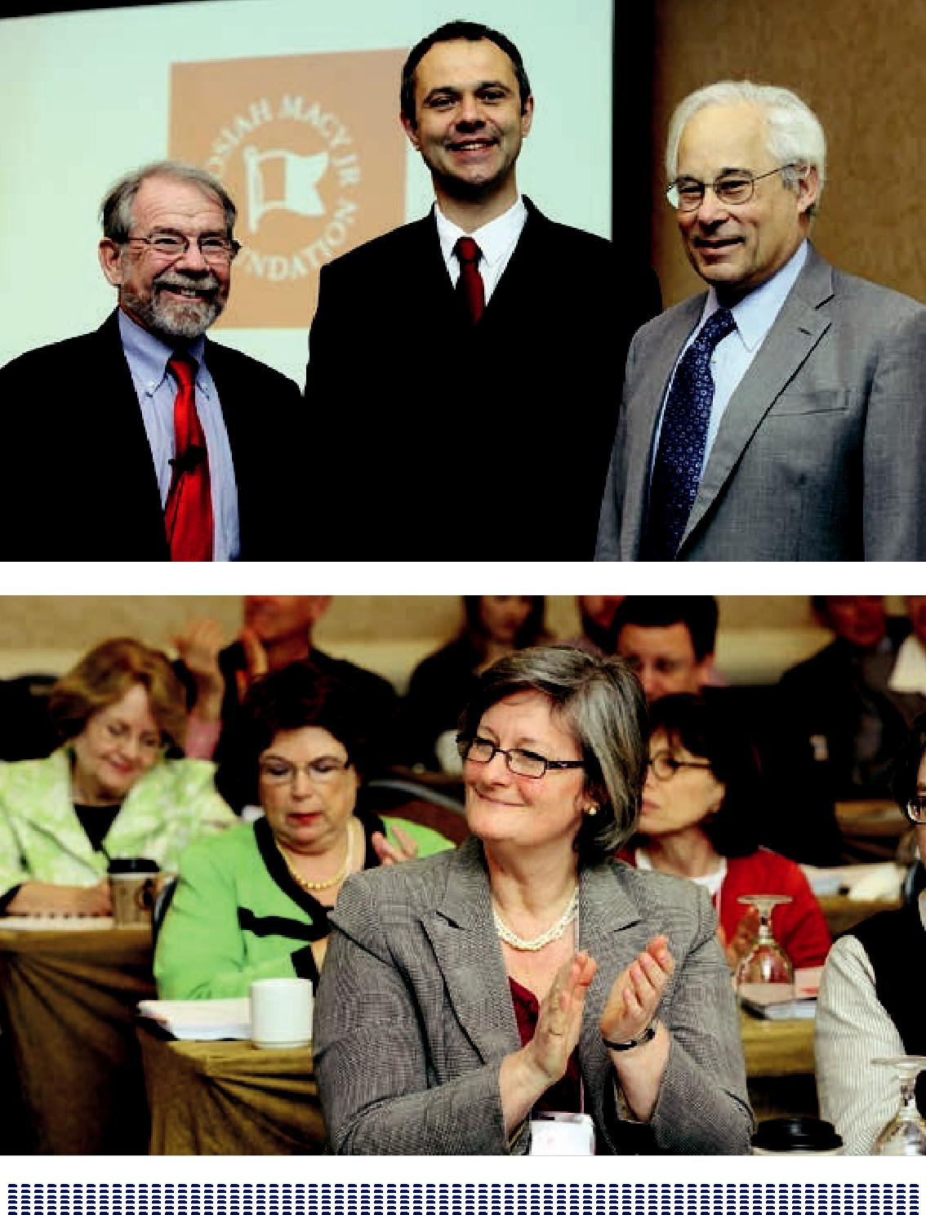

19

CONFERENCE AGENDA

Josiah Macy Jr. Foundation Conference on Interprofessional Education

SUNDAY, APRIL 1

3:00 – 6:00 | Registration
6:00 – 7:00 | Reception
7:00 – 9:00 | Dinner (assigned seats, informal introductions at each table)

MONDAY, APRIL 2

7:30 – 8:30 | Continental Breakfast
8:30 – 11:45 | PLENARY I
 | George E. Thibault, MD – Moderator
8:30 – 9:00 | Introduction – Why We Are Here – George E. Thibault, MD
9:00 – 9:45 | Why IPE Now and What Have We Learned?
 | Scott Reeves, PhD, MSc, PGCE
9:45 – 10:00 | Q & A from Floor for Scott Reeves, PhD, MSc, PGCE
10:00 – 10-15 | Break
10:15 – 11:00 | The Relationship of IPE to Healthcare Reform – Don Berwick, MD
11:00 – 11:45 | Questions from the Floor for Don Berwick, MD
11:45 – 1:00 | Lunch (assigned tables)
1:00 – 2:30 | Breakout I
2:30 – 2:45 | Break
2:45 – 4:15 | Breakout II
4:30 – 6:30 | Poster Session with Wine and Cheese
6:30 – 8:30 | Dinner (assigned seats)

20

TUESDAY, APRIL 3

7:30 – 8:30 | Continental Breakfast
8:30 – 11:15 | PLENARY II
 | Geraldine “Polly” Bednash, PhD, RN, FAAN – Moderator
8:30 – 8:40 | Introduction from Polly Bednash, PhD, RN, FAAN
8:40 – 9:55 | IPE in the VA: Centers of Excellence
 | Panel discussion and Q & A moderated by Malcolm Cox, MD
 | Participants:
 | Judith Bowen, MD
 | Rebecca Brienza, MD, MPH
 | Jill Edwards, APRN B.C, MSN
 | Theodore Long, MD
 | Elena Speroff, APRN B.C, MSN
10:00 – 11:15 | Panel on Education/Delivery System Links to Promote IPE
 | Panel discussion and Q & A moderated by George Bo-Linn, MD
 | Participants:
 | Linda M. Famiglio, MD, Geisinger Health System
 | Marilyn Chow, RN, DNSc, FAAN, Kaiser Permanente
 | Frank B. Cerra, MD, University of Minnesota
11:15 – 11:30 | Break
11:30 – 1:00 | Breakout III
1:00 – 2:00 | Lunch (Assigned tables)
2:15 – 4:45 | PLENARY III
 | David Irby, PhD – Moderator
2:15 – 2:25 | Introduction from David Irby, PhD
2:25 – 3:45 | Panel of 4 Senior Faculty on Impressions, Lessons Learned,
 | Next Steps
 | Patricia Benner, RN, PhD, FAAN
 | Molly Cooke, MD
 | Linda Headrick, MD
 | Madeline Schmitt, PhD, RN, FAAN, FNAP
3:45 – 4:30 | Questions from the Floor
4:30 – 4:45 | Summary Remarks by George E. Thibault, MD
4:45 | Adjourn

21

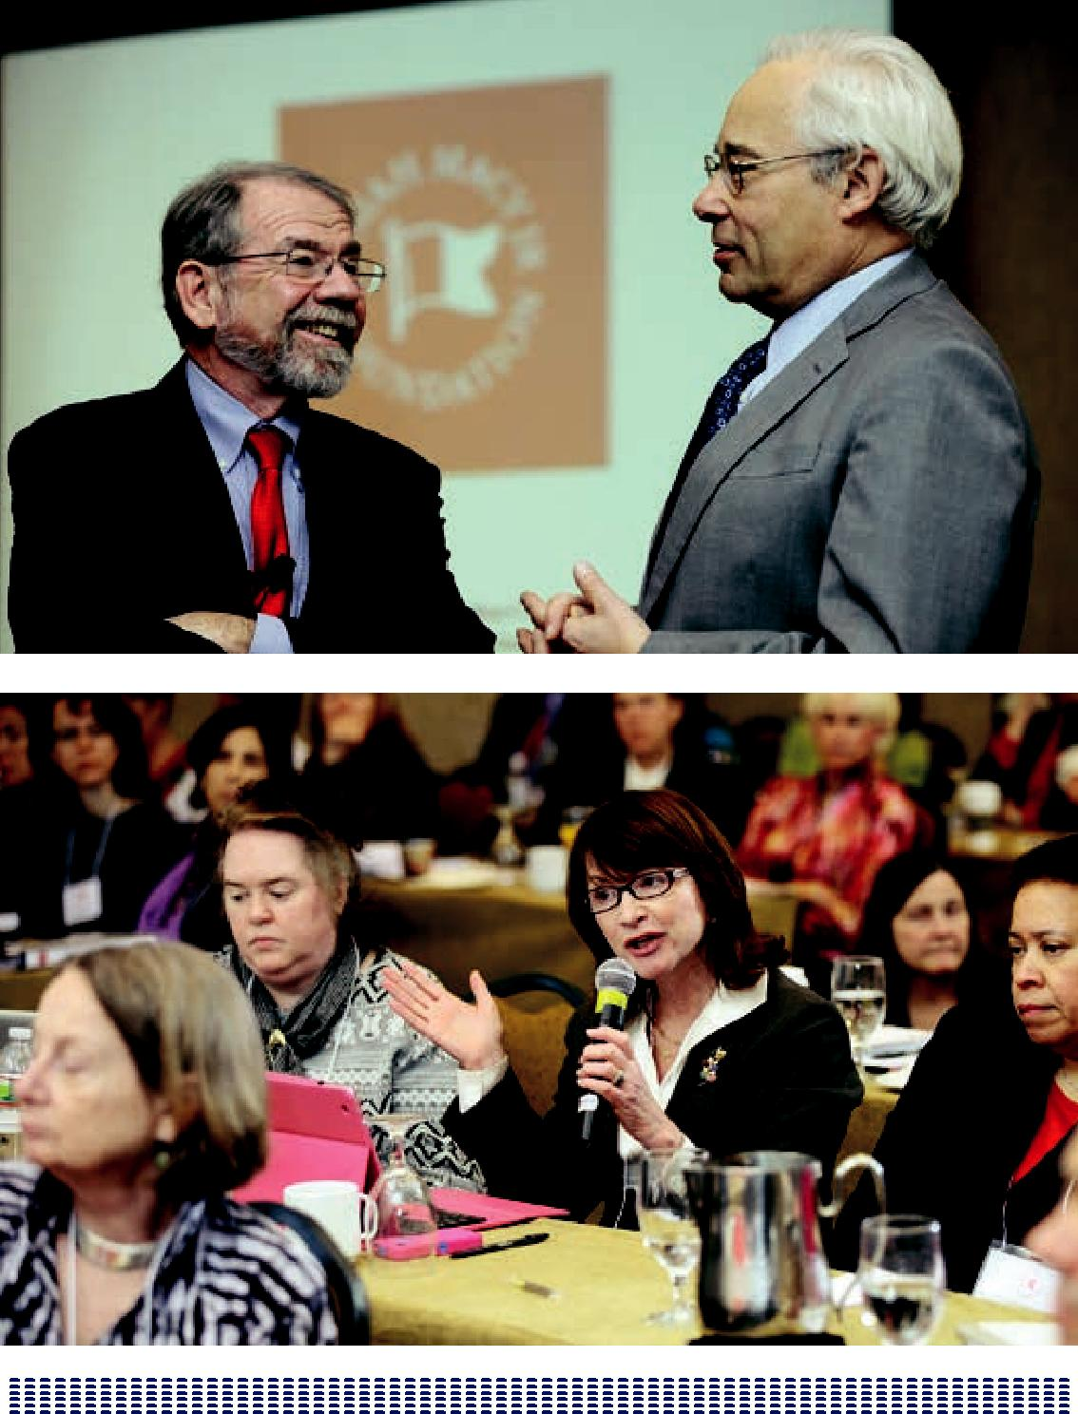

22

OPENING REMARKS

GREETINGS AND INTRODUCTION

George E. Thibault, MD

This 2012 Macy Foundation Conference on Interprofessional Education is an exciting event with the participation of 20 teams from 24 institutions. Interprofessional education (IPE) is at a tipping point where this idea that IPE should be one of the core elements of health professionals’ education is beginning to take hold. We are here to validate this work, learn from each other, and move the field forward.

This conference is a departure from the format of its predecessors. In the classic Macy conference, the Foundation assembles a group of thought leaders on a subject who will have a structured discussion for two and a half days, leading to a set of conclusions and recommendations that results in a report.

This meeting departs from that format. For the first time ever, the Foundation has a critical mass of grantees in a single area of educational innovation: IPE. Macy grantees have been invited to come together to share their work and to talk about how they and their work will advance the field. Those on the ground with Macy-funded projects will share and learn from each other. As one participant stated, describing the prospect of making progress that could not have previously been imagined, this conference is the “perfect storm.”

Those attending this meeting are part of a vanguard of a movement to change the paradigm of professional education in health care, and make it more relevant to better practice and better patient outcomes. That is what the IPE movement is all about, and you are all front and center in the movement playing key leadership roles.

You are all invited because you have been participants in endeavors that the Macy Foundation has supported over the course of the past four years to advance the cause of IPE in health care. The meeting is designed to be participatory, with a balance of interactive plenary sessions and breakout groups. We have intentionally kept the group total size to about 100 to maximize the interaction among attendees.

23

Breakout groups were designed around themes allowing for deeper discussion and in-depth conversation in a given area.

The goals for the conference are as follows:

- to have a conversation with all participants, allowing you to talk about your work both in formal and informal settings in a safe environment, where suggestions can be made and new collaborations can be formed

- to inspire and nurture participants through connections with colleagues around the country who share your interests and passions

- to find common ground among the growing family of kindred spirits, who are innovators in IPE

- to define future directions in IPE.

Aligning IPE with Society’s Needs

We, as educational leaders, can produce excellent educational products, but those products may not be what society actually needs. A greater conversation is needed about the alignment of the work of health professional educators with the needs of society. What are the contemporary needs, how are they or are they not being met, and what are the feedback loops to see that the health profession education system is responding accordingly?

If we acknowledge the growing body of evidence that health care delivered by well-functioning teams produces better results, there is a serious disconnect with the educational system that is still structured in silos. We are not preparing students for the environment in which they will be functioning as professionals. Intentionally we keep learners in each profession apart until they are “fully formed.” Then, we work to retrofit the process of trying to get them to work together.

This paradox—that the evidence supports team-based care but our educational system does not teach it—led the Macy Foundation to make a major investment in IPE. There are many at this conference who have been involved with IPE long before the Macy Foundation. These individuals inspired us to think seriously about reforming the educational paradigm and about using the Foundation’s convening function, its grant-giving power, and its bully pulpit to move this issue closer to center stage and make it a core element for educational reform.

24

In September of 2008, we gave our first major IPE grant to the University of Washington. In 2009, we gave the Institute for Healthcare Improvement (IHI) a grant called “Retooling Health Professions Education for Quality and Safety.” Through IHI, we issued an RFP for jointly developed nursing and medical school proposals for novel ways to design curricula for teaching quality and patient safety interprofessionally to nursing students and medical students.

Six pairs of schools were selected and participated in that process over 2 years: Case Western Reserve University, the University of Colorado, Johns Hopkins University, University of Missouri, Penn State University, and the University of Texas San Antonio. These grants accelerated the momentum in IPE. In 2009, we gave four additional IPE grants to Geisinger Healthcare System, New York University, the University of Pittsburgh, and Texas Woman’s University (TWU) in partnership with Baylor College of Medicine. The TWU/Baylor partnership was important because it involved a separate medical school and nursing school. Those institutions where all the health professional schools are located on one campus have some real advantages in establishing IPE. But if IPE is going to be generalized, it has to be able to function across boundaries.

In June 2010, the Macy Foundation held an important conference in conjunction with the Carnegie Foundation for the Advancement of Teaching. In celebration of the 100th Anniversary of the Flexner Report (which had been sponsored by the Carnegie Foundation), the foundation funded two groundbreaking books—one on reforming nursing education and the other on reforming physician education.¹ We chose to celebrate these publications together, and we issued a call for proposals for medical and nursing schools to participate and engage in curriculum reform broadly across the two schools. We did not specify the content, but only that it had to be a joint endeavor of a medical school and a nursing school, guided by the principles for reform as outlined in the books.

Seven schools were chosen to participate: University of Colorado, Duke University, University of New Mexico, New York University, University of Minnesota, Penn State University, and Vanderbilt University. More momentum for IPE was generated, and

- Patricia Benner, Molly Sutphen, Victoria Leonard, Lisa Day, Lee S. Shulman (Foreword by). Educating Nurses: A Call for Radical Transformation. San Francisco: Jossey-Bass; 2009 Cooke M, Irby DM, O’Brien BC. Educating Physicians: A Call for Reform of Medical School and Residency. San Francisco: Jossey-Bass; 2010.

25

there was evidence that all of the obstacles to IPE that have been talked about can be overcome by careful design and planning and strong institutional leadership.

In 2010, we gave four more major IPE grants to Arizona State/Arizona Universities, Case Western Reserve University, the University of Colorado, and Vanderbilt University. In 2011, momentum for IPE continued to grow, with major professional associations joining the movement. In February of 2011, the Macy Foundation, the Robert Wood Johnson Foundation, the American Board of Internal Medicine Foundation, and the Health Resources and Services Administration cosponsored a team-based competencies conference in Washington, DC. The conference

was convened to discuss the core competencies for IPE that were developed by the Interprofessional Education Collaborative (IPEC), six associations of health

professional educational institutions.² The conference participants—thought leaders, educators, and executives of health care systems across professions—endorsed the competencies and began a discussion of action steps to make the competencies come to reality.

In May 2011, the competencies were announced at a press conference that we participated in with the other sponsors and the IPEC group. The professional associations led the way in saying “This is core.”

In 2011, we awarded four additional IPE grants to Hunter College and Weill Cornell Medical College, to the Massachusetts General Hospital (MGH) and the MGH Institute of Health Professions, to Columbia University and to the University of Virginia.

In the past year, we have seen even more organizations become interested and involved in IPE nationally and internationally. The third Collaboration Across Borders (CAB III) Conference on Interprofessional Education and Practice attracted nearly 800 participants. An international report on health professional education published in The Lancet examined health professions education globally and came to some of the very same conclusions that we have regarding the need to align education with the needs of society and to do so interprofessionally.³

- American Association of Colleges of Nursing, American Association of Colleges of Osteopathic Medicine, American Association of Colleges of Pharmacy, American Dental Education Association, Association of American Medical Colleges, Association of Schools of Public Health.
- Frank J, Chen L, Bhutta ZA, et al. Health professionals for a new century: transforming education to strengthen health systems in an interdependent world. Lancet 2010;376:1923–1958.

26

As an outcome of the work at the 2011 core competency conference, the Interprofessional Partners and Action (IPPIA) was founded. This is a coalition of funders, government agencies, educators, and health systems that are working on ways to advance the cause of IPE. The formation of the IPPIA has already led to some funded IPE activities supported by the Macy Foundation and the Robert Wood Johnson Foundation. The Institute of Medicine has started a new Global Forum on Innovations in Health Professions Education, and important innovations in IPE are a centerpiece of this activity.

As we are meeting here, there is a discussion among funders and government agencies about the creation of a national coordinating center for IPE and collaborative practice that would elevate this movement to an even higher level while at the same time advancing the scholarship in the field.

Much has happened in the past four years leading up to this moment. Because of your work, this 2012 Macy Conference will be looked on as a tipping point when the IPE movement coalesced, and IPE became a core value of all health professions education. The people in the room are providing the leadership to make this happen, and we look forward to two exciting days together.

27

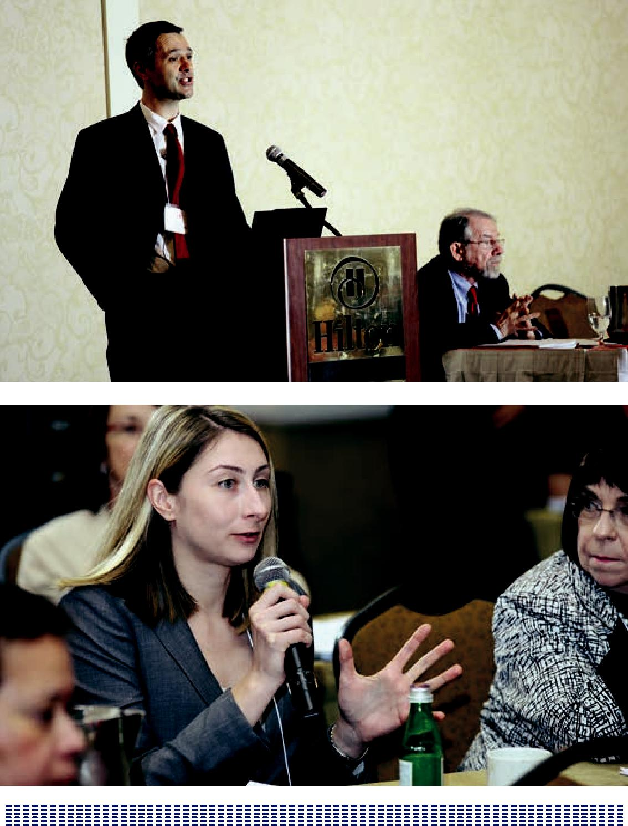

28

WHY IPE NOW AND WHAT HAVE WE LEARNED?

SCOTT REEVES, PHD, MSC, PGCE

Today represents a tipping point in the United States for IPE. For almost 20 years, Scott Reeves has tracked and monitored the progress of IPE. He presented a comprehensive summary as well as a map based on some of the systematic review work he has overseen.

WHAT IS INTERPROFESSIONAL EDUCATION?

Interprofessional education, a term that is commonly used now across the world, is defined as occasions when two or more professions learn with, from, and about

each other in order to improve collaborative practice and the quality of patient care (CAIPE 2002). This process is collaborative, egalitarian, experiential, and reflective.

IPE differs from other forms of professional education in which students sit together and passively receive education. Rather, in IPE, students participate interactively.

The collaborative aspect of IPE represents a departure from the historical hierarchical development of the health care professions. IPE brings together learners, faculty, and facilitators in a way that levels the playing field.

Success in IPE also comes about by using proven best practices in adult learning. Building awareness that IPE is experiential in nature helps increase the motivation of learners to engage in and value the IPE process. In the best IPE settings, learners spend time reflecting on their studies. IPE literature documents that some of the most powerful education that occurs in the group is the engagement of learners in their interprofessional activities and their reflections on the issues and tensions that arise.

IPE has become a focus in global health care as a means to improve quality and safety, patient-centered care, and chronic care. IPE is also considered an effective

29

tool in curbing the global rising costs in health care as it reduces redundancy in treatments. Another global development has been media coverage that has reflected failures in communication and collaboration. As IPE improves in these

areas, the media coverage becomes more reflective of IPE’s global accomplishments and contribution to improved care.

IPE involves different types of interactive learning. One is the concept of exchange-based education, often documented in the IPE literature as a sort of seminar classroom, based on small group problem-solving activities. In this learning situation, students come together to discuss the issues of a particular case scenario and to resolve those issues in a collaborative manner, drawing on each other’s respective field of training.

IPE also makes use of practice learning (placements) as another learning environment. To date this has been used to the greatest extent in Europe in its training wards and is an environment that the United States might certainly consider. Simulation (role play), in the past five years, has come to the forefront in the interprofessional field as an invaluable learning environment. Reeves is working to refine simulation, which to date has typically been task focused, with the introduction of “sociological imagination.” Borrowing from his training as a sociologist, scenarios are designed that allow for consideration of the roles that hierarchy, gender, and ethnicity can play in these experiences.

In addition to the traditional in-person training, the field is also seeing the use of elearning: the Internet, 24/7 egroup learning, and synchronous as well as

asynchronous learning. These elearning resources are effective tools for overcoming some of the historic problems that have interfered with the process of this collaborative education.

30

IPE Learning in training

- Diversity of professions, programs, settings

- Trends in learning

  - Case-based learning in the classroom

  - Increased use of simulation

  - Expanded use of clinical placements for IPE

Learning in Practice

- Diversity of professions, programs, settings

- Trends in practice

  - Team training in simulations

  - CE workshops related to clinical topics

  - Embedded in workplace through quality improvement and patient safety

IPE Research Designs

- Prevalence of single-site pilot studies

- Focus on short-term outcomes:

  - IPE well received by learners

  - Learner self-reported gains in knowledge and skills

- Limited data on behavior/practice changes

- Little focus on organizational/contextual factors

Theoretical framing of research

- Use of differing conceptualizations

- Growth in use of theories

- Shift from individualistic to social perspectives

- Focus on illumination and explanation

31

WHY WE NEED IPE

Among a number of global developments in the past 10 or 15 years that have actively promoted the engagement of IPE, one development in particular is the rise of and focus across the world on quality and safety in health care.

In response, IPE knows that if health care professionals can improve the way in which they collaborate and coordinate activities, they can enhance quality as well as patient safety.

As many know, the patient-centered movement has adopted IPE. IPE leaders now think about the patient in the center, and about training different professions to focus on the delivery of patient-centered care.

IPE has also responded to global crises in health care such as the increase in chronic care and the increase in health care costs. The complexity of chronic care is well-suited to multidisciplinary interprofessional teams. IPE effectively reduces health care costs by reducing duplication of efforts and through collaborative teamwork.

Again on the global front, a number of policy makers are now more actively involved with IPE, and various policy documents have been published during the past 10 years. The World Health Organization recently published an interprofessional report from the IP Study Group, and the Institute of Medicine is also active. In the United Kingdom, the Department of Health is advocating for IPE, and in Canada, Health Canada. And, interestingly, in the past five years, Japan’s Ministry of Health, Labor and Welfare adopted select IPE activities. IPE leaders are seeing policy makers across the world, in an almost unified voice, calling for better and more IPE.

WHAT HAVE WE LEARNED?

A tremendous amount of research is going on. The field is looking at the use of case-based learning and training, the increased use of team-based simulated activities (including classroom-based role- playing activities), the expanded use of clinical placements, the creation of student-run clinics, and the seminar format of learning based in the classroom setting where students learn in small groups trying

32

to solve a patient problem collectively.

IPE is considering outcomes from the study of whether learners enjoyed their experiences and valued their experiences as well as how their IPE changed their attitudes and/or improved their perceptions of one another. Researchers are also looking at how knowledge and skills improved. Studies are moving from individual behavior to a sort of collective, to see whether IPE can actually have an impact on organizational behavior. And most importantly, researchers are looking at the impact of IPE on patient care.

And IPE is also learning from the training wards in Europe where students come together to work in teams to care for patients under the supervision of clinical staff.

IPE is also seeing continuing education workshops (many classroom based) focused on clinical areas such as chronic care and diabetes management.

Research is looking at the role of IPE in quality improvement in patient safety and in quality improvement initiatives.

Often there is uncertainty with how to facilitate IPE around intervention. When is the best and optimum time for facilitators to intervene with a group that may be struggling with a patient case? Or maybe some friction has arisen around a

professional issue or a specific professional role and no one knows when or how to intervene. And some research indicates that facilitators don’t quite know when is the best time to intervene and enhance the learning.

One of the big problems we’re finding is that the facilitation of this type of education relies on a small group of highly enthusiastic and highly committed individuals—a group whose numbers need to be expanded.

Often assessment is focused on individuals and competencies in relation to the IPE that they’ve done. Yet when learners are working together as a team or

interprofessional group, there is little or no assessment. If IPE strives to get learners to work together collectively as a team, how do educators assess the individual in context of the collective?

What’s encouraging in the past few years, though, is the increase of new types of assessments. Although the Objective Clinical Standardized Examination (OCSE) is not new, its use in the IPE field is.

33

IPE leaders know the difficulties of developing IPE in terms of the scheduling of different student groups, in terms of class sizes, and in terms of just finding space to accommodate big groups in small group–learning types of spaces. In addition, the field faces accreditation challenges, particularly for learners in training, and not all the professional orders are aligned in terms of their interest and commitment to IPE.

On the macro level, IPE also has to be mindful of the different professional cultures. Professional cultures in nursing, in medicine, and in occupational therapy vary, which complicates the task of delivering equitable IPE. IPE educators have to be thoughtful about the powerful influence of the hidden curriculum, in terms of the role modeling of faculty in front of students and how powerful that can be in terms of sending the wrong messages to learners such as “if the faculty aren’t really engaged, why should I bother?”

IPE needs to learn more about how the education students receive interprofessionally can translate to their collective behavior in teams and in groups and also how their behavior as teams can link into practice changes. The field needs a better sense of the longer term outcomes of this type of education as well as a review of short-term learner outcomes. These are the phenomena that are really going to impede or possibly promote IPE activity and its sustainability over time.

With theoretical framing, it’s encouraging to see—and the Journal of Interprofessional Care is working on a special themed issue to be published later this year—the examination of different types of theories in IPE and practice. The field is becoming more theoretically informed.

What IPE needs to do is synthesize the best practices, the best models, and the emergent common models of IPE both in training and also in practice in an easy-to-use online repository.

The field needs to expand and also evaluate faculty development opportunities. IPE has relied on a small group of highly dedicated faculty, but needs to expand now in a number of ways including the evaluation of the opportunities for faculty development.

As George mentioned previously, IPE is indeed at a tipping point, as IPE becomes more of a mainstream activity and less as an additional curricular activity.

Stable funding streams are difficult to find, as traditionally education itself isn’t well

34

funded. Canada has been hard hit. In the past few years, IPE in Canada saw a huge injection in finances across the provinces. But those funds have now ebbed and IPE activity has waned. Similar funding situations have arisen in other areas of the world.

IPE needs to think more purposely, especially how to create appropriate sequencing: learners start with some introductory activities, then move through to an intermediate level and then on to an advanced level just before they practice. Then, at some point, continuing education follows.

Again, we need to understand and encourage better awareness of these broader contextual issues, because if we don’t understand them and their influence, we will be affected and they will inhibit the things that we do. So, we need to have more scholarship looking at those things. Similarly, with the hidden curriculum, we need to examine it, understand it, have a better awareness of it and then try to intervene to ensure that these mixed messages that students and learners can pick up are pushed down.

Organization

- Ensure mainstreaming opportunities

- Better coordinate professional curricula

- Identify stable funding streams

- Expand numbers of facilitators

- Create appropriate developmental sequencing of learning

Context

- Explore and create better awareness of socio-economics, culture, socialization

- Examine and intervene in hidden curriculum

- Advocate for IPE expansion & associated policy changes

35

WHERE ARE WE HEADED?

The establishment of new IPE centers, such as that at the University of California San Francisco (UCSF), will expand the future of the field. In the case of UCSF, this initiative was created and supported by senior management including the Chancellor and the Dean. UCSF demonstrated that top-down efforts supersede those at the grassroots levels. Centers are able to come on line sooner with more sustainable funding. And learning from UCSF, IPE centers function best when

situated in a professional, neutral part of the University. The five schools involved in the Center are working toward a common time when all the students at UCSF will be receiving IPE.

Questions arose as to how seminars will play out with medical students at the graduate level, nursing students at the undergraduate level, and how many nurses are still graduating from associate degree nursing programs. Are centers such as that at UCSF’s Center for Innovation and Interprofessional Education collaborating with its local community college, City College of San Francisco, which graduates a number of RNs into professional practice who will be an integral part of the clinical team?

Disparities occur from the different levels of nursing education and the disparities that surface when varying professions come together in an educational setting.

The nursing profession, the largest of all the health care professions, also involves LPNs and CNAs who are not considered professionals, but who still play vital roles on the team, especially in nursing homes (chronic care). How will IPE address all of these disparities in preparation and education in this interprofessional team? Bringing diverse practice opportunities together into this learning construct will counter these disparities, socializations, and socioeconomics.

The question was then raised: if IPE is not situating the education in the wrong place, then perhaps the best place to turn IPE on its head is in the health systems rather in than in medical and nursing schools. It’s in the health systems where all the trainees come together. At the VA, for example, IPE is doing its work in clinics and beginning to think about doing it in the hospital. Trainees come to the VA from a range of places, but all come together at that practice site, at that experiential

opportunity. That’s where perhaps the education needs to be done. And making that

36

happen may be far more feasible and can be accomplished sooner than trying to get medical and nursing schools to coordinate their curricula.

IPE has a great group of core enthusiastic, dedicated faculty that needs more opportunities for professional development and embedded rewards, especially leading toward tenure. Abilities in facilitating IPE and in faculty role modeling as well as teaching skills should all contribute to opportunities for career advancement.

One of the key issues surfacing now is the integration of practice with the academic world universities that is a global phenomenon. Universities create individual institutions and deliver a relatively straightforward classroom-based role-play for IPE. The practice world, with more logistics to organize, is a bit harder but can take lessons from models of success such as the previously mentioned training wards in Europe. The evaluation work related to the training wards show that students have a rich experience in interprofessional learning and value that sort of contact with patients. The students reflect on seeing real-life activities in the delivery of care and the attentions involved in that delivery.

The field also needs documentation in a searchable repository of best practices in particular settings. Participants described a number of extraordinary initiatives that unfortunately remain ephemeral until they’re published with some data showing their efficacy—with empirical evidence. This is a call to IPE to raise the scholarship in gathering data so that these case studies are no longer ephemeral but rather useful and long lasting in meaning.

Columbia’s Rita Charon, MD, PhD, presented an example of a consultation with a small group of professionals working as a team in a hospital in Gothenburg,

Sweden. All on the team interview patients on admission and all are present when patients are given any serious diagnoses. These professionals saw the difference in this team approach; there was no redundancy in the patient’s care and few, if any, miscommunications. And now these professionals are transformed—wanting to practice no other way but in such teams. The IPE field sees over and over that once learners and professionals participate in a truly effective and meaningful

interprofessional activity, they never want to return to old ways. The interprofessional experiences are that self-reinforcing.

37

ADVOCACY FOR IPE

Leaders, institutions, and systems need to advocate for the expansion of IPE, assuring a shared agenda with policy makers.

In terms of the future research and theory building, the field is doing a good job of looking at the short-term outcomes related to IPE but now need to think about the longer term issues. Consideration needs to be given to how IPE can impact behavior, practice, and patient care. For example, what is the profile of an effective interprofessional facilitator?

IPE has done some really impressive work in terms of developing, delivering, evaluating and assessing IPE. And with the endeavors of the Macy Foundation as a case study, leaders can see that the expansion of IPE, evaluations, and dissemination of funding has all been very impressive.

IPE has achieved some important milestones as a field, collectively. The field can be creative and push forward. And the best way to move forward is collectively, and especially to think about how IPE can share and do things collaboratively as well.

38

Learning, pedagogy, assessment

- Synthesize best practices/models of IPE in training and in practice

- Develop rigorous assessment of learner/practitioner performance

- Expand and evaluate faculty development

Assessment

- Predominance of formative assessment

- Prevalence of self-assessment

- Focus on individuals (not teams)

- Growth of new approaches (OCSE, portfolios)

Future research and theory building

- Focus more evaluation on:

  - Long-term impact (behavior, practice)

  - Learning and teaching processes

- Expand use of mixed methods designs

- Study perspectives of multiple stakeholders

- Adopt wider theoretical frameworks and research methods

- Impressive progress to date

- Important milestones achieved

- Difficult challenges ahead

- Exciting path forward

39

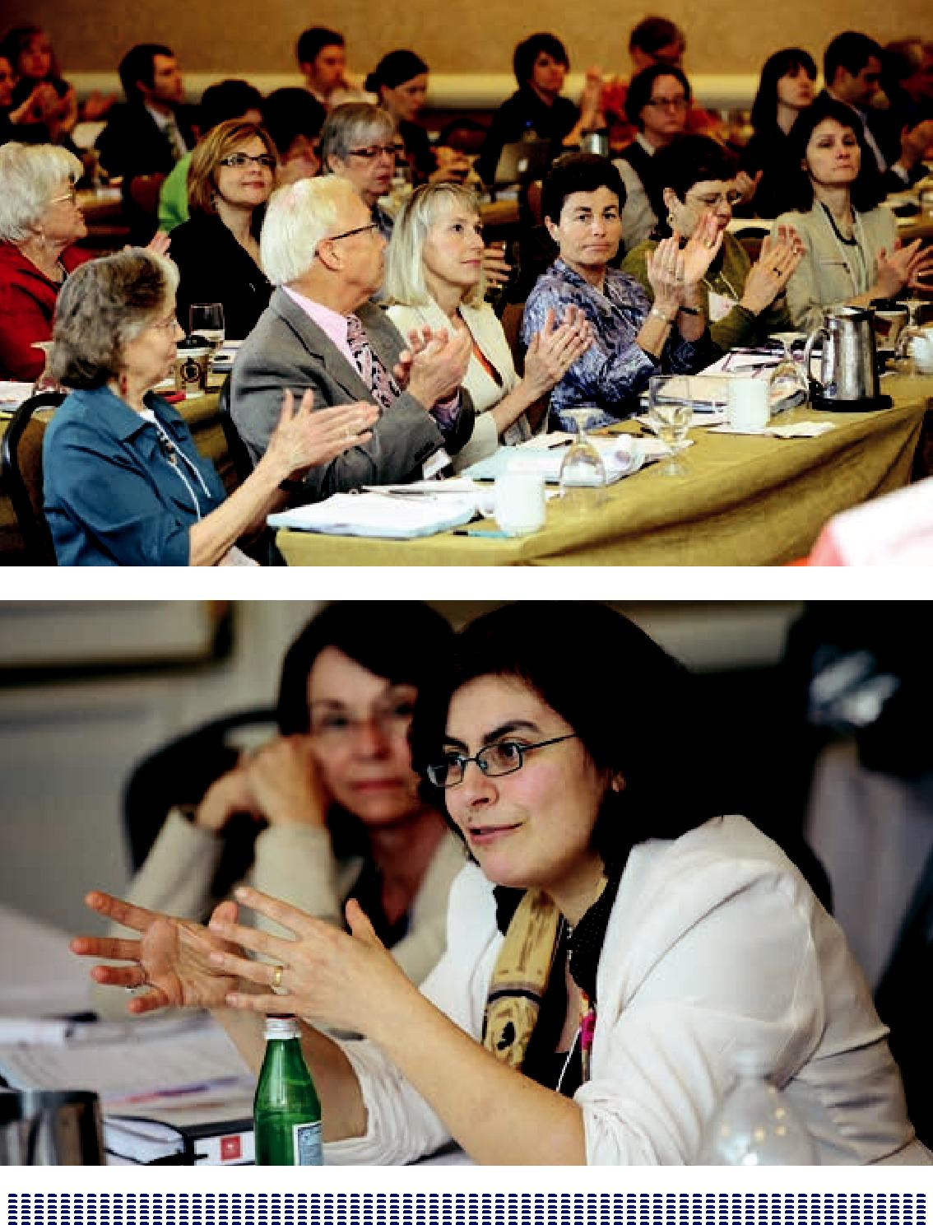

40

INSTITUTIONAL SUMMARIES OF IPE ACTIVITIES

ARIZONA STATE UNIVERSITY AND

UNIVERSITY OF ARIZONA

The Arizona State University (ASU) and University of Arizona (UA) Macy grant team is designing and plans to implement an integrated curriculum in primary care for MD, DNP, PharmD, and MSW students. We chose a primary care focus to address the need to build the workforce and collaborative capacity of primary care professionals in Arizona. We also wanted to develop a curriculum that emphasizes graduate level practice for each of the four professions with close attention to consistent leveling of competencies across professions and time.

Our curriculum model capitalizes on the ongoing interprofessional education (IPE) work at two universities. Both ASU and UA have active health care IPE committees that sponsor regular IPE projects and initiatives. Several other professions, including law, architecture, and engineering, have participated in this work. The Institute

for Advanced Telehealth (T-Health), sponsored by the Arizona Telemedicine Program, has been an important catalyst for IPE at both universities. The Institute has developed new technologies for distance IPE that we plan to fully capitalize on in our primary care and rural health curriculum. Importantly, many of the rural

community networks used for clinical training of primary care professionals in Arizona are linked on the statewide telemedicine network.

Our pilot interprofessional primary care curriculum focuses on three competency areas: teamwork, quality, and patient-centered care. Competencies in each of these areas are introduced and built incrementally across classroom and clinical experiences. We have identified a “golden window” that we believe will align student readiness for competency development with current curriculum designs and schedules. Our initial goal is to establish a credit-neutral IPE curriculum as the foundation for future work.

41

In our focus groups and discussions, students have emphasized the need for more practical and impactful IPE experiences. We will soon launch an IPE Technology Challenge for students at both universities to help us learn better ways to teach. IPE Student teams will receive awards for innovative technology-enhanced IPE strategies.

We are in the process of preparing funding applications to implement our integrated primary care curriculum model across two universities and four professions using technology-enhanced teaching strategies. We believe it will be an important step to test the impact of this model on IPE competence and collaboration-readiness of new primary care professionals.
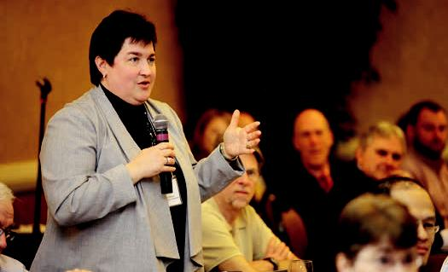

42

CASE WESTERN RESERVE UNIVERSITY

Overview

The I-LEAD program is aimed at developing an interprofessional curriculum that integrates several models (FAIECP, Kolb’s Experiential Learning Theory, & IHI Improvement model) and learning experiences to prepare collaborative practice-ready health care providers. Learning occurs within interprofessional teams

and includes simulated and actual practice experiences. Medical and Master of Nursing students are the primary participants because they both enter prelicensure education with at least one previous college degree. BSN students and, most recently, entering Dental and Social Work students have also been included in small group learning experiences to develop an appreciation for collaborative interprofessional practice and initial team skills. Incorporation of the additional students has exponentially increased the participation of students and faculty to create attention and a critical mass of students and providers engaged in and committed to advancing interprofessional practice as a means of transforming the delivery system and improving the quality of health care. All learning experiences are currently in the phase of pilot testing. Key elements in the curriculum include

providing opportunities for meaningful work, developing team skills, and supporting quality improvement in health care. Intra- and interprofessional learning experiences are included. Faculty development experiences are being expanded. All faculty facilitating the small groups of students from the four schools receive two hours of training prior to facilitating groups of 12 students. Learning experiences in current pilot testing include the following:

Interprofessional Interface

The objectives for this series of experiences are to appreciate the complementary roles/education of each of the four professions, to appreciate each other’s literature, and to begin to build team skills by working in small group learning experiences. Students from the four schools will come together for a three-hour

43

facilitated small group learning experience once a semester for four semesters. Each session will build on previous concepts, introduce some new concepts central to interprofessional practice, facilitate the practice of team skills, and provide an opportunity for simulated application.

Shared Language

Both intra- and interprofessional experiences are included in the development of communication skills to facilitate interprofessional communication. It is critical not only to use common terms but to have consistent definitions of the concepts employed. The objectives are to develop programs to introduce both faculty and

students to select team tools, provide them with strategies to implement their use in small group settings, and to enable them to apply select tools based on the Team Strategies to Enhance Performance and Patient Safety (TeamSTEPPS) protocol in interprofessional care settings.

Community

Students are developing and applying team skills in a series of experiences within public health settings including providing foot care to a homeless population, assessing blood pressures for children within the public schools as part of a large study of obesity and hypertension among urban youth, and developing health education programs for families in conjunction with the public library and natural history museum.

In-patient Shared Learning Experience

The objectives for this experience are to improve the understanding of each profession’s roles, share insights and perspectives on the full trajectory of care (admission through transition/discharge), and develop effective interprofessional collaborations in care. Medical and Nursing students will work in pairs to assess mutual patients; discuss the challenges in care coordination/delivery and interprofessional communication; and plan for discharge/transitional care. They will also work on completion of a systems-based hospital improvement plan.

Interprofessional Student Run Free Clinic (ISRFC)

The ISRFC was initially conceived as a capstone experience for the medical and nursing students in the application of interprofessional care in the outpatient

44

community. It remains that way for the nursing students. Medical and nursing students see patients and plan for their care as provider teams without public distinction as to role. The mutual as well as distinct professional contributions are recognized and either profession might take the lead in planning care for a given patient. The ISRFC also provides students with the opportunity to develop a system of care delivery for an underserved population. Students take the lead in planning for the clinic’s operation including determining how it will operate, be financed (they engage in fund-raising), made known to the public, acquire appropriate licensed professional supervision, and schedule the student providers. Students have formed a structured organization succession planning, and faculty assume a coaching role.

Virtual Interprofessional Education Resource Center (IPEC)

In addition to the curricular development, a virtual resource center is being created. It will provide accessible learning resources and faculty development materials to support intra- and interprofessional learning and collaboration for students and faculty among the medical, nursing, dental and social work schools. It will include both internal project and public components. The former has been developed and provides all faculty involved with the I-LEAD project access to documents, minutes, and resources for all components of the project. The public component

is in the development stage. It will showcase interprofessional education and provide interested parties with access to resources as well as tested learning modules and measures.

Challenges

Structural challenges included delay in hiring a project administrator in year one and the transition to a new MD co-leader in year two. Creating a collaborative curriculum that supports students working in teams has been challenged by the imbalance in the number of medical versus nursing students and the available clinical resources in the inpatient and free clinic settings. The number imbalance has been addressed for some learning experiences by drawing in upper division BSN students and Dental and Social Work students. Scheduling of opportunities for shared clinical application is also a challenge due to differences in academic schedules, the availability of clinical units, and the complexity of medical and nursing curricula.

45

Lessons Learned

Even with a shared commitment to interprofessional education and practice, it is critical to address from the beginning cultural differences, varied perspectives, and differences in meanings among commonly used terms. Core faculty need to practice and model teamwork. Students are engaged when they view learning experiences as “meaningful” work. Ongoing faculty development is critical and there needs to be sufficient time for planning and evaluation.
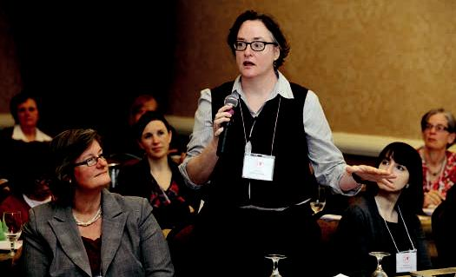

46

COLUMBIA UNIVERSITY

Macy Executive Core

Eight senior faculty from the four health sciences schools of Columbia University participated in a year-long Interprofessional Education Planning Year, with funding from the Josiah Macy Jr. Foundation. During the planning period, the faculty met every other week throughout the calendar year. On the background of significant long-standing institutional suspicion between disciplines and with several failures to address the dysfunctionality of teams in our institution behind us, we eight

created for ourselves an intensive collaboratively taught seminar, relying on narrative methods of teaching and learning, that opened up the disciplines to one another and paved the way toward interprofessional seminars for all our students. We learned from our own seminar to focus on content that lies outside the expertise of any one of our disciplines; to structure the sessions with rotating chairs, being highly mindful of not centralizing authority; and to build in experiences of contact in dyads or triads to achieve a personalized contact. We see, in retrospect, that our year was spent well—in developing familiarity, respect, trust, confidence in our capacities to work together, and simply liking to be together.

Columbia–Macy Scholars in Health Care Team Effectiveness

The short-term result of the planning year is an intensive, four-school, semester-long weekly 90-minute seminar. The seminar is cross-registered in all four schools. We designed the seminar to accommodate 16 students per semester, four from each of four schools. All students achieve credit that applies to a required course, that

is to say, our course “counts” as part of the students’ required curriculum. To get there was, of course, a mammoth undertaking requiring exquisite diplomatic skills, administrative muscle, cohesion among the eight faculty, pedagogic inspiration, and commitment.

47

The seminar, “Cultures of Health, Illness, and Health Care” is now in its third month. The students are intensely engaged—writing reflections every week and posting them for all students to read; graduate-level reading assignments; collaborative work accomplished in “tetrads” composed of one student from each school;

and preparations for field observation projects witnessing well-functioning and dysfunctional teams. One of us functions as “host” and is present at each seminar meeting. The others take turns, usually teaching in pairs (each from a different school), giving the students contact with professors from all four schools. Each teaching faculty pair have chosen the readings, the writing assignments, the in-class tetrad project, and have read the students’ posted writing ahead of class. Students fill out evaluations every week at the close of class, and they are consistently highly enthusiastic and even grateful for the chance to work together in this way.

Planning for Next Year

The plan is to mount this seminar in each spring semester. By next year, we foresee being able to run two or three sections of the seminar. We will concentrate on faculty development through the summer and fall in order to equip additional faculty from each school to teach the seminar. As we go forward, we plan to continue to offer this seminar each spring and will expand the offerings with new seminars as well.

We are well aware that we will need to work toward sustainability beyond the Macy funding and that even by next year, we will need funding sources for those not currently funded on this grant. Accordingly, we have worked on sustainability

strategies and have a promising mechanism whereby faculty can become trained for this teaching work with funding from another source.

Primary Care Dental Medicine

With funding from the Macy Foundation, the Dental School has initiated a research and clinical effort to incorporate primary care screening methods into routine dental care. The Core Faculty of the Macy project were instrumental in this project’s design and conception. The goal is to build the team communications among dentists, primary care internists, family medicine physicians, and advanced nurse practitioners in medicine and family medicine. The goal of this collaboration will be to make available to primary care clinicians the results of screening interventions and to assure appropriate follow-up for patients who have undergone screening testing in the dental clinic.

48

Certificate Program in Health Care Team Effectiveness

The Mailman School of Public Health has undergone a substantial curriculum reform. One of the innovative mechanisms of learning is the inauguration of Certificate Programs in the major “concentration” areas of MPH candidates. We are happy that Health Care Team Effectiveness was chosen as the subject of an 18-credit certificate program. Members of the Macy Executive Core have collaborated in the design of the Certificate Program. There will be interlacings of this program with the Columbia-Macy Seminar, perhaps with Certificate Program credit paid to students who complete the Columbia-Macy Seminar. This Certificate Program design and implementation was undertaken with support from the Macy Foundation.

Student Initiatives

Students at the Columbia School of Dental Medicine have spearheaded a new student association devoted to developing health care team effectiveness. With the encouragement and assistance of Macy Core Faculty, this group has widened its reach, engaged many faculty from all four schools, and inaugurated promising programs open to all health sciences students. Medical students have designed a Nursing Rotation, in which medical students can enroll in a rotation taught by nurses that exposes medical students to what nurses do. The student-run clinic for uninsured patients (CoSMO) combines students from our four schools in an

increasingly effective clinical services unit and a powerful teaching site for students and clinicians. La Romana is a free-standing clinic in the Dominican Republic to which more and more students have elected to rotate for primary care training. La Romana’s director is committed to providing training opportunities for students from all four schools, and the Macy Core Faculty are hoping to provide such opportunity to those students who work together in Columbia-Macy Scholar Seminars as the summer’s “culmination” to an intense semester of collaborative learning.

49

DUKE UNIVERSITY

The Interprofessional Collaboration in Education (ICE) group was founded in 2003. It consists of curriculum directors from each of Duke’s graduate health professions programs, and meets monthly to develop opportunities for and support of IPE activities.

Faculty Development for Teaching

An interprofessional group of health professions educators recently collaborated on the development of Duke’s Consortium of Health Professions Educators. The Consortium consists of 13 faculty and staff members from the various graduate health professions programs at Duke and the Medical Center Library. Over the course of a year, the Consortium developed a web-based set of teaching resources for health professions educators.

During the Community Partners Program, teams consisting of one first-year medical student and one nursing student are paired with a member of the Durham community with a chronic disease. These interprofessional teams meet with their Community Partner several times over the year to establish a relationship, learn the meaning of illness to their Partner, and help their Partner navigate the health care system.

The Interprofessional Prevention Course begins in the first month of each graduate health professions students’ curriculum. First-year medical students, physician assistant, and physical therapy students complete a 16-hour course on prevention (four-hour sessions once a week for four weeks). Interprofessional student teams meet in lecture and small group settings for interactive activities and community assignments. A final team project is required. In addition to learning about prevention, students learn about each other’s profession and role in the health care team. Interprofessional respect is a stated goal of the course and is modeled by the interprofessional group of faculty members conducting the course.

50

ABSN students participate in three 3-hour sessions with second-year medical students during their final Nursing Synthesis course and the medical students’ Year 2 Practice course. The first session is a structured interactive discussion in small groups about bias in health care. The second is a structured interactive discussion in small groups about palliative care, followed by a large group presentation and discussion with palliative care clinicians (one MD, one NP). The third is a structured interactive discussion in small groups about communication between doctors and nurses. All student small groups include faculty from the nursing and medical schools. The discussions are facilitated by co-student leaders—one medical student and one nursing student—in each small group. The overall goal of these sessions is to enhance professional development among and between the two health professions.

An interprofessional experience in Disaster Preparedness (with medical, nursing, physician assistant, and physical therapy students) is offered in the spring each year. Faculty from all four programs collaborated on the development and delivery of this course. Students are required to work in interprofessional teams to develop and implement coordinated responses to natural and man-made disasters.

Medical and nursing students complete a three-hour interactive session on patient safety during the medical students’ fourth-year Capstone course. The session requires team work and problem-solving around quality improvement for enhanced patient safety. Proposed solutions to potential problems in patient safety are shared with the chief operating officer of the hospital.

Interprofessional Case Conferences are conducted on a quarterly basis by the Department of Community and Family Medicine, with an interprofessional team of faculty designing the various cases for teams of students from a variety of

educational levels. Interprofessional teams of students from the Schools of Medicine, Nursing, Pharmacy, Community Health, Physician Assistant, and Physical Therapy programs review a patient case, elicit a history, develop a multidisciplinary plan of care, and communicate the plan to standardized patients, who help provide a “real-life” element to the simulated clinic visit as students engage in a team approach to patient care. Faculty members from various disciplines serve as facilitators for each of the interprofessional student teams.

A course titled The Applied Genomics and Personalized Medicine in Clinical Care was developed by the School of Nursing. Offered for the first time in Spring 2012, the focus of the course is on the clinical application of genomics for the prevention,

51

prognosis, and treatment of complex disease states. Health professionals acquire knowledge and skills to evaluate the application of genomics to clinical practice. Learning approaches include didactic lectures, case studies, and exploration of actual genomic test results.

Proposed/planned Interprofessional Activities

Creation of a Duke Academy for Innovation and Research in Education (DAIRE). The Academy would be a scholarly unit that provides an organizing and coordinating structure for faculty responsible for the education of students in graduate health professions programs at Duke. The structure of the Academy would emphasize teaching, research, and administration of health professions education programs and would be based on collaboration between education scholars from different departments and schools within Duke Medicine. One subunit of the Academy, the DAIRE’s Education Innovation Groups (EIGs), are designed to facilitate development of innovative strategies for education. Each EIG includes an ongoing research agenda. EIGs may be formed around such topics as:

- The future of health professions education (to keep ahead of anticipated changes in health care delivery models)

- Interprofessional education (e.g., working in teams, communication, patient safety)

- Innovation in education and assessment (e.g., team-based learning, reverse engineering, assessment in simulated environments).

- Technology in teaching and learning (simulation, medical games, web-based resources, distance learning).

- Streamlining education across the continuum.

Development of an interprofessional dedicated education clinic (IDEC). The IDEC would be devoted to the clinical education of the graduate health professions students at Duke. A core group of identified health professionals (physician, nurse, physician assistant, physical therapist) would have the sole responsibility of supervising this student-centric clinic. Health professions students would work in health care teams to provide care to the Durham community. In addition to profession-specific clinical education, students would experience first-hand the

52

role of each profession in the care of individual patients and within the overarching health care system.

Creation of a parallel curricular track for medical and nursing students interested in becoming leaders in primary care. The goal of the Primary Care Leadership Track is to create primary care MD and non-MD providers who can work in teams to improve the health of a community. This includes learning medicine and nursing, but also learning about community assessment, engagement, and quality improvement. During their first clinical training year (second year for medical students, second year for most MSN nursing students in relevant tracks), interprofessional teams of students would be assigned to an ambulatory community clinic/practice to follow

a panel of patients over the course of the year. This longitudinal outpatient clinical experience would be supplemented by brief (e.g., four-week) rotations in medicine and surgery and others (to be determined) in an inpatient setting.

We are building an Immersive Learning Environment @ Duke (ILE@D); a three-dimensional, collaborative world accessible from any Internet-connected computer that provides an innovative, interactive “front-end” to distance education in the health care professions. ILE@D will maximize face-to-face interactions between teachers and students through interactions in a classroom setting, and facilitator-led preparatory activities in the virtual environment. In this project, we will bring together multiple ongoing efforts in virtual environments for the benefit of medical students, nurses, physician assistants, residents, and other health care professionals. Our goal is to develop ILE@D with a focus on improving the reach, scope, and efficacy of interprofessional learning in medical and nursing education at Duke.

53

GEISINGER HEALTH SYSTEM

Introduction

Education for the Geisinger professional workforce is based on several principles: 1) Integration across the system including all facilities, practice groups and care management/insurance entities; 2) longitudinal experiences across the continuum of education; 3) interprofessional activity whenever possible; and 4) building and teaching team-based approaches.

We have chosen to focus on four competencies extracted from the Interprofessional Education Consortium¹ (IPEC) led by HRSA:

Competency Domain 1: Values/Ethics for Interprofessional Practice. Act with honesty and integrity in relationships with patients, families, and other team members.

Competency Domain 2: Roles/Responsibilities for Collaborative Practice. Communicate one’s roles and responsibilities clearly to patients, families, and other professionals.

Competency Domain 3: Interprofessional Communication.

Express one’s knowledge and opinions to team members involved in patient care with confidence, clarity, and respect, working to ensure common understanding of information and treatment and care decisions.

Competency Domain 4: Interprofessional Teamwork and Team-Based Care. Engage other health professionals—appropriate to the specific care situation—in shared, patient-centered problem-solving.

- Interprofessional Education Collaborative Expert Panel. (2011). Core competencies for interprofessional collaborative practice: Report of an expert panel. Washington, D.C. Interprofessional Education Collaborative.

54

Organizational Structure. Traditional single profession (e.g., MD/DO, RN, PharmD) structures provide the support for undergraduate, graduate, and professional development processes. Student activity at Geisinger is 40% medical, 30% nursing, and 30% other health professions. Members from each profession link through matrix relationships for specific content or functions. Examples of these structures include the following: 1) the Continuing Professional Development Committee (CPDC) with members from eight different professions analyzes practice gaps

and sets the agenda for system-wide education; 2) the Advance Practice Council (APC) manages the education needs across the continuum for Nurse Practitioners, Physician Assistants, Nurse Anesthetists, and Nurse Midwives; 3) the newly forming Interprofessional Committee on the Clinical Learning Environment gathers multiple professionals to review issues that impact the learning environment (this group is a direct result of a current Macy Foundation–sponsored project.); and 4) the Geisinger Quality Institute (GQI) provides interprofessional courses in quality.

Examples of Interprofessional Integrated Learning (other than Macy-sponsored activities) include 1) Lipid Clinic: teams of pharmacologists, pharmacology students, physicians, resident physicians, nurses and other learners integrate to teach and provide care to patients receiving lipid management therapy in selected ambulatory sites; 2) ProvenHealth Navigator®: Interprofessional faculty lead this initiative and provide experiential and course-based learning on Advanced Medical Home

topics and issues; 3) Mock Code Teams: high-fidelity simulations involving three or more professions are recorded and analyzed for team skills and patient outcomes; and 4) Standardized Teams (ST): our newest interprofessional endeavor will use interprofessional faculty in standardized roles for learners to practice and improve their skills in “time out,” hand offs, and other team activities.

55

HUNTER COLLEGE AND

WEILL CORNELL MEDICAL COLLEGE

Integrating Transdisciplinary Education Across Cornell Hunter (ITEACH)

This collaborative program, funded by the Josiah Macy Jr. Foundation, is a public-private partnership between Hunter College and the Weill Cornell Medical College. Students from nursing, public health, social work, and medical schools are engaged in structured team learning to develop competencies in collaborative, patient-centered teamwork. The overall goal is to increase understanding of the values

of different professional identities and enhance collaborative behavior to improve the delivery of patient care. This innovative transdisciplinary experiential program utilizes simulation, patient visits, narratives of patient experiences, and other learning modalities to stimulate deeper understanding of barriers to health services for chronically ill, underserved populations. Using relational coordination as the conceptual framework, evaluation strategies include development of a logic model, group OSCEs, scenario recordings, and focus groups.

Clinical & Translational Science Center (CTSC)

A multi-institutional consortium at Weill Cornell Medical College with Cornell University, Ithaca, Cornell University Cooperative Extension in NYC, Hospital For Special Surgery, Hunter-Bellevue School of Nursing, Hunter Center for Study of Gene Structure and Function, Memorial Sloan-Kettering Cancer Center, New York Presbyterian Hospital, and Weill Cornell Graduate School of Medical Sciences.

56

JOHNS HOPKINS UNIVERSITY

History

A range of IPE initiatives were developed and implemented in 2010 and 2011.

These programs included:

- A required IPE simulation in structured communication strategies for second-year medical and fourth semester nursing students (funded by Macy).

- An elective IPE course in collaborative health care for the aging focused on the aging population.

- “Difficult conversations in the ICU,” simulation for third semester nursing students, medical students in their ICU rotations, and chaplaincy residents.

The Johns Hopkins Interprofessional Collaborative recognizing the need to build on these initiatives, to sustain them, and to integrate these activities into the prelicensure, graduate, and ongoing education of health professionals, the School of Nursing and School of Medicine leadership (Drs. Pamela Jeffries and Pat Thomas) called for a retreat for faculty and stakeholders. On January 5-7, 2012, thirty interdisciplinary colleagues from the Schools of Nursing, Medicine, and from the Johns Hopkins Hospital met and worked together, leading to the establishment of the “Johns Hopkins Interprofessional Collaborative.” Four interprofessional working teams have formed and are meeting regularly:

Team 1: prelicensure nursing and medical student curriculum for IPE Team 2: graduate education and clinical practice

Team 3: culture and infrastructure Team 4: IPE faculty development

57

MASSACHUSETTS GENERAL HOSPITAL/MGH INSTITUTE OF HEALTH PROFESSIONS

Despite a movement for more than a decade to increase patient safety and reduce medical errors, recent research highlights that patients with limited English

proficiency (LEP) are more likely to suffer adverse events than their English-speaking counterparts. Additionally, the adverse events that affect LEP patients tend to have more serious consequences, including physical harm.⁴⁻⁷ Health professions students do not typically receive routine, formal training on the key principles of patient safety and the prevention of medical errors. However, there is a movement toward improving education on this important issue and several curricula have been piloted and published in both the medical and nursing literature.²³⁻³⁰ Although some training programs include basic sessions on working effectively with medical interpreters, we could find no published articles describing curricula that focus on patient safety specifically among culturally diverse patients and patients with LEP

The lack of training in this area has consequences on the preparedness of medical students, nursing students, and ultimately on practicing clinicians to care for the growing minority and LEP population in the United States. Eighty percent of first-year students surveyed at Harvard Medical School felt inadequately prepared to care for patients with LEP, and even by the fourth year the figure only dropped to 70%.³² While we do not have published figures for nursing education, anecdotal evidence suggests a similar pattern. There is a great need for health professions students to learn about the root causes of racial/ethnic disparities in health care and medical errors among LEP patients and to learn new approaches to work together across disciplines to prevent these medical errors and safety events. The particularly high rate of errors among LEP patients makes this an ideal focal point for teaching a new set of attitudes, concepts and skills for patient safety that are both specific to this issue and also generalizable to the “culture of patient safety” movement that is widely recognized. The right time to engage in this training is when health professionals first begin to form their core values and attitudes about clinical care, and when they first become part of a care team. As we look ahead, physicians and nurses will not be able improve safety and achieve equity in their respective silos,

58

as they will need to learn team-based approaches to care that include other health professionals (such as interpreters and support staff). They will also need to acquire the tools and skills of quality improvement and teamwork and the basic tenets of high-performing health systems. This in turn will equip them with the capacity to assure quality, safe care for all, including linguistically and culturally diverse patient populations, and realize the promise of a high-performing health system.

Project

We are developing a focused, interprofessional curriculum for medical and nursing students centered on a team-based approach to providing high-quality, safe, and effective care for culturally diverse and LEP and multicultural patients. The curriculum will be built on a web-based teaching platform with associated group and self-study materials that has the flexibility to be used by other health professions schools to implement their own approach to training. The curriculum will include the following content areas, which stem from work carried out by our group in collaboration with the Agency for Health Care Research and Quality (AHRQ).⁴¹

Background on Health Care Disparities, Quality and Approaches to Quality Improvement, and Patient Safety.

The curriculum will begin by teaching the basic concepts and principles of racial/ ethnic and linguistic disparities in health care, quality in health care, and patient safety. The curriculum will also teach the interconnection between these fields so that students will understand these not as separate areas in health care but as part of a continuum.

Team-based strategies based on the AHRQ’s TeamSTEPPS module we recently developed, which focuses on recognizing signs of potential errors with LEP patients and preventing them through effective, structured team communication.

TeamSTEPPS is an evidence-based teamwork system aimed at optimizing patient outcomes by improving communication and other teamwork skills among health care professionals. It was developed initially by the AHRQ and the Department of Defense. The approach is scientifically rooted in more than 20 years of research and lessons from the application of teamwork principles. We have used the principles and structure of the TeamSTEPPS approach to develop a new TeamSTEPPS Module specifically focused on building a health care team’s capacity to improve safety for LEP patients.

59

The Module provides structured communication tools—such as briefs, check-backs and teach-backs—to make it easier for staff members and patients to identify and raise patient communication issues. Students will learn how to prevent miscommunications by creating a psychologically safe environment for others

to clarify misunderstandings. They will learn specifically how to implement this approach in the care of LEP patients where the risk of medical errors is extremely high.

Methods

The project will consist of two phases: development and implementation. In the development phase we will carry out focus groups and key informant interviews with medical faculty/leadership from HMS, nursing faculty/leadership from MGH-IHP, and medical and nursing students. We review our literature on the topic from the Abt/ AHRQ project and create the following components of the curriculum:

- The e-learning program

- Facilitator’s Guide

- Case Studies

- Evaluation Tools

We will conduct usability testing on the initial e-learning program and materials. In the implementation phase we will roll the program out to a pilot group of second-and third- year medical students and second- and third-year nursing students.

Results

- We have accomplished the following to date (currently in month 3 of the grant)

- Created logic model, implementation plan, and timeline.

- Organized regular team meetings, identified roles, and began working as a team. Recruited new project staff and key participants in the “Interpersonal Advisory Group” from HMS, MGH, and MGH IHP.

- Created all of the study instruments and submitted to IRB.

60

- Reviewed literature and identified key interprofessional team competencies.

- E-learning module: preliminary model as submitted in the grant has been reviewed by an Instructional Designer (another profession) for input on including team-based and online learning expertise.

REFERENCES

- Divi C, Koss RG, Schmaltz SP, Loeb JM. Language proficiency and adverse events in US hospitals: a pilot study. Int J Qual Health Care. Apr 2007;19(2):60-67.

- Cohen AL, Rivara F, Marcuse EK, McPhillips H, Davis R. Are language barriers associated with serious medical events in hospitalized pediatric patients? Pediatrics. Sep 2005;116(3):575-579.

- John-Baptiste A, Naglie G, Tomlinson G, et al. The effect of English language proficiency on length of stay and in-hospital mortality. J Gen Intern Med. Mar 2004;19(3):221-228.

- Quan K, Lynch J. (2010) The high costs of language barriers in medical malpractice. University of California, Berkeley: School of Public Health.

- Chenot TM, Daniel LG. Frameworks for patient safety in the nursing curriculum. J Nurs Educ. Oct;49(10):559-568.

- Thornlow DK, McGuinn K. A necessary sea change for nurse faculty development: spotlight on quality and safety. J Prof Nurs. Mar;26(2):71-81

- Bakken S, Currie L, Hyun S, et al. Reducing health disparities and improving patient safety and quality by integrating HIT into the Columbia APN curriculum. Stud Health Technol Inform. 2009;146:859.

- Howard JN. The missing link: dedicated patient safety education within top-ranked US nursing school curricula. J Patient Saf. Sep;6(3):165-171.

- Leung GK, Patil NG, Ip MS. Introducing patient safety to undergraduate medical students--a pilot program delivered by health care administrators. Med Teach. 32(12):e547-551.

61

- Bell SK, Moorman DW, Delbanco T. Improving the patient, family, and clinician experience after harmful events: the “when things go wrong” curriculum. Acad Med. Jun;85(6):1010-1017.

- Paxton JH, Rubinfeld IS. Medical errors education: A prospective study of a new educational tool. Am J Med Qual. Mar-Apr;25(2):135-142.

- Keller DR, Bell CL, Dottl SK. An effective curriculum for teaching third-year medical students about medical errors and disclosure. WMJ. Feb 2009;108(1):27-29.

- Rodriguez F, Cohen A, Betancourt JR, Green AR. Evaluation of Medical Student Self-Rated Preparedness to Care for Limited English Proficiency Patients. BMC Medical Education. Jun 1 2011;11(1):26.

- Betancourt. JR, Wasserman M, Green AR, Brach C, Renfrew MR. Improving Patient Safety Systems for Patients with Limited English Proficiency: A Guide for Hospital Leaders. The Disparities Solutions Center, Mongan Institute for Health Policy, Massachusetts General Hospital, Abt Associates, Inc., and Agency for Healthcare Research and Policy; To be released in 2012.

62

NEW YORK UNIVERSITY

New York University’s (NYU) School of Medicine (NYUSoM) and College of Nursing (NYUCN) are nationally recognized leaders in academic and clinical excellence that have strong track records in IPE. Examples of the programs currently in place that foster development of IPE include:

NYU 3T: Teaching, Technology, Teamwork

A collaborative, four-year project funded by the Josiah Macy Jr. Foundation to provide NYU medical and nursing students with longitudinal exposure to systematic IPE in the competencies of team-based care. The program uses novel technologies such as web-based learning, virtual patients, and high-fidelity simulation to overcome some of the common barriers and drive implementation of evidence-based teamwork curricula. As part of this program and based on the goals set forth by our team during participation in the “Educating Nurses and Physicians: Toward New Horizons in Healthcare,” to date we have developed and implemented: five web-based modules and two virtual patient cases that are embedded in regular nursing and medical student curricula; two interprofessional simulation cases and one interprofessional simulation faculty training workshop scheduled as optional interprofessional activities; and a website where we post our curricular products

for dissemination to the health science public. We finalized selection of student assessment strategies for web-based components of the curriculum and piloted an observation checklist for rating team performance in interprofessional simulation. For more information please visit: http://dei.med.nyu.edu/research/nyu3t (contact Marc Triola at Marc.Triola@nyumc.org, Maja Djukic at md1359@nyu.edu).

Graduate NYU3T: Teaching, Technology, Teamwork

The above-described technology-enhanced interprofessional curriculum will be adapted and piloted with a small group of primary care medical residents and novice registered nurses who are part of the UHC/AACN Nurse Residency Program. TM Participants collaboratively complete five web-based modules and two virtual

63

patient cases during an intensive four-week time period, and conclude with participation in two interprofessional simulation cases. Implementation is planned for spring of 2012. (Contact Jennifer Adams at Jennifer.Adams@nyumc.org.)

Substance Abuse Research Education and Training

Program (SARET)

A program funded by a grant from the National Institute on Drug Abuse to educate an interdisciplinary group of NYU’s medical, advanced nursing, and dental students about addiction and the fundamentals of clinical research. Participants engage in

a series of interactive, content-rich web-based learning modules hosted by NYU faculty experts in the field of substance abuse research, and are given opportunities to engage in stipend-supported summer-time or year-long research investigations with leading NYU substance abuse scientists across diverse disciplines. For more information please visit: http://medicine.med.nyu.edu/dgim/saret. (Contact Laura Huben at 212-263-2938.)

Technology-Enhanced IPE for Dental Students, Dental Residents, and Pediatric Nurse Practitioner Students to Provide Collaborative Oral-Systemic Healthcare to Children under 5-years old

NYUCN pediatric nursing practitioner students and NYU College of Dentistry (NYUCD) dental students and residents work on a six-week preschool outreach program that focuses on development of 1) interprofessional oral health core competencies; 2) skills in cultural competency to reduce incidence or early childhood caries; and 3) collaborative interprofessional practice and respect. (Contact Donna Hallas at dh88@nyu.edu; Jill Fernandez at jbf2@nyu.edu.)

Inter-collaborative Experience in Dental Admission Clinic 1A

NYUCN nurse practitioner students from the NYUCN Faculty Practice work at chair side with NYUCD dental students to collaboratively assess the dental and medical needs of patients who present to the dental clinic for treatment. Nurse practitioner students learn how to conduct an oral health assessment and exam, while dental students learn how to conduct a general health history and take action to refer patients to NP Faculty Practice or make another appropriate referral. (Contact Edwidge Thomas at et535@nyu.edu; Jamesetta Newland at jan7@nyu.edu.)

64

Developing Critical Thinking for Clinical IPE

Faculty from the NYUCN and NYUSoM submitted a competitive abstract and attended the 2011 Millennium Conference on Critical Thinking sponsored by the Shapiro Institute Center for Education and Research and the Josiah Macy Jr.

Foundation. Based on conference workshop, the medical and nursing school faculty champions are collaborating to develop pedagogical strategies for effective delivery of curricula to promote critical thinking in clinical IPE. Implementation is planned

for fall of 2012. (Contact Barbara-Krainovich Miller at bk30@nyu.edu, Adina Kalet at Adina.Kalet@nyumc.org.)

New York Simulation Health Sciences Center (NYSIM): IP Patient Simulation Collaboration Teaching Sessions

Development and implementation of interprofessional patient simulation collaboration as part of the respective curriculum teaching sessions that will include NYUCN acute care and primary care nurse practitioner students, nurse-midwifery students, and NYUSoM medical students. Planned implementation Spring of 2012. (Contact Barbara-Krainovich Miller at bk30@nyu.edu.)

65

PENNSYLVANIA STATE UNIVERSITY

Interprofessional education (IPE) is widely recognized as integral to quality education of health care providers. As early as 1972, health care leaders recognized the importance of promoting team-based learning for the health professions as a

way to improve the quality of health care. Penn State has been committed to this goal through its current projects focused on interprofessional quality and safety education and end-of-life care. Pending projects include the development of a model IPE experience with elderly patients enrolled in a medical home and further development of case studies related to IPE on end-of-life care. A future initiative (2012-2013 academic year) is the development of Grand Round seminars for medical and nurse practitioner students.

Nurses and physicians both share the responsibility for improving quality and safety in health care systems. Such shared responsibility argues for shared learning of core concepts in quality improvement and patient safety. The goal of this project was

to create and evaluate an interprofessional curriculum in core quality improvement concepts. The curriculum required in both the medical and nursing schools and participants included first-year medical student and senior year nursing students at the Penn State Hershey Campus. Building on the success of the quality and safety curriculum, a second course was developed that addressed end-of-life issues from an interprofessional perspective. Students are challenged to conduct complex case analyses of end-of-life scenarios and develop collaborative plans of care.

As part of a project grant pending at the Centers for Medicare and Medicaid Innovation, an IPE experience was developed to explore the impact of collaborative education on learner characteristics and patient outcomes in elderly, community living clients who are part of a medical home. Also pending is a grant from Robert Wood Johnson which will allow us to extend the development of case studies used in exploring complex end-of-life issues.

66

In the fall of 2012, Penn State will be implementing interprofessional grand rounds with medical and nurse practitioner students. Each case presentation will be done by a physician/advanced practice nurse pair and address the challenging issues

in health care delivery. A discussant will be included who will link the state of the science research to the practical realities of providing care in the clinical setting. An evaluation of the impact of this new initiative will be implemented.

While most of our current IPE initiatives involve only medicine and nursing, we continue to scan our environment to see if other disciplines should be included in our IPE activities.
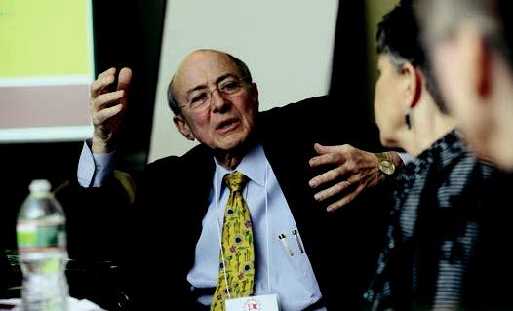

67

TEXAS WOMAN’S UNIVERSITY /

BAYLOR COLLEGE OF MEDICINE

The Houston campus of TWU has been engaged with IPE activities since the fall of 2007, with the ICCP project with Baylor College of Medicine, and most recently in collaboration with the University of Houston Pharmacy program. Abstracts for each activity are as follows:

ICCP ABSTRACT: T WU/BCM

Background

Interdisciplinary education enables the nursing graduate to enter the workplace with competencies in establishing collegial relationships with physicians; to recognize role expectations and unique disciplinary practice spheres; be prepared for open communication; and have an optimized level of respect and trust that can lead to better patient care outcomes (AACN, 2008). The Interdisciplinary Clinical Collaborative Practice (ICCP) project was an integrated effort between a state-supported college of nursing and a private medical school, designed to develop a new interdisciplinary instructional model that incorporates communication strategies in a “patient safe,” risk-free environment. The purpose of this presentation is to share the project genesis, outcomes, and lessons learned with our colleagues.

This prospective study primarily employed survey methods to measure participants’ pre- and postintervention knowledge, attitudes, and behaviors regarding TeamSTEPPS communication strategies. All students received TeamSTEPPS training for specific communication strategies in a facilitated face-to-face session or via

a video-recorded presentation. All students were randomly paired (medical and nursing students) to form a two-person team to practice their communication tools during a patient care scenario using high-fidelity simulator manikins as standardized patients. The Intervention group (approximately one-half of the students pairs) also participated in a guided networking session before their simulated scenario.

68

Findings

The qualitative data gathered from this project confirmed that there is a strong positive correlation between interdisciplinary/interprofessional education and perceptions of improved abilities to communicate between doctors and nurses, which ultimately impacts patient safety. The overarching theme stated by the students indicated a passion and appreciation for taking time to get to know each other and “practicing” together. Each group clearly articulated their lack of understanding of the respective roles, responsibilities, and academic preparation,

thus impeding their abilities to communicate and work effectively as team members.

Conclusion/Implications

There must be a fundamental shift in how nurses and physicians are educated. The time is ripe for nursing and medical schools (especially those housed on the same academic campuses) to open dialogue on how to revamp their programs in incremental steps to attain the goal of interdisciplinary education. In order for interdisciplinary education between nurses and doctors (with a resulting focus on developing communication competencies) to become a reality, there must be additional research done that provides solutions to the barriers and challenges in the educational process. Efforts must be undertaken to improve communication,

teamwork, socialization, and patient care by restructuring the academic environment itself and resolving the systemic problems inherent in administering the discipline-specific focused programs.

ICCP ABSTRACT: T WU/U OF H

This new study (March 2012-Aug 2012) replicates the previous IPE project, but uses pharmacy students.

The Association of Colleges of Nursing (AACN), the American Association of Colleges of Pharmacy (AACP) and the Inter-professional Education Collaborative (IPEC) recognized negative patient outcomes due to ineffective communication among health care teams. They support educational programs that promote effective communication between disciplines. This study, between TWU and UH, will use high-fidelity learning environments to create “real life” patient scenarios to allow nursing and pharmacy students to practice communication. No research on these types of learning environments exists between nursing and pharmacy educational

69

programs. This qualitative and quantitative design, using tools developed by the TWU and Baylor College of Medicine, will investigate the organizational barriers to implementing these activities in programs, identify competencies, and investigate the effects of networking among the students. Thirty teams of one nurse and one pharmacy student will participate in the project. Half will receive an additional networking activity to determine the impact of networking on the learning activity.

Interprofessional Activities at Baylor College of Medicine

- See Activities done with TWU in the TWU document

- Beginning a five-year grant in partnership with TAMUHSC centered around IPE

- Interprofessional student geriatric home visits

- Simulations in the subinternship involving IPE scenarios

- Quarterly think tanks on IPE

- Reflections involving the identification of role models in clinical care from other health professions.

- Use of Implicit Association Tests to recognize bias and how it impacts care delivery

- Basic Science courses with learners from other professions:

  - Anatomy

  - Neuroscience

  - Ethics

  - Problem-based learning

70

UNIVERSITY OF COLORADO

ANSCHUTZ MEDICAL CAMPUS

The goal of the IPE program at the University of Colorado Anschutz Medical Campus is to develop interprofessional practice competencies in all health professions students through an integrated, longitudinal, developmentally appropriate curriculum. The program has four core curricular elements and several co-curricular activities, which are all linked through an electronic web portal called E-Commons. The IPE program is called REACH (Realizing Educational Advancement in Collaborative Health).

Fundamentals of Collaborative Care

This course (formally known as “Health Mentors”) is designed to teach competencies in teamwork, interprofessional communication, and interprofessional role clarification by providing a common theoretical framework for the competencies and engaging students in iterative team-based learning activities over the course of four semesters. Students are grouped into interprofessional teams during their first week on campus. They maintain continuity with these teams for the two-year experience.

Ethics

The interprofessional course in bioethics is now over 15 years old. The course involves students from all health professions and is required for almost all of them. The course is taught in a case-based format, with individual facilitators for each of the small groups. The students maintain the same groups from the Fundamentals of Collaborative Care course. The course is organized around an eight-step analytical process for decision-making in clinical ethics. The course is organized and taught by the Center for Bioethics and Humanities. The faculty of the ethics course works closely with the faculty and staff of REACH to align the course with the Fundamentals of Collaborative Care course and the IPEC competencies.

71

Clinical Transformations

Clinical Transformations is a half-day experience that takes place in the CAPE (Center for Advancing Professional Excellence), our clinical simulation center. The experience will be required of all health professions students starting in the fall of 2012. The experience consists of a short course in the TeamSTEPPS communication model followed by two clinical simulations involving an interprofessional team and a standardized patient or high-fidelity manikin. The half-day experience is designed to consolidate the skills learned in the Foundations of Collaborative Care course and to serve as bridge to the clinical learning taking place in the rest of the curriculum for these students.

Interprofessional Clinical Rotations

The ultimate goal of the interprofessional clinical rotations curriculum is to provide each student with an authentic experience in interprofessional collaborative care within a clinical environment. This element consists currently of multiple pilots and ongoing planning. It will ultimately be required for all students when the program has the capacity to provide it.

Several elements are currently in place:

- IP Quality and Safety at Children’s Hospital Colorado. Developed as a part of the IHI/Macy Retooling for Quality and Safety initiative, this interprofessional project pairs medical and nursing students during their clinical rotations with a staff member from the hospital’s QI department for two didactic/discussion sessions followed by student involvement in an ongoing, hospital‐wide QI project.

- Interprofessional Rural Health Experiences through AHEC. This program offers clinical experiences in rural settings around the state of Colorado to students in medicine, dentistry, and pharmacy. Students from these

professional programs collaborate to complete Service Learning Education experiences providing education and care to rural communities. In addition, the program offers a Rural Immersion Week each year that allows students from medicine, physician assistant, pharmacy, nursing, dental medicine, and psychology to travel to a rural area and work in small interprofessional groups to explore aspects of that specific community (such as public health, government, and economy) that influence overall community health.

72

Other elements are planned for pilot during the 2012–2013 academic year:

- Self-directed clinical projects. This project will be embedded within existing courses for some programs, and offered as a separate course within other programs. Students will complete small group didactic work in interprofessional teams at the beginning of the course. This work will prepare students to complete a clinical project focusing on quality/safety, analysis of care team function, or advanced problems in communication. Students will gather at the end of the course to present and review their projects.

- Exemplary practice models. Students can choose an elective clinical experience at certain sites which have been identified as embracing an interprofessional practice model with a commitment to clinical education. Part of the student’s clinical time will be spent with practitioners from professions other than the student’s own. Focus will be on understanding how members of an interprofessional clinical care team interact with each other, their patients, and the patients’ families in order to provide quality, patient-centered care.

Interprofessional Co-Curricular Activities

- Interprofessional Student Interest Groups. The REACH program, in partnership with the Student Senate, provides funding and support for interprofessional student interest groups (IPSIG). Groups of students with common, cross-disciplinary interests (e.g., Global Health, Rural Health, Wellness and Fitness, Ethics and Humanities, Geriatrics) can incorporate annually as an interprofessional SIG. These groups are eligible for funding to support programming and assistance from REACH staff to schedule and organize the events, which take place in classrooms but also in less formal spaces on campus (known as Student Academic Community spaces) that are set aside exclusively for student use. The centerpoint for these co-curricular activities is the newly opened Commons Café: a centrally located café in the education space on campus that includes large-screen monitors displaying all interprofessional co-curricular activities on campus.

- Interprofessional Tracks. Curricular tracks began as programs in the School of Medicine. These tracks provide a longitudinal didactic curriculum for students as well as experiential learning in the community. Several of the

73

tracks have opened up to learners from other professions, and REACH is working to foster more interprofessional tracks. Currently the CU-UNITE (Urban Underserved Track) and LEADS (Leadership Education Advocacy Development Scholarship) track are interprofessional. Global Health has some interprofessional offerings. We are working with the Rural Track and Global track to increase the interprofessional offerings.

- Interprofessional Electives. REACH has been encouraging and supporting students and faculty who wish to offer interprofessinal electives. The only current example is the Refugee Health elective: an eight-week course that takes place over the noon hour that is student-run with two faculty sponsors.

eCOMMONS

eCOMMONS is a Microsoft Sharepoint web portal that serves multiple purposes for REACH.

- Content Management and Delivery. eCOMMONS is currently embedded in Blackboard, which is the campus’ common curriculum management system. The functionality of eCOMMONS provides additional functionality to Blackboard, but embedding it within Blackboard reduces confusion and allows students a single port of entry to all curriculum management. Each student has personal profile and each interprofessinal student team has a common virtual workspace in eCOMMONS.

- Evaluation and Assessment. eCOMMONS is the common point for data entry of all evaluative and assessment activities. The data are stored in a Sequel database and provides the opportunity to for multisource assessment of students as well as feedback about their collaborative practice competence.

CATME

CATME is a peer assessment tool developed at the Purdue College of Engineering that allows individuals within a team to assess both themselves and team-mates on their contributions and performance. CATME evaluations are performed at multiple points and can be linked to other measures of students’ performance through eCOMMONS.

74

UNIVERSITY OF MINNESOTA

Minnesota’s long-standing commitment to interprofessional education began in 1970 when the University’s six health professions schools and colleges joined

together as an academic health center and committed to collaborating across the professions. Early IPE efforts consisted primarily of elective courses, “interdisciplinary hours,” and co-curricular activities that provided students with valuable experiences and interaction with peers in other professions. However, because these activities and courses were not required, many students did not experience interprofessional collaboration during their education. In 2009, the AHC launched a bold three-phase initiative “1Health” to leverage experiences to transform its approach to health professions education by requiring health professions students to achieve

a defined set of collaborative competencies in the areas of professionalism/ethics, communication and teamwork. Not only is the commitment to 1Health surviving— but also thriving in the face of senior leadership transitions and reorganizations.

The AHC deans have charged the associate deans of education to work with the AHC Office of Education on academic IPE implementation and operational issues. Faculty rotate through the AHC Office of Education to provide leadership for the advisory groups that implement the program. Recently, the Clinical and Translational Institute’s Community-University Board, leaders of the health systems and Minnesota payers, have formed a partnership to offer team-based training for interprofessional collaboration. Our faculty has partnered with the University of Toronto Centre for IPE to offer certificate programs and workshops on integrating interprofessional skills into uniprofessional activities.

Phase I, or “Orientation to IPE”, begins with the required course, “Foundations of Interprofessional Communication and Collaboration”, which includes nearly 900 entry-level allied health, dental, medical, nursing, occupational therapy, pharmacy, and veterinary medical students. Last fall, faculty, community preceptors and advanced students facilitated these students in 76 interprofessional groups to focus on promoting understanding of the professions while addressing stereotypes and

75

biases that students have about their own and other professions. Early experience indicates that students who take this course are forming their own groups and organizing their own interprofessional activities.

Phase II, or “Establishing the Toolbox”, occurs during the middle portion of a student’s educational program. This phase allows students to choose from a menu of interprofessonal courses—many preexisting and others that are being created. Faculty members are working on three foci to promote development of

“collaboration workforce skills”: required coursework and competency assessment, co-curricular activities, and operations and implementation issues and barriers. Examples of the menu of activities include a CDC-funded Disaster Preparedness activity, Phillips Neighborhood student-run clinic, the CLARION national case competition, simulations, and longitudinal curriculum.

Phase III, or “Authentic Experiences”, is led by a pharmacy and a medical school faculty member to assure the development of experiential rotation sites to identify high-performing clinical teaching sites, using the AHC-wide operations platforms and systems such as the affiliation agreement database, convening AHC experiential education directors, and faculty development focused on experiential education. Integral to this development is the engagement of the Minnesota Area Health Education Center and IPE teaching sites.

76

UNIVERSITY OF MISSOURI

The Schools of Medicine, Nursing and Allied Health Professions at the University of Missouri currently collaborate to offer students five interprofessional educational opportunities. These include 1) The Integrated Interprofessional Patient Safety curriculum (TIIPS), 2) Interprofessional Curriculum in Patient Safety and Quality Improvement, 3) Partners in Education-Partners in Care, 4) Achieving Competence Today (ACT), and 5) Clarion competition. Students participating in IPE projects include first-, second-, third-, and select fourth-year medical students, prelicensure nursing students (in the baccalaureate program) and accelerated nursing students. Students from pharmacy, respiratory therapy, and health management/informatics also participate in selected activities. Collectively, approximately 575 students and 100 faculty/staff participate in these interprofessional learning activities annually.

The Integrated Interprofessional Patient Safety Curriculum (TIIPS)

The TIIPS project, initiated in 2009 with the support of the Josiah Macy Jr. Foundation and the Institute for Healthcare Improvement (IHI) Open School, pairs second-year medical students and prelicensure nursing students in the

baccalaureate nursing program in a series of experiences focused on patient safety with an emphasis on fall prevention. After independently completing prework and participating in an interprofessional aging/mobility simulation, interprofessional student dyads work together on a bedside assessment of a hospitalized patient’s fall risk. The dyad surveys the hospital room for safety hazards and reviews a customized handout of fall prevention strategies with the patient. This required experience occurs in the Internal Medicine Clerkship and the Adult Nursing Clinicals. Interprofessional faculty facilitate a debrief including discussion of case studies related to fall safety, exploration of fall data at our institution, and brainstorming methods to reduce a patient’s risk of falls. Discussion reinforces general patient safety and improvement principles.

77

Interprofessional Curriculum in Patient Safety and Quality

Improvement

This four-week, eight-hour interprofessional curriculum in patient safety and quality improvement has been presented annually since 2003. Participating students include second-year medical students, senior prelicensure nursing students, second-year graduate health management students, undergraduate respiratory therapy students, and pharmacology doctorate students. Interprofessional small group discussions, simulation, and a brief lecture are combined to increase student knowledge in

areas of patient safety and quality improvement. Annual evaluations by faculty/ students and pre/post surveys of knowledge, skills, and attitudes have led to many modifications in the curriculum. In the most recent (2012) version of the four-week interprofessional curriculum, 250 students attended four two-hour sessions. Interprofessional groups of 10 to 12 students (facilitated by two faculty) complete interactive exercises exploring professional roles, a modified root cause analysis of a patient case with an adverse event, and brainstorm potential solutions, along with their impact. Related simulation activities include identification of safety risks

in a simulated hospital room (as an individual and a team) and an exercise requiring each group of students to function as an interprofessional team assessing simulated patients in a hypothetical emergency.

Partners in Education–Partners in Care

Partners in Education–Partners in Care, initiated in 2010, provides early longitudinal small group learning experiences for first-year medical students and nursing students in an accelerated baccalaureate degree program for students with prior degrees in other disciplines. The six sessions, two hours each, are scheduled throughout the academic year. Focus areas are selected from mutually relevant areas that reinforce the importance of effective interprofessional teams: i.e., communication within the health care team, patient safety, health literacy, cultural humility, and ethics. Active learning strategies such as simulation, standardized patient encounters, and case discussions promote development of interprofessional skills and values. Each small group consists of six to seven first-year medical students, three prelicensure nursing students, and two facilitators.

Achieving Competence Today (ACT)

Originally developed through an initiative of the Robert Wood Johnson Foundation

78

in 2005, ACT provides an opportunity for students to partner with faculty and other health care workers to participate in interprofessional improvement teams while learning principles of quality improvement. Clinical departments select faculty advisors to attend the five session (12 hour) curriculum with their students. An improvement project consistent with the needs/goals of the institution and clinical area is selected as a focus for the formation of the interprofessional team of five to six participants. These include select fourth-year medical students (those staying at the University of Missouri for residency) and faculty along with staff nurses, graduate nursing students, pharmacists, residents, IT experts, etc. Faculty experienced in

QI methodology also mentor the team faculty advisor as the entire team learns improvement principles and develops and executes their project. Teams share their early results, impact on the institution, and plans for sustainability at the conclusion of the program.

CLARION Competition

The CLARION competition is hosted annually by the University of Minnesota. Clarion emphasizes improvement of patient safety and care quality through interprofessional leadership, teamwork, and communication. Student teams from University of Missouri have participated in the CLARION competition since 2005 and have received first prize honors three times, most recently in 2011. Each year a team of four students, two representing medicine and nursing and two from other health care professions, analyze the CLARION case and present their analysis and recommendations.

Conclusion

The IPE opportunities at University of Missouri demonstrate a sustained effort by faculty to develop integrated and required experiences with an emphasis on experiential learning. These efforts are supported by the commitment of a core

team of faculty champions and their deans and associate deans, along with a rapidly growing number of faculty participants. Partnerships with our Center for Healthcare Quality, our hospital and its Office of Clinical Effectiveness have been critical to the success of these endeavors. A team of faculty designs learning activities, prepares materials, and leads training sessions for small-group facilitators. Analysis of feedback from faculty and student evaluations and pre/post surveys routinely lead to improvements in the learning opportunities. Furthermore, while the focus of these efforts remains improved student experiences, the faculty development that occurs as a result is an important benefit as well.

79

UNIVERSITY OF NEW MEXICO

HEALTH SCIENCES CENTER

Background

Vision 2020 states, “Working with our community partners, University of New Mexico Health Sciences Center (UNMHSC) will help New Mexico make more progress in health and health equity than any other state by 2020.” To address this strategic vision, The University of New Mexico School of Medicine (UNMSOM) integrated

a four-year public health curriculum into medical school education beginning with the matriculating class of 2010. All graduating students receive both a medical degree and a Public Health Certificate (PHC). The first medical school course is Health Equity: Introduction to Public Health, which creates a conceptual framework for understanding health and illness from a socioecological perspective and lays the groundwork for public health concepts and skills that are reinforced throughout medical school. This prominent timing signals students about the value UNMSOM places on its vision for improving the health of New Mexico communities.

Educational Methods

All matriculating medical and physician assistant students are required to take the two-week Health Equity: Introduction to Public Health course. While the course incorporates many of the same educational methods utilized in UNMSOM’s general curriculum, it is unique in that it also employs team-based learning, Geographic Information System (GIS) mapping, and community center engagement. This year, a pilot effort to broaden the scope of interprofessional learning, to include pharmacy, public health, law, architecture, and business disciplines will be incorporated into the course.

Project Goals

Create transformational learning experiences for entering students that will 1) provide students with an understanding of the impact of social determinants on health, using community as classroom; 2) introduce students to interprofessional

80

education through team-based and service learning methods; and 3) develop a foundation for building population health promotion and intervention skills to augment their success as health professionals.

Project Description

The Health Equity course begins with a viewing of the documentary, “Unnatural Causes: Is Inequity Making Us Sick?” Following the documentary, students

are assigned to small groups to research communities throughout the greater metropolitan area. In teams, students are required to explore the demographics of their assigned community and compare and contrast these findings to other urban neighborhoods. Using “community as classroom,” students conduct sequential visits to a community center in their assigned community, where they apply structured tools to survey the neighborhood environment, interview the community center director, staff, and neighborhood residents; and participate in center activities.

Throughout the 40-hour course, student teams also participate in faculty-facilitated small-group sessions to reflect on community experiences and discuss cases exploring contemporary public health issues. Student teams are required to compile data and present a capstone oral and poster presentation profile of their assigned community as well as an identified public health issue with proposed interventions to faculty and community leaders. The course ends with a panel of senior students discussing ongoing community volunteer opportunities.

Conclusion

An introductory course in public health using community as classroom can provide a foundation for an interprofessional learning continuum across professions and enrich understanding of the power of collaboration to effectively address community needs. Provided with tools for gathering information, engaging in dialogue with community members, and an urban community site assignment to examine public health concepts, students cross the boundaries of siloed perceptions of their profession of interest, and value diverse contributions to problem identification, assessment, interventions, and evaluation.

81

UNIVERSITY OF PITTSBURGH

The Working Group on Interprofessional Education at the University of Pittsburgh provides the leadership to advance IPE across the six health sciences schools (dental medicine, health and rehabilitation science, medicine, nursing, pharmacy, and public health) and the Health Sciences Library System. The Working Group functions as the coordinating body across the University for development of IPE opportunities, events, and curricula; and provides opportunities for networking among those with educational leadership responsibilities within component Schools and the Office of the Senior Vice Chancellor, Health Sciences.

In January 2012, the Working Group hosted curriculum leaders from across the six schools and component programs at a meeting to discuss opportunities to advance interprofessional learning across the health sciences programs and how best to integrate the Core Competencies for Interprofessional Collaborative Practice. The participants also discussed improvements to a draft instrument that will be used

in spring 2012 to conduct an inventory of interprofessional content and learning activities (classroom-based and experiential) to 1) determine where the schools and programs are, independently and collaboratively, in the implementation of teaching, learning, and assessment targeted to interprofessional collaborative practice; and 2) enable the Working Group to further advance IPE. The items on this instrument are anchored to the Core Competencies. The discussion was enthusiastic and there was agreement that quarterly meetings of the large group would be productive.

THE WORKING GROUP PL ANS AND COORDINATES THE FOLLOWING ACTIVITIES

Annual Interprofessional Forum

An annual Interprofessional Forum is held each fall. This cross-schools event is designed to introduce to first-year students the importance of interprofessional team-based care as a contemporary standard of quality care and a strategic initiative on campus. The program includes introductory remarks by the senior vice chancellor;

82

participation of the school-specific leaders in a moderated dean’s dialogue; a simulated patient interview, followed by interprofessional panel commentary; and student presentations on their interprofessional experiences.

National CLARION Case Competition

The University of Pittsburgh Schools of the Health Sciences were represented in the national CLARION case competition in 2010 and in 2011, and have been accepted to participate again in 2011. Across the three teams, each of the six health sciences schools has had at least one student participant. The Pitt team placed first in the national competition in 2010.

COURSES AND COURSEWORK

Interprofessional Modeling and Caring for the Elderly (IP-MACY): Educating a health care workforce to meet the needs of a changing health care system: funded by the Josiah Macy Jr. Foundation and the Jewish Healthcare Foundation.

Advanced Interprofessional Nursing Home Health Care is a four-week experiential course designed to provide advanced students in medicine, pharmacy, and nursing with the knowledge, skills, and attitudes needed to provide integrated, team-based care to geriatric residents in nursing home facilities. Core topics include geriatric syndromes, pain and palliative care, and regulatory issues. The curriculum also addresses the Core Competencies for Interprofessional Collaborative Practice. Students participate in daily rounds, as well as focused discussions with intact IP staff teams (e.g., falls, wound care). Debriefing sessions with the course faculty focus on patient cases and students’ observations of the IP interactions in their own groups and among the nursing home staff. In fall 2011, five students (two pharmacy, two medicine, and one nursing) participated. Students evaluated the experience highly and articulated increased knowledge in geriatric patient care issues and interprofessional development. Administrators and staff found the presence of the students highly valuable and expressed a desire to repeat the experience in the future.

Geriatric Medicine is a three-day intersession experience that uses an interprofessional approach to recognize and address common problems in older adults in inpatient, outpatient, and nursing home environments. Participants include 25 medical students, 25 advanced-practice nursing students, and 10 pharmacy

83

students. Students worked in six interprofessional teams throughout the experience, which culminated with presentations of a transitions-of-care case, with a focus on interprofessional collaboration.

A Content Renewal subcommittee analyzed the geriatric content in each School’s curriculum and identified chronic pain management as a content area that was addressed only to a limited degree across the curricula. An online module focusing on chronic pain management is in development and will include an interactive computer-based patient simulation requiring cross-professional communication, didactic content and readings, and a discussion board where students will interact across professional boundaries.

Interprofessional Health Care Teams is an elective clinical rotation designed and delivered in collaboration across programs in medicine, nursing, physician assistant, and social work. Course goals are to teach the importance of coordinated, team-based health care delivery for renal patients (dialysis and transplant); provide opportunities to observe models of interprofessional care; engage students in

the provision of interprofessional care; clarify the knowledge, skills, and resources different professions contribute to a health care problem or patient need; and explore roles and responsibilities of health care team members.

We Need to Talk is a 2-hour activity in which students (pharmacy) interact with a standardized colleague (e.g., physician, medical student, resident, nurse) in

scenarios designed around specific “crucial conversations” that have been found to lead to decreased staff morale, increased staff turnover, and poor patient quality when they are not addressed. The activity is embedded within a required course in the second year of the curriculum. The strategy has also been integrated into the nursing curriculum.

STUDENT- LED ACTIVITIES

Institute for Healthcare Improvement (IHI) Open School Chapter

Now in its second year, the Pitt Chapter of the IHI Open School has a fully operational and engaged student executive board, with student representatives from each of the six health sciences schools. Initial chapter activities have included student-led journal club discussions and the initiation of a shadowing club to support the work of the UPMC Innovation Center and implementation of this patient

84

and family-center care model. The student executive board is also finalizing a proposal to build on the Interprofessional Forum for first-year students with a spring interprofessional colloquium for advanced students about to engage more fully in clinical education opportunities.

Project CHIP: Controlling Hypertension Interprofessionally

in Patients

In the project, pharmacy, dental, and medical students will intervene with hypertensive patients to lessen adverse cardiac events, improve continuity of care, and increase medication compliance. This project was selected to receive a Project CHANCE (Chapters Helping Advocate for Needy Communities Everywhere) grant from the American Pharmacists Association Academy of Student Pharmacists (APhA-ASP), in collaboration with the Pharmacy Services Support Center (PSSC) of the Health Resources and Services Administration (HRSA) Office of Pharmacy Affairs.

OPPORTUNITIES OUTSIDE THE UNIVERSIT Y IN WHICH STUDENTS PARTICIPATE

Albert Schweitzer Fellowship

The Pittsburgh Schweitzer Fellows Program is one of 12 such programs in the nation that challenge students to act on their idealism by serving needy individuals and communities. This one-year interprofessional fellowship program focuses

on community service, leadership development, and reflection. The Pittsburgh Schweitzer Fellows Program aims to help Fellows improve skills in working with communities including basic knowledge about approaches to community work, community outreach, community building, networking, publicity, fundraising, and advocacy; gain exposure to the impact of health disparities and health policies on local communities; learn about other health-related professions; and develop their overall capabilities for leadership in service.

Jewish Healthcare Foundation Programs

Salk Fellowship introduces students in a variety of health-related disciplines to the prominent ethical issues facing the health care system. Students are challenged to explore complicated dilemmas in health care and to investigate these issues from bioethical and religious perspectives.

85

In the Patient Safety Fellowship, current students or recent graduates from health science fields learn leadership skills needed to refine team-based approaches to solving patient care problems; test solutions and refine them in real-time; and redesign work based on results.

86

UNIVERSITY OF TEXAS

HEALTH SCIENCE CENTER

The University of Texas Health Science Center (HSC) comprises the Schools of Medicine, Nursing, Dentistry, and Health Professions. Within the School of Medicine, there is the Pharmacy Education and Research Center housing a regional campus of the University of Texas at Austin College of Pharmacy. In addition, The University of Texas School of Public Health has a regional campus in the HSC.

An undergraduate campus of the UT System, The University of Texas at San Antonio, is nearby and allows for interactions with the basic science departments, the Department of Social Work, and the Department of Engineering. In 2009, the HSC President, Dr. William Henrich, chartered an Interprofessional Education (IPE) Task Force to identify, describe, and propose IPE activities across the HSC campus. As a result, a permanent IPE Council was established in 2010 with faculty leaders from each of the HSC Schools to foster the ongoing development of IPE activities. A compendium of IPE activities across the HSC was compiled and described several IPE courses. These included the Quality Improvement and Patient Safety course for medical and nursing students together in the standard SOM and SON curriculum, and a longitudinal elective in Interprofessional Care in HIV that involved medical, nursing, health professions, public health, and social work students, an interprofessional multilevel approach educating medical and nursing students about geriatric falls and mobility problems in a simulated environment. In the Dental School, Dental and Dental Hygiene Clinical Integration addressed communication and team building for dental and dental hygiene students. Students from several health professions (respiratory therapy, occupational therapy, and dental hygiene) participated together in an online and didactic Interdisciplinary Education course and an ethics course. A basic course in pharmacology is a joint program for basic science pharmacology students and pharmacy students.

The Center for Medical Humanities and Ethics (CMHE) provides many IPE opportunities in community service learning (CSL). These include a health and wellness program for underserved San Antonio teens, a longitudinal CSL experience,

87

and a course on Poverty, Health, and Disease and an Art Rounds IPE elective, which is an interactive, interprofessional course that takes students to a local art museum to learn physical observation skills.

Other activities of the IPE Council included development of an IPE website to increase awareness and interaction (http://ipe.uthscsa.edu/). The IPE course compendium was posted on the website, as well as IPE resources. An IPE Day was planned at the HSC in coordination with the Academy for Health Science Education Annual Meeting. Educators and students from throughout the UT System and the state came to present work and ideas related to IPE; the keynote speaker was Dr. Amy Blue from Medical University of South Carolina.

An Institute for Healthcare Improvement (IHI) Open School San Antonio chapter was formed and includes medical, nursing, pharmacy, and other health professions students as well as Masters of Health Administration students from Trinity University, a local undergraduate institution. The chapter has been active in QI activities, regular meetings, and presentations at the IHI National Forum in 2010 and 2011.

Faculty development in IPE has included an IPE team that attended the Association for Prevention and Teaching Research IPE Symposium in 2008, the IPE emphasis at the Academy annual meeting in 2011, and plans for an IPE team to attend the 2012 Interprofessional Educational Collaborative at the American Association of Colleges of Pharmacy.

88

UNIVERSITY OF VIRGINIA

Abstract

The University of Virginia Interprofessional Education Initiative (UVA IPEI) is a systematic, collaborative effort by the Schools of Medicine (SOM) and Nursing (SON) and the UVA Health System, whose purpose is to create, assess, and logically integrate IPE experiences into the education, faculty development, and research activities of students, faculty, and clinicians.

Education

IPE curriculum “threads” have been integrated into the SOM and SON programs of study so that IPE experiences can build on one another toward the goal of graduating students who can demonstrate core teamwork competencies. Students begin basic knowledge acquisition about professional roles and teamwork competencies during their first year. Interprofessional teams of doctors, nurses, chaplains, social workers, nutritionists, and pharmacists serve as preceptors

and instructors in a variety of courses. Classroom and clinical courses in which medical and nursing faculty teach together include pathophysiology, immunology, bioinnovation, geriatrics, acute and primary care, and women’s health. Students build on these experiences through participation in local, regional, and international interprofessional community service opportunities. In a series of small group events, nursing students provide instruction for medical students as part of SOM basic clinical skills modules. With support from the Josiah Macy Jr. Foundation, all third-year medical and nursing students participate in a program called “Introduction to Collaborative Care” in which they learn about roles, collaborative behaviors, and the SBAR communication tool. A series of high-fidelity simulation and standardized patient modules focused on the IPE core competencies are required for students during their clerkships/clinical rotations. Attitude and skill surveys and newly implemented Interprofessional Teamwork Objective Structured Clinical Examinations (ITOSCEs) will provide rigorous longitudinal evaluation of undergraduate student

89

competencies. In the Health System, new opportunities for bedside clinical IPE are being expanded and continuing IPE programs for clinical preceptors are being implemented. In clinical experiences, medical and nursing students and faculty

participate together during in-hospital patient rounds and in shared family meetings that occur on the Palliative Care service, in Neurology, and in Geriatrics; and in several clerkships and electives, nurse practitioners have a direct role in teaching medical students. Acute care nurse practitioner students round with residents in the hospital, and primary care nurse practitioner students engage in history and physical learning modules and OSCEs with fourth-year medical students. Graduate students have recently opened a UVA chapter of the IHI Open School. A new UVA IPEI website will highlight all of these activities and serve as a resource for students and educators.

Faculty Development

Building on work done with the help of a Pfizer Corporation grant and the Josiah Macy Jr. Foundation, faculty/clinician development is an ongoing effort that includes supporting faculty/clinician participation in programs both at UVA and across the country.

Research

To date, two significant external and four internal grants have been awarded to develop and assess creative and sustainable IPE initiatives, and several new grant proposals are in development. Collaborative research and quality improvement projects involving students, residents, clinicians, and faculty from many disciplines across the University are in progress.

90

UNIVERSITY OF WASHINGTON

In order to develop the team training simulation curriculum and necessary faculty development in simulation and interprofessional competencies, Principal

Investigators Zierler and Ross identified eight key needs for the project and created the following work groups utilizing faculty with specific curricular and clinical expertise:

Acute Scenario Case Development

Created a standardized simulation scenario development template and recruited students and faculty from the Schools of Medicine, Nursing, PA program and Pharmacy to develop scenarios for anaphylaxis, cardiac dysrhythmia, acute asthma, congestive heart failure, and chest tube management.

From 2009 to 2011, executed four faculty workshops for scenario development and storyboarding. Trained approximately 120 interprofessional faculty and clinical educators.

Ran a two-day pilot test of the three scenarios (supraventricular tachycardia to ventricular fibrillation, asthma and congestive heart failure) with 49 medical, nursing, pharmacy and MEDEX students (June 3–4, 2010).

Integrated the curriculum into a larger segment of the health sciences student population during the Capstone sessions (May 31–June 3, 2011). Partnered with two ISIS locations (UW Medical Center and Harborview) and Children’s Hospital to run additional simulations focused on pediatrics and obstetrics. Approximately 305 interprofessional students and 50 faculty members participated in the team training.

Implemented the acute care team training scenarios into the medical school anesthesia rotation curriculum in fall of 2010. To date approximately 49 medical, 54

91

nursing, and six pharmacy students have been trained together. Additional training sessions are planned through the end of 2012.

Facilitator scenario and debrief guides were tested and revised for the May/June 2011 Capstone sessions. Final versions of the guides currently are being posted on the grant website for fall 2011.

Started disseminating the curriculum to other institutions, including Washington State University and the University of Florida College of Medicine.

Assessment

Developed and tested assessment tools for measuring knowledge, attitudes and skills in effective team communication including 1) web assessment (error disclosure/ skills); 2) observational assessment (simulation): metrics include a checklist of key behaviors, global and targeted behaviors, rating of the quality and assessment of student and team performance, and the opportunity for the behavior to occur; 3) self/peer assessment (simulation), and team/peer assessment (simulation).

Implemented a pre/post assessment with the 305 students participating in the May 31–June 3 Capstone team training sessions. We had a 71.6% response rate for the pre and 60.5% response rate for the post. Results currently are being analyzed.

Curriculum Mapping

Faculty representing the Schools of Medicine, Nursing, Pharmacy, and the PA program conducted a curricular and technology mapping exercise of their

respective professional degree programs and determined current alignment to interprofessional competencies, identified active learning strategies that lend themselves to IPE training, identified where they are presently offered in the curriculum, identified gaps and areas of overlap with respect to IPE competencies, and identified additional opportunities for IPE collaborative learning. Thirty-

nine interprofessional competencies classified under four primary domains—1) collaborative teams, 2) clinical care, (3) health systems management, and (4) professionalism, Ethics, and Advocacy—were reviewed. Mapping of clinical topics was also performed to determine optimal times to embed various IPE training.

92

Error Disclosure Case Development

Created and piloted curriculum for a half-day error disclosure team training for students, including an interactive lecture, four simulation cases, coaching and debriefing guides for facilitators, coaching guides for standardized patient actors, and course evaluation. Twenty-one interprofessional students from the schools of medicine, nursing, and pharmacy were recruited for the pilot study conducted on July 20 and 21, 2010.

Large-scale implementation of the error disclosure curriculum was executed on March 8, 2011, with over 415 students and 75 faculty from the schools of Dentistry, Medicine, Nursing, PA program, and Pharmacy.

A major milestone for this training occurred in April 2011 when the school curriculum boards agreed to build the error disclosure half-day session into their school’s curriculum. The next session was scheduled for March 6, 2012.

Faculty Development

In 2009, developed a web-based module for faculty on team-based communication.

To date, 15 Macy grant staff and faculty members attended the AHRQ Master TeamSTEPPS training.

Executed two half-day workshops on IPE competencies (May 17–18, 2010) facilitated by a consultant, Lesley Bainbridge, who is the Director of Interprofessional Education at the College of Health Disciplines in Vancouver, BC. Fifteen faculty and five staff members from the Schools of Dentistry, Medicine, Nursing, Pharmacy, and the Physician Assistant program attended the workshops.

Executed a half-day interprofessional team training faculty development workshop on February 8, 2011, in conjunction with the UW Department of Medical Education. Approximately 70 faculty attended from over six health sciences schools.

Partnered with the UW Department of Medical Education to develop an IPE Scholars program to be folded into an existing faculty scholars program. Eight IPE scholars from the Schools of Medicine, Nursing Pharmacy, and Public Health were chosen to participate in the year-long program.

93

Literature Review Project

Extracted data from 155 articles to examine training models commonly reported in the literature pertaining to the development and implementation of IPE involving a diverse range of health sciences students.

Team presented results from a preliminary analysis of 41 randomly selected articles at the American Educational Research Association (AERA) Annual Conference in Spring 2011.

Produced a comprehensive manuscript that describes commonly reported IPE features pertaining to curriculum and faculty development—accepted for publication in the Journal of Interprofessional Care.

Operations Team

Created a UW Chapter of the IHI (Institute for Healthcare Improvement) for students. Membership to date is over 100 students from the various health sciences schools.

The University of Washington was named by the AHRQ as the nation’s first west coast training center for TeamSTEPPS in 2009. Under Dr. Ross’ executive direction, UW’s Institute for Surgical and Interventional Simulation (ISIS) began providing quarterly Master Trainer certification courses for health care providers and hospital personnel in February 2010.

The operations team has presented results of the grant at over 12 conferences and has two publications to date.

Technology and Web Development

Created a magnet/portal site for educators to understand available resources on interprofessional training and how best to use those resources: http://collaborate. uw.edu/. The site includes online faculty development modules, a blog, and a recent news section.

Developed a learning site where modules can be housed, users can be tracked, learners can have a personalized page of their trainings, and resources can be downloaded and incorporated in other institutions’ curriculum.

94

VANDERBILT UNIVERSITY

SCHOOLS OF MEDICINE AND NURSING

The Schools of Medicine and Nursing are currently involved in multiple IPE activities and are actively planning additional future initiatives. The most recent focus of our work has been the development and implementation of the Vanderbilt Program

in Inter-professional Learning (VPIL). Other activities that preceded VPIL and have continued include joint courses, seminars, case competitions, and fellowship programs.

The VPIL program is an experiential learning experience that includes both didactic and clinical portions for nursing, medicine, pharmacy, and social work students. Students begin learning and working together when they first enter their programs of study, concurrently with learning within their own disciplines. The students work and learn together in teams of four (one from each discipline) in the same clinic site with the same team of students one afternoon a week for the duration of the time they are enrolled in their academic program of study. The overall program goals are to 1) cultivate respectful professions, 2) create self-directed learners, 3) prepare leaders that contribute to a collaborative-practice ready workforce, and 4) improve the health care delivery system. The VPIL program began in fall of 2010 with a cohort of 30 students from all four disciplines who were organized in eight teams. The 2011 cohort had a total of 36 students who have clinic experiences in eight different clinics. Key factors that contribute to the success of the program has been starting with a dedicated immersion experience for the students, continued faculty and preceptor development, listening and learning from the students, and making changes in response to the work and learning environment.

Examples of Other IPE Opportunities

The Institute for Healthcare Improvement Open School at Vanderbilt began with the formation of a chapter composed of nursing, medicine, and business students, but quickly morphed into the Vanderbilt Health Improvement Group and offers a formal course housed in the Owen School of Business. Currently there are students from

95

the schools of medicine, nursing, law, business, and the education. This program has been recognized by IHI for creativity and excellence.

Shade Tree Clinic. The medical students developed a free clinic, which now has an interprofessional student health care team comprising medical, advanced practice nursing, and pharmacy students.

The Vanderbilt Institute for Global Health attracts students from multiple areas across campus. Students have the opportunity to take courses to earn a Global Health Certificate as well as participate in regular lectures and seminars.

The Meharry-Vanderbilt Alliance Case Competition showcases the value of teamwork and the importance of an interdisciplinary approach in patient care. The program has grown to include students from 10 disciplines including undergraduate nursing of neighboring colleges, medicine, dentistry, public health, social work, pharmacy, and advanced practice nursing.

96

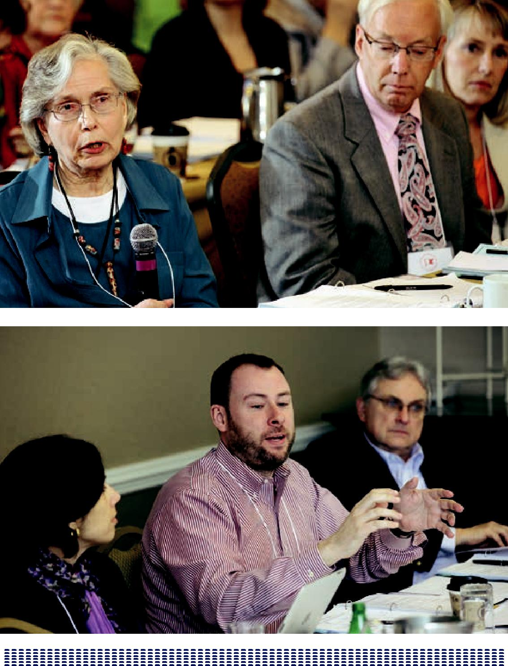

97

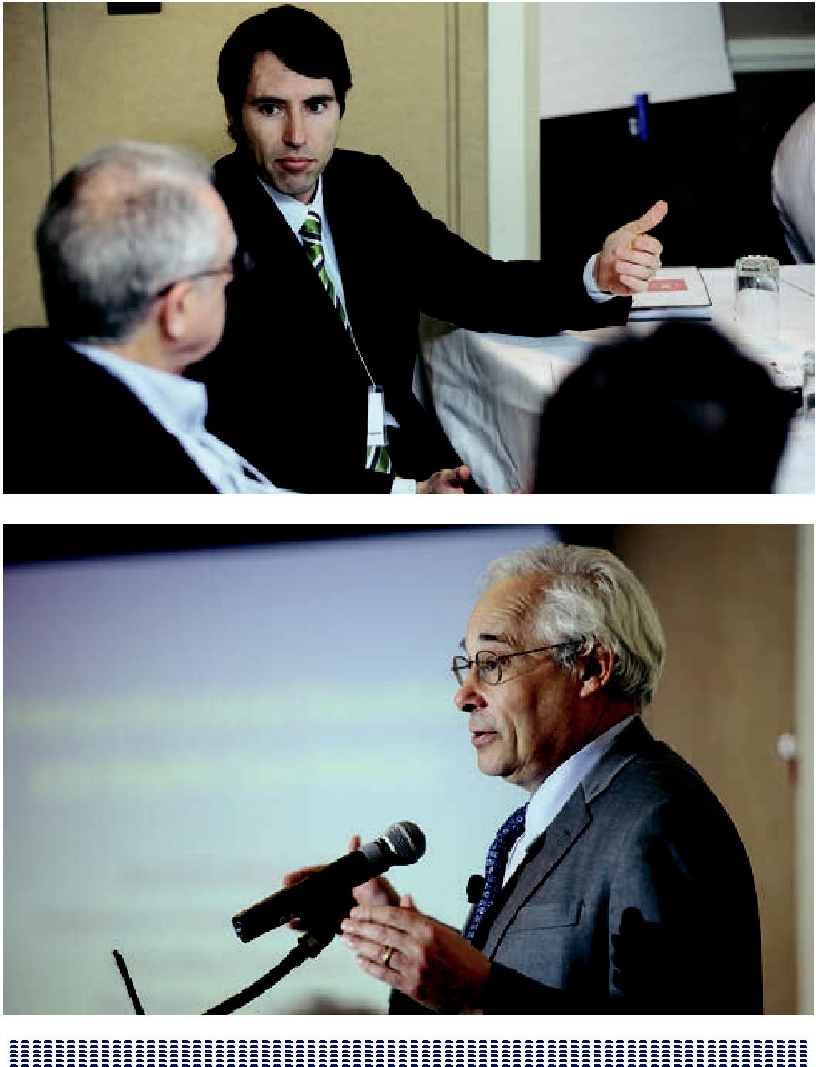

98

ABSTRACT SUMMARIES

Each team that presented a project in a breakout session was asked to submit a structured abstract of the project. The team from the University of Washington, led by Brenda Zierler, analyzed these abstracts and provided the following summary. It is hoped that this nosology will be helpful in comparing and contrasting these IPE interventions and others in the future.

Summary of Abstracts of Macy Grantees

Since the mid-1900s, the Josiah Macy Jr. Foundation has focused on improving health care through innovation in health professional education. In April 2012, representatives from 20 schools with interprofessional education (IPE) grants from the Macy Foundation came together to share their projects, progress, and lessons learned.

Each conference participant completed a RIPE tool to describe their IPE projects (attached). The RIPE tool is designed to facilitate increased replicability of interprofessional education (RIPE) through more structured and standardized reporting (Abu-Rish et al. 2012). The RIPE tool consists of 25 questions divided into six sections: 1) Title, 2) Introduction, 3) Intervention Methods, 4) Implementation Methods, 5) Outcomes, and 6) Summary of IPE Intervention: Lessons Learned. The RIPE tool was completed online and participants were asked to complete

one application per IPE intervention if their projects were multifaceted (i.e., had specific faculty development and IPE intervention components). A total of 36 RIPE assessment tools were completed from the 20 schools.

The following is a summary of data provided by faculty who completed the RIPE tool for an IPE intervention. There may be overweighting of some elements, as schools were able to submit more than one tool for different aspects of their projects as noted above. However, there was enough variation among projects within individual schools that impact on overall trends within the group should be minimal. In addition, some questions were “select all that apply,” so there may be more than 36 total responses.

99

Introduction

A wide cross-section of IPE competency domains were targeted in the projects (Table 1). Most projects identified more than one competency domain, with all but one of the respondents targeting interprofessional communication (n=35) as the most common competency. Teams and Teamwork (n=31) and Roles/Responsibilities (n=29) were the next most commonly targeted competencies. Patient/Community-Centered Care was the least targeted (n=17) competency. A wide variety of conceptual models were reported, including TeamSTEPPS (n=2) (TeamSTEPPS, n.d.), the WHO Framework for Action on Interprofessional Education and Collaborative Practice (n =2) (WHO Collaboration Framework, 2010), and Kolb’s model of experiential learning (n=1) (Kolb and Kolb, 2005). The majority of respondents described their approach (e.g., “learning about teams by being on teams;” “strategic coordination across schools and programs”) rather than naming a specific conceptual model.

Intervention Methods

Academic faculty were involved in the development of all IPE interventions described (n=36); however, they were joined by clinical faculty in 31 of the interventions described. Students were involved in the development in over half of the described interventions (n=21). Patients and/or families were only involved in four of the reported interventions. Thirty-three of the interventions included small group work in their teaching strategies, followed by discussion groups (n=31), case-based/problem-based learning (n= 26), and didactic in-person lectures (n=23). Fifteen of the interventions included clinical teaching and direct patient interaction and 18 used simulation. Seventeen of the respondents selected “other” for this question, and their responses included technology or web-based training (n=3), quality improvement (n=2), community-based (n=2), and team-based training (n=2).

Classrooms (n=31) and online environments (n=20) were the most common settings for reported IPE interventions, followed by clinical settings (n=16) and simulation labs (n=15). All interventions utilized mixed discipline groups (n=36); though nine also incorporated single-discipline groups into their teaching strategy. The length of interventions varied significantly from 1 hour (n=1) to 200 hours (n=1), with the remaining interventions falling within the following ranges: < 10 hours (n=13), 10–19 hours (n=6), 20–39 hours (n=6), 40–100 hours (n=6), >100 hours (n=2).

The frequency of the interventions also varied, with eight occurring annually, six

100

occurring weekly, five monthly, five each quarter/semester, and four as one-time activities. However, the majority occurred at frequencies not defined above (n = 19) and varied a great deal (see Table 1, Question 11 for detailed responses). The majority of interventions were required and integrated into existing coursework

(n=19), but one-third (n=13) were required stand-alone experiences. Eleven were not required—however, in six of the interventions, students could get optional academic credit, but academic credit was not offered in five other interventions. Five offerings targeted licensed health professionals (n=2) or had mixed requirements within participants (e.g., some students were required to participate while others were not) (n=3) (Table 1, Question 12).

Implementation Methods

Implementation is a multifaceted aspect of the reported IPE projects. This section of the RIPE tool focuses on faculty recruitment and development, funding/supports, and materials/supplies. Faculty participating in IPE interventions were recruited through a variety of strategies including voluntary participation (n=30), grant-related activities (n=24), assigned workload (n=13); within projects there was usually a mix of faculty participating voluntarily, in grant-related capacities, and as part of their assigned workload. Faculty development activities were required in two thirds of interventions (n=24). Among those that did require faculty development, 22 offered in-person faculty development activities; six of those also offered online faculty development training either as a complement (e.g., IHI Open School online courses, n=2) or substitute for in-person work prior to development (e.g., if faculty not able to attend in person, n=2). Two respondents did not specify if faculty development was offered in-person versus online. The length of faculty preparation time varied significantly from 1.5 hours (n=3) to 100 hours (n=2), with a majority of responses

in the following ranges: < 10 hours (n=17), 10–19 hours (n=4), 20–39 hours (n=2), 40–100 hours (n=5), >100 hours (n=2).

The majority of programs did not report additional external funding sources (n=23). Those reporting external funding in addition to Macy Funding (n=13) indicated a variety of sources including external funding (n=10) (e.g., HRSA grants), internal funding (n=3), and donations/charity (n=1) (see Table 2, question 17 for further details). Almost all (n=30) respondents reported having materials available for sharing—ranging from faculty guides/toolkits and curricula to presentation materials and cases (see Table 1, Question 19). Equipment and supplies required for intervention most commonly consisted of handouts (n=29), web-based modules (n=16), simulation (n=17), and standardized patients (n=11). Other types of

101

equipment and supplies reported by 12 respondents included presentation materials (e.g., PowerPoints, trigger videos) (n=5), video equipment/IT support (n=3), and rooms/space (n=3) (see Table 2, Question 20 for further details).

Barriers reported by projects included scheduling (n=25), funding (n=14), and administrative support (n=3). Sixteen of the projects reported ”other” barriers than the options above (a complete list can be found in Table 2, Question 23) and

included logistics (n=5), infrastructure (n=4), and space (n=4). Despite the reported barriers, much progress has been made and most reported having discretionary/ adaptable components of their programs (n=25) ranging from faculty development being able to be used separately from other curricular activities (n=6) to specific cases being able to stand alone (n=6); see Table 2 Question 25 for detailed information.

Summary/Conclusion

The above results provide a summary of IPE interventions being carried out by Macy grantees in health professions schools around the United States. Common themes emerged in the areas of targeted competencies, teaching strategies, and faculty recruitment, and challenges. Yet, innovation and variation in the above areas as well as length of interventions, approaches to faculty development, and project settings are also clearly evident. Individually completed RIPE tools by schools are also included in these conference proceedings, and readers are encouraged to review, compare, and contact project PIs for further information. In addition, detailed information is provided in the individually completed RIPE tools as to student and faculty participation, numbers by discipline, as well as outcome measurement tools being employed by IPE projects.

102

Table 1: Summary of IPE Competencies and Intervention Methods (n=36 Responses)
Q5: IPE Competency Domains

Values/Ethics for |  | Roles/ |  | Interprofessional |  | Teams and | Patient/Community- |  | Other
Interprofessional |  | Responsibilities |  | Communication |  | Teamwork | Centered Care
Practice
25 |  | 29 | 35 |  |  | 31 | 17 |  | 2
Q6: Intervention Developers
Academic Faculty |  | Clinical Faculty |  | Students |  | Patients and/or | Community | Other
 |  |  |  |  |  | families | Members (e.g.,
 |  |  |  |  |  |  | clinicians, public
 |  |  |  |  |  |  | health)
36 |  | 31 |  | 21 |  | 4 | 10 | 10

Other: Steering Committee (n=4), curriculum Committee (n=2), Center for IPE staff in AHC Office of Education (n=1), Adapted from Achieving Competence Today curriculum from a RWJF initiative in 2005 (n=1), Center for Patient Safety and Health Policy staff (n=1), standardized patients (n=1), Simulation Development Committee (n=1), Project Manager (n=1), University administrators (n=1)

Q7: Teaching Strategies

Small Group | Case-Based/ | Discussion | Didactic | Clinical Teaching/ | Simulation
 | Problem Based |  | Lecture (In- | Direct Patient
 |  |  | Person) | Interaction
33 | 26 | 31 | 23 | 15 | 18

Other (n=17) including: technology or web-based training (n=3), quality improvement (n=2), community-based (n=2), and team-based training (n=2)

Q8: Settings and Locations Where Intervention Carried Out

Classroom | Simulation Labs | Online/ | Clinical Settings | Other
 |  | web-based
 |  | environment
31 | 15 | 20 | 16 | 7

Other: Community-based activities (n=1), phone conferences (n=1), Using “Community as Classroom” students conduct sequential visits to a community center (n=1), community centers and urban neighborhoods (n=1), discussion/debriefing room (n=1), rented venue large enough to accommodate full-scale disaster drill (inside, outside) (n=1), street (n=1)

Q9: Method of Assignment for Students

Mixed Discipline | Single-Discipline | Other
Groups | Groups*
36 | 9 | 1 (Algorithm sort
 |  | by schools into
 |  | teams)

*Note: In addition to time spent in mixed discipline groups, nine interventions also included training components involving only one discipline.

Q 10: Duration of IPE Intervention Per Participant (n=33)

<10 hours | 10–19 hours | 20–39 hours | 40–100 hours | >100 hours
13 | 6 | 6 | 6 | 2

*Note: Minimum duration = 1 hour (n=1); maximum duration = 200 hours (n=1); duration varies (n=1) or TBD (n=2) in three interventions.

103

Table 1 (Continued):

Summary of IPE Competencies and Intervention Methods (n=36 Responses)

Q11: Frequency of Occurrence of the IPE Intervention

Weekly | Monthly | Each Quarter/ | Annually | One-Time Activity | Other
 |  | Semester
6 | 5 | 5 | 8 | 4 | 19

Other: Multiple times per quarter/semester (n=6), multiple sessions throughout the year (n=5), varies by discipline (n=4), continues throughout degree program (n=1), different events throughout the year (n=1), N/A (n=1), TBD (n=1)

Q12: Course Type

Required: Stand-Alone | Required: | Not Required: | Not Required: No | Other
Experience | Integrated into | Academic Credit | Academic Credit
 | Existing Course | Optional
13 | 19 | 6 | 5 | 7

Other: Mixed requirements (required for some disciplines, elective for others) (n= 3), continuing education for licensed health professionals (n=2)

Table 2: Implementation Methods, Barriers, and Discretionary/Adaptable Components
Q 14: Faculty Recruitment Strategies

Assigned Workload | Voluntary | Grant-Related | Other
13 | 30 | 24 | 4

Q15: Was Faculty Development for IPE Intervention Required?

No | Yes | If yes, in person | If yes, online
12 | 24 | 22 | 6
Q16: Estimated Number of Hours of Faculty Preparation Time
<10 Hours | 10–19 Hours | 20–39 Hours | 40–100 Hours | >100 Hours
17 | 4 | 2 | 5 | 2

*Note: Minimum duration=1.5 (n=3); maximum duration=(n=160); duration varies (n=1), TBD (n=2), N/A (2) in 5 interventions.

Q17: Additional External Funding Sources

No | Yes
23 | 13

Describe yes: External funding (n=10), internal Funding (n=3), donations/charity (n=1)

Q19: Presentation and/or Faculty/Student Educational Materials Available for Sharing (e.g., Toolkit, Appendices, and/or Online Resources)
No | Yes
6 | 30

Examples of yes: faculty teaching guides/toolkits (n=10), curricula (n=9), presentation materials (e.g., PowePoint, online) (n=8), cases (n=4), still under development (n=2)

Q20: Training Equipment and Supplies Required for Intervention

Handouts | Web-based modules | Standardized patient | Simulation | Other
29 | 16 | 11 | 17 | 9

Other: Presentation materials (e.g., PowerPoints, trigger videos) (n=5), video equipment/IT support (n=3), rooms/space (n=3), guest lecturers/activity leaders (n=2), readings (n=1), in-development (n=1)

104

Q23: Barriers to Intervention

Administrative | Funding | Scheduling | Other
Support
3 | 14 | 25 | 16

Other: Logistics (n=5), leadership (n=4), infrastructure (n=4), space (n=4), lack of relevant existing materials (e.g., cases, faculty development) (n=4), TBD (n=1)

Q25: Discretionary/Adaptable Components of Program

No | Yes
11 | 25

Examples if yes: curriculum (all or in part) (n=11), faculty development (n=6), yeaching materials (n=6), cases/ content (n=6), TBD (under development) (n=2)

Works Cited

Abu-Rish E, Kim S, Choe L, Varpio L, et al. (2012) Current trends in interprofessional education of health sciences students: A literature review. J Interprof Care. 2012 Aug 27. [Epub ahead of print].

Kolb AY, Kolb DA. (2005) Learning styles and learning spaces: Enhancing experiential learning in higher education. Academy of Management Learning and Education, 4(2), 193-212. DOI: 10.5465/AMLE.2005.17268566.

TeamSTEPPS: National Implementation. (n.d.) Retrieved from http://teamstepps.ahrq. gov/. Accessed September 20, 2012.

WHO Collaboration Framework (2010). Framework for action on interprofessional education and collaborative practice (WHO reference number: WHO/HRH/HPN/10.3). Retrieved from http://www.who.int/hrh/resources/framework_action/en/index.html. Accessed September 20, 2012.

105

REPLICABILITY OF INTERPROFESSIONAL

EDUCATION (RIPE) FORM

Macy Grantee IPE Conference (April 1-3, 2012)

Please fill out one form for each intervention you have implemented.
Select all that apply for multiple choice questions.

!"#$%&'()*+#",-'.#*!"

#$ |  | %&'()*+",-.)!"" |  |  |  |  |  |  |  |  |  |  |  | " |  |  |  | " |  | " |  |  |  |  |  | " |  |  |  | " |  |  |  | " |  |  |  |  |  |  | " |  |  |  |  | " |  |  |  |  | " |  | " | " | "
/$ |  | 0&-1+))"2%3",-.)4!" |  |  |  |  |  |  |  |  |  |  |  | " |  |  |  | " |  | " |  |  |  |  |  | " |  |  |  | " |  |  |  | " |  |  |  |  |  |  | " |  |  |  |  | " |  |  |  |  | " |  | " | " | "
(
)*'"#/0&'.#*!
5$ |  | 6'1*)7+8-9":';)9!" |  |  |  |  |  |  |  |  |  |  |  | " |  |  |  | " |  | " |  |  |  |  |  | " |  |  |  | " |  |  |  | " |  |  |  |  |  |  | " |  |  |  |  | " |  |  |  |  | " |  | " | " | "
<$ |  | =>()*+?@)ABC?.A"'D"3%E"31+)&@)1+?'1!"
 |  | " |  |  |  |  |  |  |  |  |  |  |  |  |  |  |  | " |  | " |  |  |  |  |  | " |  |  |  | " |  |  |  | " |  |  |  |  |  |  | " |  |  |  |  | " |  |  |  |  | " |  | " | "
 |  | " |  |  |  |  |  |  |  |  |  |  |  |  |  |  |  | " |  | " |  |  |  |  |  | " |  |  |  | " |  |  |  | " |  |  |  |  |  |  | " |  |  |  |  | " |  |  |  |  | " |  | " | "
 |  | " |  |  |  |  |  |  |  |  |  |  |  |  |  |  |  | " |  | " |  |  |  |  |  | " |  |  |  | " |  |  |  | " |  |  |  |  |  |  | " |  |  |  |  | " |  |  |  |  | " |  | " | " | "
F$ 3%E"6'.7)+)1*G"H'.-?1A! |  |  |  |  |  |  |  |  |  |  |  |  |  |  |  |  |  |  | J-98)AB)+K?*A"D'&"?1+)&7&'D)AA?'1-9"7&- |  |  |  |  |  |  |  |  |  |  |  |  |  |  |  |  |  |  |  |  |  |  |  |  |  |  |  |  |  | *+?*)"""""I"""L'9)AB&)A7'1A?>?9?+?)A"
 |  |  | 31+)&7&'D)AA?'1-9"*'..81?*-+?'1" |  |  |  |  |  |  |  |  |  |  |  |  |  |  |  |  |  |  |  |  |  |  |  |  | -.A"-1;"+)-.N'&O""""" |  |  |  |  |  |  |  |  |  |  |  |  |  |  |  |  |  | -+?)1+B*'..81?+GP*)1+)&);"*-&)"
 |  |  | =+K)&"" |  |  |  | " |  |  |  |  |  |  | " |  |  |  | " |  | " |  |  |  |  |  | " |  |  |  | " |  |  |  | " |  |  |  |  |  |  | " |  |  |  |  | " |  |  |  |  | " |  | " | " | "
(
)*'%"1%*'.#*(2%'3#/4!"
Q$ |  | 31+)&@)1+?'1"H)@)9'7)&A!" |  |  |  |  |  |  |  |  |  |  |  |  |  |  |  | "C*-;).?*"D-*89+G""""" |  |  |  |  |  |  |  |  |  |  |  |  | 69?1?*-9"D-*89+G""""" |  |  |  |  |  |  |  |  |  |  |  |  |  |  |  |  | R+8;)1+A"
 |  |  | %-+?)1+A"-1;B'&"D-.?9?)A |  |  |  |  |  |  |  |  |  |  |  |  |  |  |  |  | 6'..81?+G".).>)&A"2)$S$"*9?1?*?-1AT"78>9?*"K)-9+K4"
 |  |  | ""=+K)&"" |  |  |  | " |  |  |  |  |  |  | " |  |  |  | " |  | " |  |  |  |  |  | " |  |  |  | " |  |  |  | " |  |  |  |  |  |  | " |  |  |  |  | " |  |  |  |  | " |  | " | " | "
U$ |  | M)-*K?1S"R+&-+)S?)A!" |  |  |  |  |  |  |  |  |  |  |  |  | R.-99"S&'87""""" |  |  |  |  |  |  |  |  |  |  |  |  | 6-A)P>-A);B7&'>9).">-A);"2)$S$">-A);"'1"7-+?)1+A4"
 |  |  | ""H?A*8AA?'1 |  |  |  |  |  |  |  |  |  | ""V)*+8&) |  |  |  |  |  |  |  | 69?1?*-9"+)-*K?1SB;?&)*+"7-+?)1+"?1+)&-*+?'1"
 |  |  | ""R?.89-+?'1"2K?SK"D?;)9?+G"A?.89-+'&"-1;B'&"A+-1;-&;?W);"7-+?)1+"
 |  |  | ""=+K)&"" |  |  |  |  |  |  |  |  |  |  | "" |  |  |  | " |  | " |  |  |  |  |  | " |  |  |  | " |  |  |  | " |  |  |  |  |  |  | " |  |  |  |  | " |  |  |  |  | " |  | " | " | "
X$ R)++?1SA"-1;"9'*-+?'1A"NK)&)"?1+)&@)1+?'1"*-&&?);"'8+!" |  |  |  |  |  |  |  |  |  |  |  |  |  |  |  |  |  |  |  |  |  |  |  |  |  |  |  |  |  |  |  |  |  |  | "69-AA&''.""""" |  |  |  |  |  |  |  |  |  |  |  |  | "R?.89-+?'1"9->A"
 |  |  | =19?1)BN)>P>-A);")1@?&'1.)1+ |  |  |  |  |  |  |  |  |  |  |  |  |  |  |  |  |  |  |  |  |  |  | "69?1?*-9"A)++?1SA""""" |  |  |  |  |  |  |  |  |  |  |  |  | =+K)&"" |  |  |  |  |  |  | " |  |  |  |  | " |  | " | " | "
Y$ |  | :)+K';"'D"CAA?S1.)1+"D'&"R+8;)1+A!""""" |  |  |  |  |  |  |  |  |  |  |  |  |  |  |  |  |  |  |  |  |  |  |  |  |  | :?Z);";?A*?79?1)"S&'87A""""" |  |  |  |  |  |  |  |  |  |  |  |  |  |  |  |  |  |  | R?1S9)";?A*?79?1)"S&'87"
 |  |  | ""=+K)&"" |  |  |  |  |  |  |  |  |  |  |  |  |  |  |  |  | " |  |  |  |  |  |  |  |  |  | " |  |  |  | " |  |  |  |  |  |  | " |  |  |  |  | " |  |  |  |  | " |  | " | " | "
#[$ H8&-+?'1"'D"+K)"3%E"31+)&@)1+?'1"7)&"%-&+?*?7-1+"2)$S$"<"K'8&AT"/["K'8&AT")+*$4!"""""""""""""""""""""K'8&A"
##$ \&)]8)1*G"'D"=**8&&)1*)"'D"+K)"3%E"31+)&@)1+?'1!" |  |  |  |  |  |  |  |  |  |  |  |  |  |  |  |  |  |  |  |  |  |  |  |  |  |  |  |  |  |  |  |  |  | ^))O9G"" |  |  |  |  |  |  |  | :'1+K9G |  |  |  |  |  |  |  |  |  | E-*K"]8-&+)&BA).)A+)&"""""
 |  |  | ""C118-99G""""" |  |  |  |  |  |  |  |  | =1)"+?.)"-*+?@?+G"""" |  |  |  |  |  |  |  |  |  |  |  |  |  |  |  | =+K)&"" |  | " |  |  |  | " |  |  |  |  |  |  | " |  |  |  |  | " |  |  |  |  | " |  | " | " | "
#/$ 6'8&A)"MG7)!" |  |  |  |  |  |  |  |  |  | L)]8?&);"P"A+-1;P-9'1)")Z7)&?)1*)""""" |  |  |  |  |  |  |  |  |  |  |  |  |  |  |  |  |  |  |  |  |  |  |  |  |  | L)]8?&);"P"?1+)S&-+);"?1+'")Z?A+?1S"*'8&A)"
 |  |  |  |  |  |  |  |  |  |  |  |  |  |  |  |  |  |  |  |  |  |  |  |  |  |  |  |  |  |  |  |  |  |  |  |  |  |  | "",'+"&)]8?&);"P"1'"-*-;).?*"*&);?+"
 |  |  |  |  |  |  |  |  |  | "",'+"&)]8?&);"P"-*-;).?*"*&);?+"'7+?'1-9"""""
 |  |  |  |  |  |  |  |  |  | =+K)&"" |  |  |  |  |  |  |  | " |  | " |  |  |  |  |  | " |  |  |  | " |  |  |  | " |  |  |  |  |  |  | " |  |  |  |  | " |  |  |  |  | " |  | " | "
RIPE: A Tool to Improve Replicability of Interprofessional Education Interventions
Erin Abu-Rish, MA, RN, PhD student & Brenda Zierler, PhD, RN; University of Washington

106

#5$ %-&+?*?7-+?1S";?A*?79?1)A"-1;"D-*89+GBA+8;)1+"7-&+?*?7-+?'1"18.>)&A!"279)-A)"D?99"?1"+K)"-**8.89-+);" 18.>)&"'D"D-*89+GBA+8;)1+"7-&+?*?7-1+A"D'&")-*K";?A*?79?1)"G'8"*K''A)"-1;".-&O",BC"?D"1'+"-779?*->9)4!""
"
 |  | Disciplines |  |  |  |  |  |  |  |  |  |  |  | Number of Faculty |  |  |  |  |  |  |  | Number of Students |  |  |  |  |  |  |  |  |  |  |  | Student Level
H)1+?A+&G" |  |  |  |  |  |  |  |  |  |  |  |  |  | " |  |  |  |  |  |  | " |  |  |  |  |  |  |  |  |  |  | "
:);?*?1)" |  |  |  |  |  |  |  |  |  |  |  |  |  | " |  |  |  |  |  |  | " |  |  |  |  |  |  |  |  |  |  | "
,8&A?1S" |  |  |  |  |  |  |  |  |  |  |  |  |  | " |  |  |  |  |  |  | " |  |  |  |  |  |  |  |  |  |  | "
%K-&.-*G" |  |  |  |  |  |  |  |  |  |  |  |  |  | " |  |  |  |  |  |  | " |  |  |  |  |  |  |  |  |  |  | "
%KGA?*?-1"CAA?A+-1+" |  |  |  |  |  |  |  |  |  |  |  |  |  | " |  |  |  |  |  |  | " |  |  |  |  |  |  |  |  |  |  | "
%KGA?*-9"MK)&-7G" |  |  |  |  |  |  |  |  |  |  |  |  |  | " |  |  |  |  |  |  | " |  |  |  |  |  |  |  |  |  |  | "
=**87-+?'1-9"MK)&-7G" |  |  |  |  |  |  |  |  |  |  |  |  |  | " |  |  |  |  |  |  | " |  |  |  |  |  |  |  |  |  |  | "
R'*?-9"^'&O" |  |  |  |  |  |  |  |  |  |  |  |  |  | " |  |  |  |  |  |  | " |  |  |  |  |  |  |  |  |  |  | "
R7))*K"%-+K'9'SG" |  |  |  |  |  |  |  |  |  |  |  |  |  | " |  |  |  |  |  |  | " |  |  |  |  |  |  |  |  |  |  | "
=+K)&________________________" |  |  |  |  |  |  |  |  |  |  |  |  |  | " |  |  |  |  |  |  | " |  |  |  |  |  |  |  |  |  |  | "
=+K)&________________________" |  |  |  |  |  |  |  |  |  |  |  |  |  | " |  |  |  |  |  |  | " |  |  |  |  |  |  |  |  |  |  | "
"
),56%,%*'-'.#*(2%'3#/4!
#<$ \-*89+G"L)*&8?+.)1+"R+&-+)S?)A!" |  |  |  |  |  |  |  |  |  |  |  |  |  |  |  |  | CAA?S1);"N'&O9'-;""""" |  |  |  |  |  |  |  |  | J'981+-&G""""" |  |  |  |  |  |  |  | -1+P&)9-+);"
 | I"""=+K)&"" |  |  |  | " |  |  | " |  |  |  |  |  | " |  |  | " |  | " |  | " |  |  | " |  | " |  |  | " |  |  | " |  | " | "
#F$ ^-A"D-*89+G";)@)9'7.)1+"D'&"3%E"?1+)&@)1+?'1"&)]8?&);` |  |  |  |  |  |  |  |  |  |  |  |  |  |  |  |  |  |  |  |  |  |  |  | I""",'""""""I"""a)A"
 | 3D"G)AT""" |  |  |  | ?1P7)&A'1""""" |  |  |  |  |  |  |  | '19?1)$"
 | %9)-A)";)A*&?>)" |  |  |  |  |  |  |  |  |  |  |  |  |  |  |  |  |  | "" |  |  |  |  | " |  | " |  |  | " |  |  | " |  | " | "
 |  |  |  |  |  | " |  |  |  |  |  |  |  |  |  |  |  |  | "" |  |  |  |  | " |  | " |  |  | " |  |  | " |  | " | "
#Q$ EA+?.-+);"18.>)&"'D"K'8&A"'D"D-*89+G"7&)7-&-+?'1"+?.)!_______________"""""""""""""""""""
#U$ C;;?+?'1-9"EZ+)&1-9"\81;?1S"R'8&*)A!"""I""",'"""""I"""a)A"✔
 | 3D"G)AT"79)-A)";)A*&?>)" |  |  |  |  |  |  |  |  |  |  |  |  |  |  |  |  |  |  |  |  | " |  | " |  | " |  |  | " |  |  | " |  | " | "
 |  |  |  |  |  |  |  | " |  |  |  |  |  |  |  |  |  |  |  |  | " |  |  | " |  | " |  |  | " |  |  | " |  | " | "
#X$ H)A*&?7+?'1"'D"31Pb?1;"'&"H'1-+);"6'1+&?>8+?'1A"'D"31A+?+8+?'1-9"R877'&+")$S$"?1A+?+8+?'1-9";?&)*+?@)T"
 | ?1D&-A+&8*+8&)"A877'&+"2'DD?*)B*9-AA&''."A7-*)T"A+-DDT"A8779?)AT"A?."*)1+)&T")+*$4"
 | " | " |  |  | " |  |  | " |  |  |  |  |  | " |  |  | " |  | " |  | " |  |  | " |  | " |  |  | " |  |  | " |  | " | "
 | " | " |  |  | " |  |  | " |  |  |  |  |  | " |  |  | " |  | " |  | " |  |  | " |  | " |  |  | " |  |  | " |  | " | "
#Y$ %&)A)1+-+?'1"-1;B'&"D-*89+GBA+8;)1+");8*-+?'1-9".-+)&?-9A"-@-?9->9)"D'&"AK-&?1S"2)$S$"+''9O?+T"-77)1;?*)A"
 | -1;B'&"'19?1)"&)A'8&*)A4!"I""",'"""""I"""a)A"
 | 3D"G)AT"79)-A)";)A*&?>)"" |  |  |  |  |  |  |  |  |  |  |  |  | " |  |  | " |  | " |  | " |  |  | " |  | " |  |  | " |  |  | " |  | " | "
 |  |  |  |  |  |  |  | "" |  |  |  |  |  | " |  |  | " |  | " |  | " |  |  | " |  | " |  |  | " |  |  | " |  | " | "
 |  |  |  |  |  |  |  | "" |  |  |  |  |  | " |  |  | " |  | " |  | " |  |  | " |  | " |  |  | " |  |  | " |  | " | "
 |  |  |  |  |  |  |  |  |  |  |  |  |  | "
RIPE: A Tool to Improve Replicability of Interprofessional Education Interventions
Erin Abu-Rish, MA, RN, PhD student & Brenda Zierler, PhD, RN; University of Washington

107

"
/[$ M&-?1?1S")]8?7.)1+"-1;"A8779?)A"&)]8?&);"D'&"?1+)&@)1+?'1!""" |  |  |  |  |  |  |  |  |  |  |  |  |  |  |  |  |  |  |  |  | -1;'8+A""""" |  |  |  |  | ^)>P>-A);".';89)A""""""
 |  |  | R+-1;-&;?W);"%-+?)1+""""" |  |  |  |  |  |  |  |  |  | ?.89-+?'1(
 |  |  | =+K)&" |  |  |  |  | " | " |  |  | " |  | " | " | " |  | " |  |  | " | " |  |  |  | " | " | " | (
(
70'&#,%4:
/#$ %9)-A)";)D?1)"-1;";)A*&?>)"+K)"+'7"+K&))"-AA)AA.)1+B'8+*'.)".)-A8&)A"8A);"?1"G'8&"?1+)&@)1+?'1!"
"
Outcome Measured |  |  |  |  |  |  |  |  |  |  |  |  | Administering Method |  |  |  |  |  |  |  |  | Tool Name |  |  |  |  |  | Validation
" |  |  |  |  |  |  |  |  |  |  |  |  |  |  |  |  |  | " |  |  |  |  |  |  |  |  |  | "
"
80,,-"9(#+()!:()*'%"1%*'.#*;(<%44#*4(<%-"*%/(
//$ C1G"*K-1S)A"+'"-77&'-*KB'>()*+?@)A"-D+)&"+K)"A+8;G"A+-&+);T"N?+K"&)-A'1A!"
" |  |  |  | " |  |  |  | " | " |  |  | " |  | " | " | " |  | " |  |  | " | " |  |  |  | " | " | "
" |  |  |  | " |  |  |  | " | " |  |  | " |  | " | " | " |  | " |  |  | " | " |  |  |  | " | " | "
" |  |  |  | " |  |  |  | " | " |  |  | " |  | " | " | " |  | " |  |  | " | " |  |  |  | " | " | " | "
/5$ d-&&?)&A"+'"31+)&@)1+?'1!" |  |  |  |  |  |  |  |  |  |  |  |  | .?1?A+&-+?@)"A877'&+"""""I"""\81;?1S"""""I"""R*K);89?1S"
 | I"""=+K)&" |  |  |  |  |  |  | " | " |  |  | " |  | " | " | " |  | " |  |  | " | " |  |  |  | " | " | "
 |  |  |  |  | " |  |  | " | " |  |  | " |  | " | " | " |  | " |  |  | " | " |  |  |  | " | " | " | "
/<$ V)AA'1A"V)-&1);!"
#$ " |  |  |  | " |  |  |  | " | " |  |  | " |  | " | " | " |  | " |  |  | " | " |  |  |  | " | " | "
 |  |  | " | " |  |  |  | " | " |  |  | " |  | " | " | " |  | " |  |  | " | " |  |  |  | " | " | " | "
/$ " |  |  |  | " |  |  |  | " | " |  |  | " |  | " | " | " |  | " |  |  | " | " |  |  |  | " | " | "
 |  |  | " | " |  |  |  | " | " |  |  | " |  | " | " | " |  | " |  |  | " | " |  |  |  | " | " | " | "
5$ " |  |  |  | " |  |  |  | " | " |  |  | " |  | " | " | " |  | " |  |  | " | " |  |  |  | " | " | "
 |  |  | " | " |  |  |  | " | " |  |  | " |  | " | " | " |  | " |  |  | " | " |  |  |  | " | " | " | "
/F$ H?A*&)+?'1-&GBC;-7+->9)"6'.7'1)1+A"'D"%&'S&-."2)$S$"*-1"A'.)".';89)A"A+-1;"-9'1)`"68&&?*898."
 | *'1A89+-+?'1T"7&'S&-."*'1A89+-+?'1T"+)*K1?*-9"A877'&+T"&)D)&)1*)A4!"
 |  | I""",'"""""I"""a)A"
 | 3D"G)AT"79)-A)";)A*&?>)!" |  |  |  |  |  |  |  |  |  |  | " |  | " | " | " |  | " |  |  | " | " |  |  |  | " | " | "
 |  |  |  |  |  |  |  |  | " |  |  | " |  | " | " | " |  | " |  |  | " | " |  |  |  | " | " | " | "
 | %&'()*+"eLV!" |  |  |  |  |  |  |  |  |  |  | " |  | " | " | " |  | " |  |  | " | " |  |  |  | " | " | " | "
 | %&'()*+"E.-?9"6'1+-*+!" |  |  |  |  |  |  |  |  |  |  | " |  | " | " | " |  | " |  |  | " | " |  |  |  | " | " | "
" |  |  |  |  |  |  |  |  |  |  |  | " |  | "
Thank you for completing this form!

%9)-A)"A-@)"+K)";'*8.)1+"?1"+K)"D'99'N?1S"D'&.-+!"9-A+"1-.)"'D"%3T"A*K''9T"-1;";-+)"2)$S$" f?)&9)&_e^_g-1#X/[#/4"-1;").-?9"?+"+'",?*K'9-A"L$"L'.-1'"-+"nromano@macyfoundation.org

RIPE: A Tool to Improve Replicability of Interprofessional Education Interventions
Erin Abu-Rish, MA, RN, PhD student & Brenda Zierler, PhD, RN; University of Washington

108

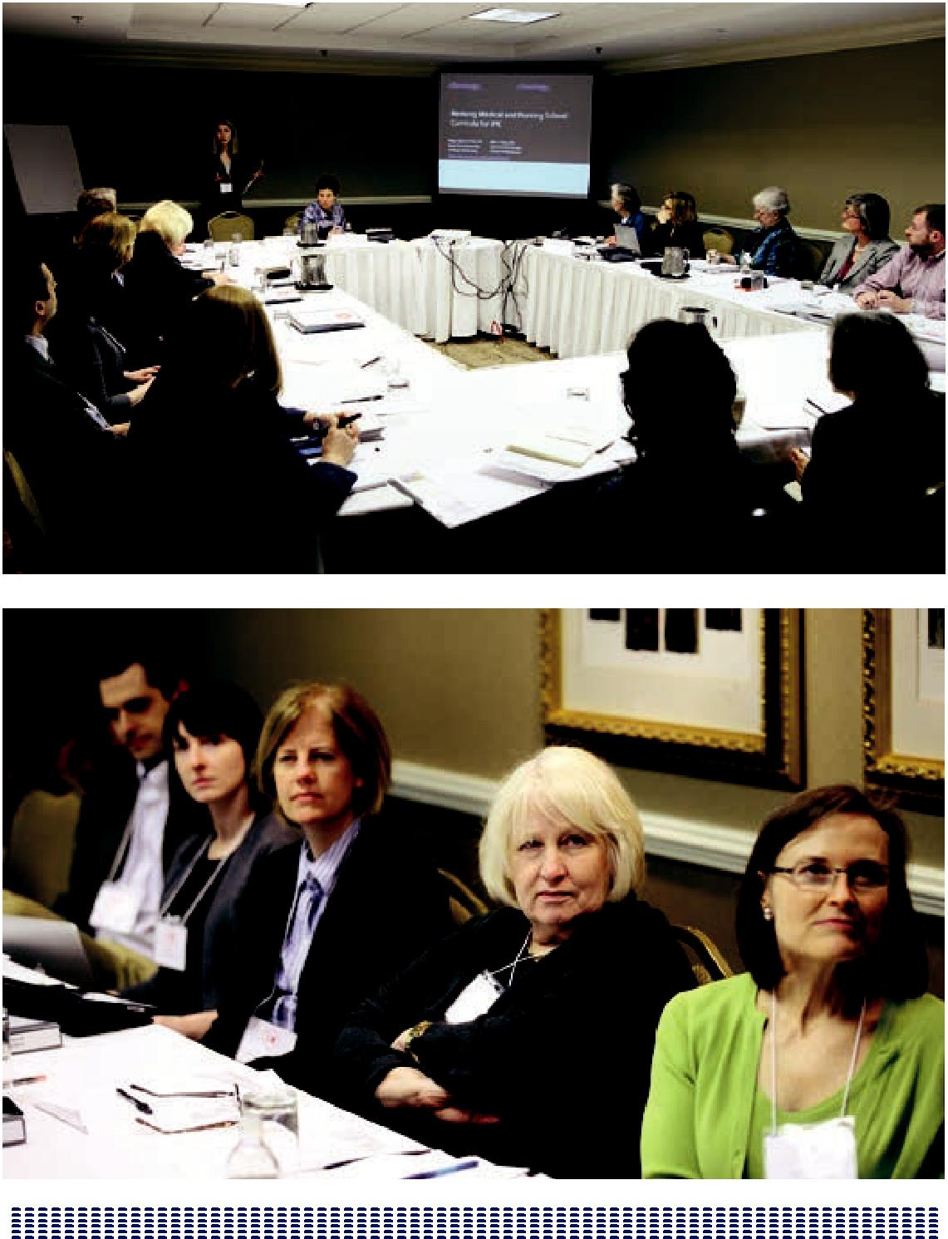

109

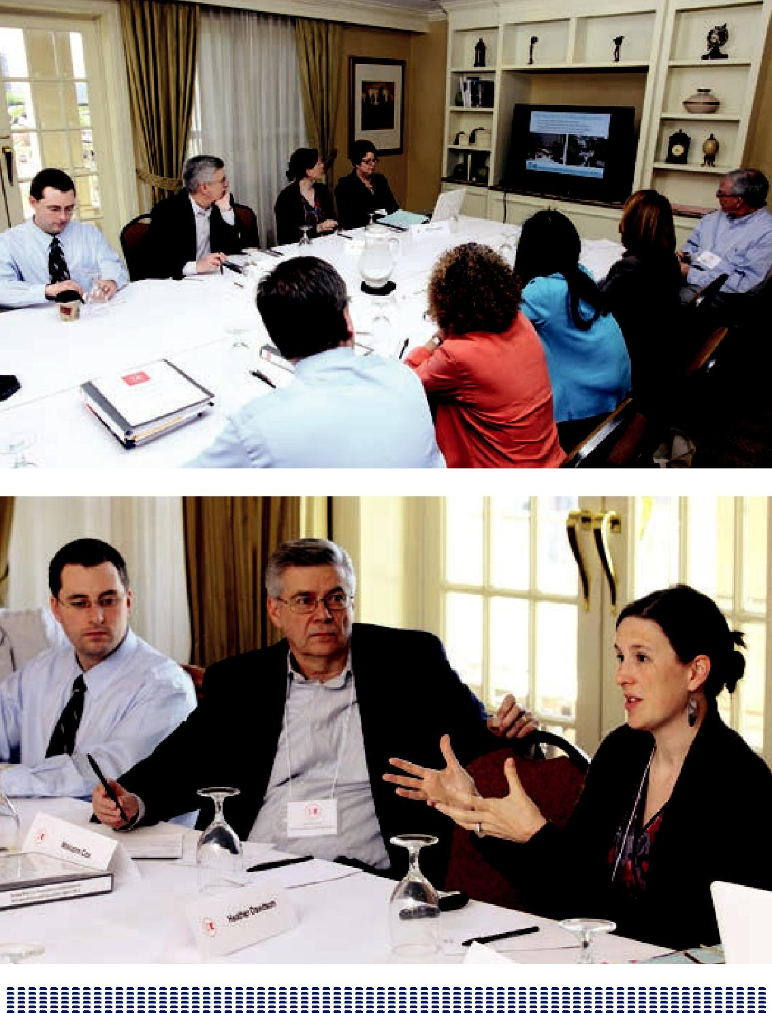

110

BREAKOUT SESSIONS

IPE CONFERENCE – BREAKOUT GROUPS 6 PER SESSION BASED ON THEME

- All breakout Groups will begin with 2 brief (5minute) presentations

- Discussions led by 2 faculty facilitators

BREAKOUT I

1. Teaching Quality and Patient Safety Interprofessionally

Faculty Facilitators: Geraldine “Polly” Bednash, PhD, RN, FAAN; and Molly Sutphen, MS, PhD

University of Texas Health Science Center San Antonio Presenter: Jan E. Patterson, MD, MS

Case Western Reserve University

Presenter: Deborah Lindell, DNP, PHCNS-BC, CNE

2. Teaching Special Content via IPE

Faculty Facilitators: George W. Bo-Linn, MD, and Stephen C. Schoenbaum, MD, MPH

Duke University: (Disaster Preparedness), Presenter: Colleen O’Connor Grochowski, PhD

University of New Mexico: (Addressing the Healthcare Needs of the Homeless), Presenter: Robert Elgie, RN, MSN, BC

3. Revising Medical and Nursing School Curricula for IPE

Faculty Facilitators: Judith L. Bowen, MD, FACP, and Madeline H. Schmitt, PhD, RN, FAAN, FNAP

New York University, Presenter: Maja Djukic, PhD, RN University of Virginia, Presenter: Valentina Brashers, MD

111

4. IPE Involving all Health Professional Schools in an AHC

Faculty Facilitators: Frederick Chen, MD, MPH, and Jeanette Mladenovic, MD, MBA, MACP

University of Colorado, Denver, Presenter: Mark Earnest MD, PhD University of Pittsburgh, Presenter: Susan M. Meyer, PhD

5. Faculty Development for IPE

Faculty Facilitators: Molly Cooke, MD, and Christopher Langston, PhD University of Missouri Columbia, Presenter: Carla Dyer, MD

Columbia University, Presenter: Letty Moss-Salentijn, DDS, PhD

6. Community Partnerships for IPE

Faculty Facilitators: Malcolm Cox, MD, and Maryjoan D. Ladden, PhD, RN, FAAN University of Washington, Presenter: Nanci Murphy, PharmD

Vanderbilt University, Presenter: Heather Davidson, PhD

112

BREAKOUT II

1. Teaching Quality and Patient Safety Interprofessionally

Faculty Facilitators: Christopher Langston, PhD, and Jeanette Mladenovic, MD, MBA, MACP

Penn State University, Presenter: Paul Haidet, MD, MPH

Johns Hopkins University, Presenter: Susan Immelt, PhD, RN, CNS

2. Teaching Special Content via IPE

Faculty Facilitators: Maryjoan D. Ladden, PhD, RN, FAAN, and David M. Irby, PhD Massachusetts General Hospital/MGH Institute of Health Professions (Patient Safety in Diverse Populations), Presenter: Alexander Green, MD, MPH

University of Colorado, Denver (Ethics), Presenter: Jason Williams, PsyD

3. Revising Medical and Nursing School Curricula for IPE

Faculty Facilitators: Molly Sutphen, MS, PhD, and Leslie W. Hall, MD, FACP University of Arizona/Arizona State University, Presenter: Stuart D. Flynn, MD, and Gerri Lamb, PhD, RN, FAAN

Case Western Reserve University, Presenter: Patricia W. Underwood, PhD, RN, FAAN

4. IPE Involving All Health Professional Schools in an AHC

Faculty Facilitators: Linda Headrick, MD, MS, and Stephen C. Schoenbaum, MD, MPH

University of Minnesota, Presenter: Barbara Brandt, PhD

Columbia University, Presenter: Rita Charon, MD, PhD

5. Faculty Development for IPE

Faculty Facilitators: Madeline H. Schmitt, PhD, RN, FAAN, FNAP, and Frederick Chen, MD, MPH

University of Washington, Presenter: Sarah E. Shannon, PhD, RN University of Virginia, Presenter: John A. Owen, EdD, MSc

113

6. Early Interprofessional Clinical Experiences

Faculty Facilitators: Judith L. Bowen, MD, FACP, and Patricia Benner, RN, PhD, FAAN Vanderbilt University, Presenter: Pamela Waynick-Rogers, DNP, RN

Hunter College/Weill Cornell Medical College, Presenter: Joyce P. Griffin-Sobel, PhD, RN, CNE, ANEF

114

BREAKOUT III

1. Teaching Quality and Patient Safety Interprofessionally

Faculty Facilitators: Frederick Chen, MD, MPH, and Stephen C. Schoenbaum, MD, MPH

Geisinger Health System, Presenter: Linda M. Famiglio, MD

University of Missouri Columbia, Presenter: Myra A. Aud, PhD, RN, LNHA

2. Teaching Special Content via IPE

Faculty Facilitators: Jeanette Mladenovic, MD, MBA, MACP, and Geraldine “Polly” Bednash, PhD, RN, FAAN

University of Pittsburgh (Geriatrics), Presenter: Sandra Engberg, PhD, RN, CRNP, FAAN

Penn State University (End of Life Care), Presenter: Paul Haidet, MD, MPH

3. Early Interprofessional Clinical Experiences

Faculty Facilitators: Maryjoan D. Ladden, PhD, RN, FAAN, and Molly Sutphen, MS, PhD

University of Colorado, Denver, Presenter: Lynne Yancey, MD

Case Western Reserve University, Presenter: Terry Wolpaw, MD, MHPE

4. Use of Simulation for IPE

Faculty Facilitators: Leslie W. Hall, MD, FACP, and Malcolm Cox, MD University of Washington, Presenter: Brian Ross, MD, PhD

Texas Woman’s University/Baylor College of Medicine, Presenter: P. Ann Coleman, EdD, RN, MSN

5. Use of Online and Asynchronous Learning for IPE

Faculty Facilitators: Judith L. Bowen, MD, FACP, and Christopher Langston, PhD Duke University, Presenter: Colleen O’Connor Grochowski, PhD

New York University, Presenter: Marc M. Triola, MD

115

6. Teaching Rural and Urban Medicine Interprofessionally

Faculty Facilitators: George Bo-Linn, MD, and Scott Reeves, PhD, MSc, PGCE University of Arizona/Arizona State University, Presenter: Robin P. Bonifas, MSW, PhD, and Michele Lundy, MD

University of New Mexico (Rural vs. Urban), Presenter: Cynthia Arndell, MD

116

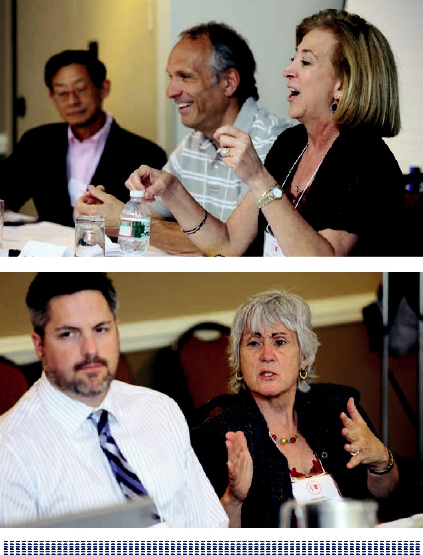

117

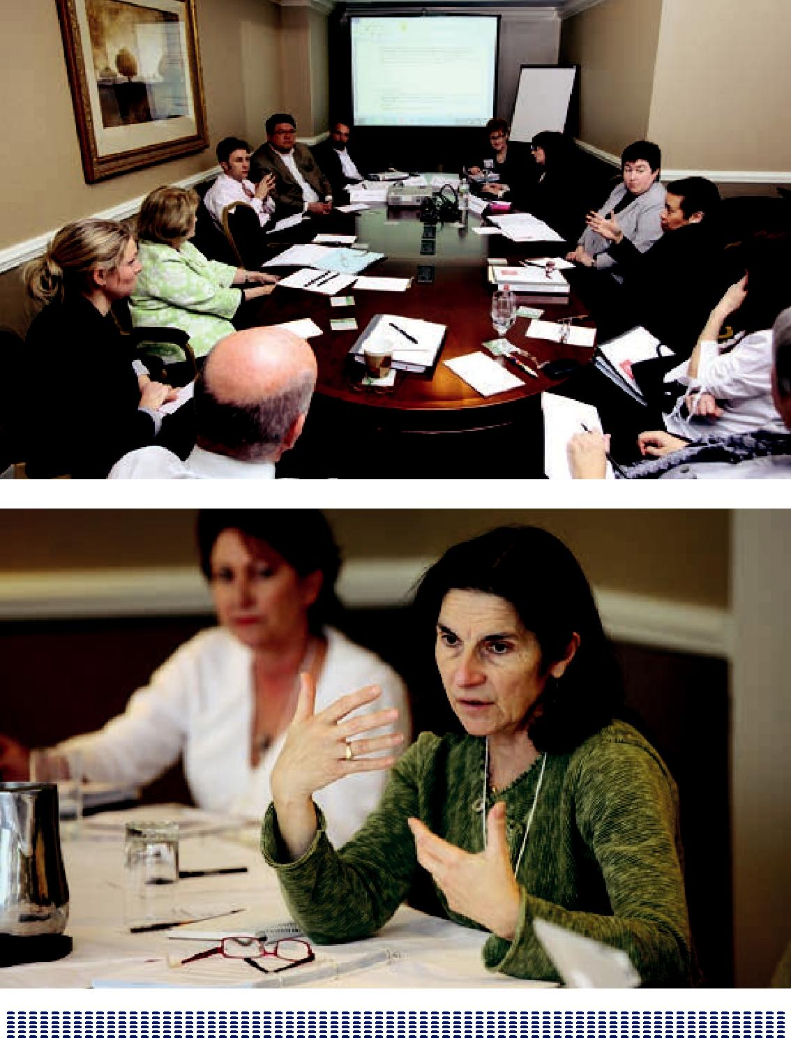

118

BREAKOUT SUMMARIES BY TOPIC

Three breakout sessions were held at the meeting, with six breakout groups running concurrently during each session. Each breakout group included two brief presentations by Macy grantees; overall there were 18 groups with 36 presentations. No presentation was repeated, but certain themes (such as teaching quality and patient safety) were repeated with different presenters and different examples. Each group was moderated by two of the invited faculty members (who were not involved in the project work being presented).

For this summary we have clustered the highlights of the breakout groups according to themes.

The themes were:

  - Teaching quality and patient safety (3 groups)

  - Teaching Special Content (3 groups)

  - Revising medical and nursing curricula (2 groups)

  - IPE involving all health professional schools in an AHC (2 groups)

  - Faculty development (2 groups)

  - Early clinical experience (2 groups)

  - Use of simulation (1 group)

  - Use of online and asynchronous learning (1 group)

  - Community partnerships (1 group)

- Rural and urban medicine (1 group)

119

The highlights are presented in bulleted form to capture as many points as possible. Inevitably there was also some overlap in the discussions, so that similar points were sometimes made in more than one thematic area.

Teaching Quality and Patient Safety Interprofessionally

As IPE continues to evolve, educators need to convey to learners that quality and patient safety are overarching to IPE and core to their practitioner responsibilities. Patient-centered experiential learning—with the idea that what students are learning is for the sake of the patients—is essential. And in learning about patient safety, medical students and nursing students should work together at the bedside. Bedside lessons in patient safety are essential to the IP-integrated patient safety curriculum.

Educators need to determine ways to transition students from simulation in the classroom setting to the internalization of teamwork in the clinical environment.

Often learners are involved in IPE for several years, including didactic events (problem-based quality problems). Learners come together on functioning quality improvement (QI) teams with mentors assisting in solving real or simulated problems. Increasingly, the goal should be for teams to be students or residents, run with a mentor or project manager who understands the type of practice with which the team is trying to integrate.

Other teaching formats include the International Health Institute (IHI) open school modules, journal articles on fall risk and risk assessment, simulation exercises, and presurveys.

Such learners in this effort previously had no understanding of QI or QI methodology and were all novices in self-assessment of quality. After training, though, educators saw solid improvements. It remains important that teams be successful in completing their projects and that the projects continue to have an impact on the organization. In some programs, former students are now serving as faculty.

Both top-down and bottom-up approaches should be used: Top-down, deciding what students should work on and structuring it; bottom-up, students work on whatever project they choose.

120

Challenges to teaching quality and patient safety remain and IPE educators are at work to overcome these problems:

- Inflexible schedules across professions

- Inability to focus on achievable aims

- Failure to connect with clinically meaningful issues

- Difficulty in finding mentors for longitudinal supervision.

Examples of teaching quality and patient safety include the following:

- University of Illinois Urbana-Champaign

  - Changing a system to reflect the shared values

- University of Colorado

  - Simulation experiences using team Systems Training for Emotional Predictability and Problem Solving (STEPPS) concepts

- University of Pittsburgh Medical Center

  - Interprofessional student shadowing: allows students to experience the system and thus involve the family in patient safety and quality

- Case Western Reserve University

  - IP student-run free clinic (video available online)

Further work that needs to be done in this area includes the following:

- Study of how different content areas engender responses in different competency domains

- Specific skills necessary for students in different situations with respect to the IPE competencies

121

- Standardization of curricula and evaluation tools so educators can learn from each other; possibly, the HRSA metrics group; Amy Bleu might function as a learning collaborative

- Sharing of case studies

- Sharing of information with QI offices

- Determination of the skills/knowledge needed to be effective IP teams and then working directly on those.

Next steps:

- A more formal research agenda on the effect of IPE

- Development of interest group expertise, in the format of communities of interest or a database so that educators can learn and develop tools from each other and avoid replicating efforts; the database, for example, might include listings of all student-run free clinics

- Review of the IHI open school modules and certificate; IHI open school modules are very good (per Geisinger), but can cover the basics in 6 hours, while the IHI certificate requires 22 hours

- Ways to aid students in learning how to work in a team setting regardless of the project

- Development of hypotheses about teams and what it means to work in teams by drawing upon the expertise of team approaches developed in other fields

- Improvement of the current educational literature so that the literature provides generalizations from one experience to the next

122

TEACHING SPECIAL CONTENT VIA IPE

IPE and the teaching of Special Content has a rationale for the process of connecting the two by highlighting similarities and differences across professions and by providing a common language and common framework for dealing with challenging issues. The two are embedded in team functioning and systems change.

Programs are linked with delivery systems as well as the education setting. For example, the Metropolitan General Hospital (MGH) Limited English Proficiency Project started in a delivery system and moved back to an educational intervention. The University of Colorado program started with a mandate from the university that connects to the larger TeamSTEPPS program in the clinical settings. Partnerships and connections are important when programs are dispersed.

The future teaching of Special Content needs:

- Concrete examples of how IPE and practice improve care and/or lower cost

- Data to justify existence, more so for innovations rather than for existing programs

- Identification of educational values—patient safety and quality; how IPE is able to spot potential errors; and how IPE is linked to other patient outcomes

- Preparation by schools of learners for next steps in the learning process (exams, licensure, boards, accreditation)

- Diversity of facilitator skills and student-centered training that includes practice and hands-on training to counter the often-generational disparity of facilitators

- Team-based learning to reduce the number of facilitators needed

- Ways to sustain online learning.

- Consideration of “Choosing the Ending” as an IPE Special Content course

123

Examples

Model cases of teaching Special Content in IPE abound. These include a disaster preparedness course at Duke University comprising an IPE course implemented in 2005, based on 3.5 days with teams of seven to eight IPE professionals (physician assistant, physical therapist, medical, nursing, pharmacist). Special Content, however, can require other resources. Duke, for example, had to bring in content experts in disaster medicine since none of the faculty responsible for developing the program had that expertise. Teaching Special Content sometimes means drawing on resources not usually tapped, but that process can be invigorating for not only the particular course but for the overall curricula.

Within its regular curriculum, the University of New Mexico offers an IPE medical respite and street outreach course (including homelessness issues), which involves nursing, medicine, and pharmacy. The program also involves social workers in the IPE sessions but not social work students. Social workers: are they part of the team? Though it’s often difficult to bring in social workers because of their academic calendars, their participation has proven invaluable to the Special Content courses at New Mexico.

Rural Health, another area of focus for Special Content, provides underserved teaching sites for IPE and for innovation.

In a particular rural health project, the University of New Mexico Health Sciences Center has involved a mix of professions including clinicians as well as non–health care learners such as architectural and law and business students who have interests in health equity. (Speaking of architects, Emory also has a multidisciplinary IPE course that includes architects.)

New Mexico’s project also makes use of ECHO telemedicine developed at the school. And in another setting, the University of Arizona/Arizona State University collaborative has a rural health project in early development, having been awarded a Macy grant in June 2012.

Case Western Reserve tackled the issue of obesity. Its IPE Special Content involved students in social work, dentistry, medicine, and nursing—over 500 in total. A featured task was to share each other’s literature (four articles) at the start of the course.

124

In further discussing Special Content, participants suggested that the IPE field might look to the NIH’s National Network for Transforming Clinical and Translational Research. Questions were also raised about connections with the IHI and the Robert Woods Johnson Foundation’s support of community-based solutions.

In most Special Content courses, the Assessment/Evaluation of student groups showed significant improvement from pre- to post-test in terms of learning and understanding about each other’s work. Students liked learning about each other and liked solving problems in IP teams. The experiences provided a high level of satisfaction.

In terms of future work, participants cited:

- Tenure codes. For example, the University of Minnesota rewrote its tenure code so that faculty can now receive tenure for interprofessional work.

- Consideration of other special topics such as QI, disaster response, health disparities, palliative care, health literacy, public health, community health, and homelessness.

- Doing IPE at the point of care. Inquire of delivery systems and ask with what they want students to come equipped. Systems seem to always be providing retraining for hires and not having to do so would be cost cutting.

- Frame what accrediting agencies are seeking to monitor in sentinel events and make the case based on this. For example, Kaiser would like to have staff members “speak up” when they see an error. If trainees come with an understanding of QI and patient safety, then they too will speak up. Equip students with an understanding of the various roles of professionals in health care (understanding scope of practice of different professions).

- Identity formation within each profession (values of respect, collaboration appreciative) as well as between professions.

- Faculty development needs to include awareness and the delineation of professional roles and responsibilities.

- Develop on-line cases—consider viewpoint and research questions.

125

- What is definition of team? What is definition of IP team?

- Looking at ways to develop networks and connections to the urban and rural communities.

- Identify plans for evaluation and for evaluation models both conceptual and contextual.

As George Bo-Linn emphasized, the way to teach IPE is through Special Content— e.g., diversity, health disparities, end-of-life care, and community health. The teaching of Special Content is one of the most valuable ways to prepare learners to effectively practice interprofessionally and, in turn, provide a more effective health care system.

126

REVISING MEDICAL AND NURSING SCHOOL CURRICUL A FOR IPE

Discussants weighed on the importance of revising medical and nursing school curricula for IPE. The importance of creating communities within the IPE educator groups was stressed as well as the importance of sequence and timing in each group. Participants stressed that common languages across professions must

be used. And core faculty must model what they want students to enact in interprofessional groups. More development or training sessions are needed that help educators learn how to model. Educators are of the mindset and generation that need to change and need support.

Leaders need to look at IPE and the accreditation by initiating conversations across accrediting agencies. Bringing the accrediting agencies into the IPE fold is critical to the revision of medical and nursing school curricula in context of IPE. And most importantly, IPE leaders need to learn from the interprofessional experiences and best practices in professions outside health care such as the military, the clergy, and the field of engineering.

A number of institutions are leading the way. New York University, Virginia, and Missouri in the area of simulation and debriefing; Yale, with new curricular developments; Memorial University of Newfoundland, with learners observing a team-based practice, then articulating what they saw and then interviewing

providers who gave the care; University of Virginia team-based Objective Structured Clinical Examinations (OSCEs); University of Texas San Antonio Nursing School with testing dedicated education units, first started in Australia where all staff on the unit—even the housekeeper and unit clerk—is dedicated to teaching the students.

Further work that needs to be done in this area includes:

- Needs Assessment: use of core competencies [IPEC]; QSEN, exit interviews help drive needs assessment of gaps.

- Diversity of learners by profession including pharmacy and dentistry, whose students are very enthusiastic about IPE; and public health students who are not specifically clinical, but good additions to help leaders in the field think “systems.” (Note: public health students are known for their appreciation of the clinical experience.)

127

- Outreach to other institutions.

- Faculty rewards for what is expected: having outside dollars makes for the “buy-in.”

- Working with nonuniversity-affiliated hospital-clinical faculty/practice people who are experienced at designing integrated clinical curricula for the range of students training with them. As an example, three teams of students who do simulations and work on real QI issues worked at Geisinger.

- Quality and safety projects for pre-licensure students. Reports of unprofessional learning, lack of interest in this topic. Focus on the problem; make IPE explicit in reflection or through another means of evaluation. Attach interprofessionalism to the vector—but not a vector that captures the students’ exclusive focus. At the University of Washington, the error disclosure is the vector.

- Determine if the vector approach is limited/contextual learning.

- Develop a learning collaborative.

- Dose/response question.

- Not all faculty understand IPE competencies.

- Students in different professions are being prepared for different postgraduate situations (e.g., medical students for residencies, dentists for practice).

- Need for IPE to all service providers.

- Students are competitive individualists and rewarded for that. Admissions not based on evidence of team work.

128

IPE INVOLVING ALL HEALTH PROFESSIONAL SCHOOLS IN AN ACADEMIC HEALTH CENTER

In the academic health center (AHC), administrators need to help students explore and navigate IPE in the current curricula. Educators at AHCs need to learn how to integrate students into effective teams where they become contributory members.

Although many programs are supported by grants, sustained funding remains a challenge. By incentivizing the programs and faculty development, IPE leaders at AHCs can better respond to the health systems that in many cases consider the product—IPE—not ready for the workplace. Meanwhile, medical colleges and nursing schools are strapped for clinical placements. The challenge remains to find sites, whether in systems or elsewhere, for students to do interprofessional practice.

Health systems, e.g., in Minnesota, are concerned about the nature of the curricula and how it relates to the students they are getting. As an example, health systems are training about system-specific issues that have not been the purview of the academic curricula.

- Health systems such as Fairview in Minnesota are developing interprofessional health care delivery sites. These sites, however, are not doing teaching, which they feel interferes with the clinical care.

- A logistic issue to be standardized is that of academic credit that is paid for differently in different schools. For example, at Columbia, the school

tuition covers all the credits for the year, whereas in the public health school, charges are based directly on credits taken.

- Develop a teaching exercise by having teams of students observe care and care settings followed by reports back about their observations and related implications.

- Consider prerequisites of what students would have to know and be able to do before they could step foot into a particular clinical setting, e.g., know how to wash hands before going onto clinical floor settings.

129

Examples of work in this area include:

- University of Minnesota: practices and three payers convened. Trainees are not prepared to practice as teams interprofessionally in their environment. The University pays for IPE at the top of the health center; three employers and health systems agreed to contribute to develop interprofessional sites for training. Schools provide baseline training to prepare students for their training at interprofessional sites.

- Case Western Reserve University: metropolitan site where medical and nursing students are able to work together.

- Interprofessionally student-run free clinics provide invaluable AHC training sites. The University of Minnesota has found that its student-run clinic is the most popular rotation and has no problem in attracting faculty.

- Learning from nursing leadership that effectively utilizes TeamSTEPPS language.

- Institute “rankless discussions.” Unpack the myths and stereotypes. Create a safe atmosphere to discuss stereotypes of professions.

IPE at the University of Minnesota involves medicine, nursing, pharmacy, veterinary medicine, dentistry, allied health and public health, with nearly 900 entry-level students in various groups and locations. Students have responded with requests for more emphasis on the “team” approach. Minnesota is mapping IPEC competencies across the curricula and, as a result, is building experiential education knowing exactly where and when students from different schools are together. The curricula are represented in three phases, with orientation to IPE starting the first day. Minnesota IPE has established an IPE toolbox that supports the program’s authentic experiences.

Columbia University, with no history of interprofessional interest, has taken another approach by starting with small groups from the top/down. Past efforts to bring students together failed and little if no trust existed among the professions. As

a result of faculty talking for a year about “what matters,” educators have come together on neutral ground and have learned what they like about one another.

130

Following these conversations, Columbia started very small with medicine, dentistry, public health, and nursing students—in total 16—in a credit-bearing, Special Content course about the nature of health and illness. Students spend time in tetrads and much time reading, discussing, and writing. By next year, Columbia expects to run at least two seminars. Students who take the seminar in one fall will in the next fall help in the teaching. And faculty hopes to be credited for teaching interprofessionally.

Interest is building elsewhere on the campus. The Columbia hospital, eager to find a program that lowers readmission rates, is looking at the trajectory that might exist between current education and the reduction of these problems.

The Columbia program appears to be related to developing humanism rather than teamwork. Both are important.

Further Work

Focus needs to be brought on financial solutions for sustaining these efforts. IPE has to be integrated so it becomes important to support. The model for financial support is not clear. In the case of Colorado, IPE costs ran $300 dollars per student per year for all schools based on past grant activity of 600K per year, which supports 1.3 full-time faculty, an administrator, an evaluator, some infrastructure; and some faculty development. IPE leaders need to look within their own institutions at the culture, e.g., available skills, senior support, in order to develop effective programs.

And as well:

- Integration with the clinical enterprise: Colorado IPE is at the table for clinical quality improvement; and Minnesota, for clinical enterprise.

- Determine core curricula that can apply across the board to students at different institutions, academic health centers, and clinical sites.

- Leadership training for faculty and students.

Because AHC systems and logistics vary, educators need to figure out how to implement programs locally by looking at where IPE occurs naturally (e.g., long-term care).

131

FACULT Y DEVELOPMENT FOR IPE

Tools for IPE

- Focus on improving our own abilities; teach faculty to be interprofessionally competent, as a goal of faculty development.

- Demonstrate IP performance as a team of educators.

- Borrow from relevant best practices of other professions.

- Health system commitment to QI creates infrastructure for “course” (e.g., office of clinical effectiveness contributes to QI expert/faculty).

- Health system stakeholders perceive value in trainees/workers in clinical settings who have gone through the Assertive Community Treatment (ACT) program.

- Penetration and scale of faculty development efforts: using teaching opportunity to recruit faculty into learning about IPE.

- Identify differences between competencies needed for IPE (educators) and IPC (collaborators); structuring the experiences (pedagogy) may require a different understanding than performing in them.

- Business case for Kano-1 improvements: the reduction of defects and costs (e.g., lawsuits).

- Faculty investment can pay off for a long time and in many ways even if the faculty’s direct impact on trainees is relatively small. There is a role for further development of higher levels of research and leadership capacity.

- Build IPE faculty development into any clinical system QI work.

IPE has two domains of faculty development:

- The knowledge of core competencies/values (communications, teamwork, role modeling). More than average facilitation skills are needed.

132

• Specific skills such as debriefing and IPE assessment.

- Faculty also needs to attend to specific IPE issues (their professional differences) and be more explicit about the skills that we are using in clinical care. Faculty should capitalize on “IPE teachable moments” when they happen.

Other examples of work in this area:

- At the University of Washington, the biggest challenge is learning how to debrief.

- IPE faculty might draw on the Harvard Business Review, such as articles on sensors that show communication patterns in relationships, or that facilitate learning about conflict resolution.

- The University of Washington offers some proven best practices in IPE on its website.

- Need for scholarship in faculty development.

- Geisinger uses ACT-like QI training approach and stealth team training.

- Naturally occurring teams coalescing around the needs of a patient population requires effective teamwork; e.g., HIV patients (patient-centered learning as opposed to school or disciplinary centered).

- Effective teams are very exciting and reinforcing to be on; these are stimulating and self-sustaining.

- Simulation movement is analogous for the faculty development needs for IPE—thereby avoiding the revolving door, burnout, and dependence on good will that runs out. There’s a need to connect to existing reward structure (e.g., IPE scholars).

- Creation of a valued career path for IPE-oriented faculty that can sustain individuals working through the system.

- Nobody wants to discuss conflict—but there is a lot of conflict around IPE.

133

- Understanding transition from elective, volunteer activity to universal mandatory experience—e.g., cheaper, faster.

- Pilot/developing work for the non–self-selected: creating infrastructure for sustainable efforts not dependent on “special champions” volunteer faculty without protected time.

- Terminate unending pilot projects. As Don Berwick observed, IPE leaders need to work at scale and within the constraints of the real system.

- Recruit and retain high-level faculty who can make significant intellectual (legitimizing) contributions.

- Crafting relationships and internal support for IPE within the unique interests and resources of an institution.

- Different types of faculty development training:

  - Immersion

  - TeamSTEPPS

  - Manual

  - Student feedback

  - Debriefing with students on what students have learned

  - Skills acquisition model vs. development model

- Assessment of faculty’s IPE competencies.

- Formal educator training: certificate program in IPE? Teaching techniques? Or master’s program in health professions education?

134

In terms of faculty development, the field of IPE needs to develop promotion criteria including:

- Rewards for faculty teaching IPE

  - IPE section on promotion portfolio

  - Recognition for teaching excellence (cross-professional academy of educators)

  - Interprofessional research criteria

  - Communicating the importance of IPE

  - Support in obtaining grants for IPE

- Propinquity

- Faculty evaluation at the start.

135

EARLY CLINICAL EXPERIENCES

- SW students are value-added through their telling the rest of their team what they do and how they do it; they craft knowledge.

- At Hunter, students self-select for “elective” course. Year 1 was a scramble because of a delayed start. This year, 57 students applied for 15 slots.

- At Hunter, faculties are generalists. Hospitalist-generalists are interested in coordinating IPE competencies on medicine third-year clerkships.

- MD candidates in these programs include those with a public health focus.

- In terms of IPE applications, students at Hunter are required to write an essay, including a discussion about a patient (if not excluded); needed high enough GPA so that was not an issue; graduate nurse students in CNS or NP programs—advertised using quotes from existing students; advisors are not that helpful, not helping to sell the program (six students signed up

then backed out); medical students also write an essay—looking for patient-centeredness in the writing.

- Faculty development needed to learn about their biases in the same way students do.

- Programs will survive if value-added. Health coaching is coming; getting students to be a part of the process; getting the clinics engaged to avoid “shadowing” experiences, finding the right student experiences appropriate to level of learner—meaningful participation on the students’ parts that are also time savers for the clinical staff (e.g., medication reconciliation); second-year learners are doing more direct patient care. Challenge: how to design IPE experience in clinical settings, not just “shadowing” in isolation. Hunter: really learning what the other professionals do.

- Hunter (Weill-Cornell): students have QI roles; students can orient new GME trainees to the hospital; both activities value-added.

- Home visits: Hunter—barrier was space; patients didn’t have room for the team, wanted them to go as a unit with a public health nurse (team size = 5), which is a lot for a New York City apartment; hard to operationalize following

136

patients long-term across the continuum of venues (may need to pick patients with less complex medical conditions); public health coordinates needs of patients with activities for learner team.

- What do the students not in the cohort do during these half-days? In SoN, students get credit for community health clinical credit (paying forward); other students take the time off. Cohort students can pull back during the summer because they are ahead. This time is not assigned as an elective, so they are not charged for this activity. Grades are pass-fail, but the criteria are set by the program directors.

- Vanderbilt: dose effect is amazing—much larger that other programs. What is “enough”? The range is huge.

- Elective versus required—will be mandated in the future and could be a “hammer.” Resource strain could be huge.

- Might develop a “core curriculum” (core dose), but have other experiences (field work could be different for different students).

- The Association of American Medical Colleges (AAMC) wants to develop new methods of collecting curricular mapping data so they can be tagged as IPE.

- For quality and safety as the core content, scaling up was easier for IPE.

- Can more senior students mentor more novice students?

- Are we teaching the students how to change the system they will graduate to? These early students may be too “green.” Might work better in longitudinal cohort.

- When together as a large group, the student teams manage the sessions for the first hour (they talk about whatever they want). Not faculty driven.

- Students have a “power” issue when trying to change the system (feel powerless). How to give them legitimate outlets for their ideas—take things to faculty?

- How to evaluate IPE and interprofessional clinical experiences—lots of

137

discussion about how difficult it can be, but several felt that OSCEs were a good idea. Long discussion on the dangers of diluting identity formation when learning in a team, especially the dangers for nurses and nursing, as their identities can be subsumed in situations where there is a power

differential with doctors. Questions came up about how to involve practice stakeholders in the education. Long discussion on reflection: how, when, and why to undertake it. Discussion about different professions’ roles: what is the role and education of physician assistants.

Further work in this area

- New idea: students apply and have to be accepted; tracking students who apply vs. others (characteristics of those who self-seek).

- New idea: use students who applied but not accepted as the “control cohort”.

- New idea: How do we ramp this up? Vanderbilt: clinic without walls (chronic obstructive pulmonary disease patients or heart failure patients)— telephone visits, home visits, get a larger population of patients for students to learn with.

- Cross-site collaboration.

- What does it do to these learners when they graduate into the world that is not functioning as IPE? Also a faculty development issue? This is an important question to study.

- Where can we study high-functioning health care teams such as: 1) orthopedics/sports medicines; 2) trauma, acute 3) military operations. Is there a way to expose students to these high-functioning teams? Hardest place may be primary care practice. Need to discover the practical wisdom of these teams—better articulation of what works (knowledge, skills, practices, impact) in health care settings, including learning settings.

- Have a lot of research to do on teamwork in the medical center—how can we apply lessons learned from other teams (e.g., military medicine, mass casualty). Need to study the organizational level of behaviors of really good teams.

138

- Can IPE be a way to counter bedside nurse burnout by giving nurses more continuing education?
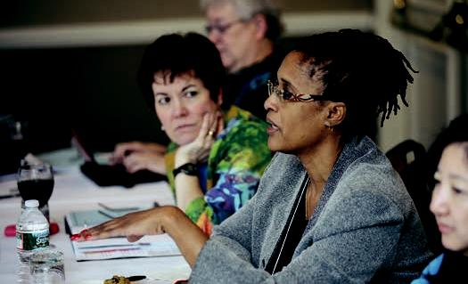

139

COMMUNIT Y AND OTHER PARTNERSHIPS FOR IPE

IPE needs to create partnership communities as well as with other types of schools such as law, business, policy, and health care. Partnering also needs to be forged with other health care organizations in providing TeamSTEPPS training, enabling students placed in those organizations to see role modeling of team behavior in those exact settings.

Industry can also provide valuable partnerships. As an example, a partnership with Boeing allows IPE leaders to learn about airline safety and they, as a purchaser of health care, need to influence health professional education.

Utilizing partnerships is a way to foster sustainability for IPE activities (once the initial funding ends). And demonstrating the value of the student services to improving patient outcomes can also support the case for sustained funding.

VA Centers of Excellence in Primary Care Education—formally building in transfer of learning from classroom to clinical setting.

140

USE OF SIMUL ATION FOR IPE

The University of Washington uses low-tech simulation (error disclosure) and high-tech simulation (adult/pediatrics/obstetrics) to teach team skills and interprofessional communication. Communication skills improved as learners progressed through three separate scenarios.

Texas Woman’s/Baylor has combined medical and nursing students to teach communication strategies around rapidly deteriorating patients. This training has been well received. Post-training surveys indicated an increased openness to interprofessional collaboration in the group that underwent a presimulation socialization process.

NYU also uses simulation to teach interprofessional communication early in the training process (first year nursing and medical students). Vanderbilt uses simulation to teach IPE teams that are working in outpatient clinics. And the University of Missouri uses simulation to teach both team skills as well as recognition of patient safety hazards.

IPE needs additional emphasis on simulation in the ambulatory environment (chronic care model; patient-centered medical home; preparation for team huddles).

141

USE OF ONLINE AND ASYNCHRONOUS LEARNING FOR IPE

What difficulty do students and/or faculty encounter in using new technologies? Students don’t have much trouble with the technologies, but they are undisciplined in pedagogical aspects.

Learning needs to be scalable in the virtual world. In the real world, size makes getting together very difficult and beyond the resources of the project.

Questions remain concerning who pays for maintaining the content: e.g., updating the material for new drugs (storyboarding, faculty engagement, peer review, and/or re-doing the film).

Sharing of content and maintenance of the websites are issues of concern involving interprofessional rights, ownership, work-for-hire, and open source.

Virtual/IT-assisted versus the real world—what is the evidence for one versus the other?

There is a need for a centralized coordination of on-line education in a crowded curriculum that is making more and more use of on-line training (avoiding traffic jams).

And IPE needs to look to engaging stakeholder faculty who can integrate online/ simulation learning in their work after the initial champion/enthusiast faculty makes it “normal.”

Examples

- Pittsburgh has simulations. Emory University has a standard VPSim being adopted by the VA system.

- “Fake” electronic medical recording as a mode for modeling.

- Minnesota occupational therapy hybrid online curriculum that became a resource to other schools.

- Minnesota/Fairview has developed a simulated surgical floor.

142

- New roles in health professional education such as knowledge managers (for updates and library functions). For example, Duke University shares materials with Singapore.

Ideas for further work in this area

- How can this work enable assessment of clinical reasoning? Does its ability to track learner activities give more insight?

- Can IPE untangle the impacts of educational tech/simulation itself versus IPE content?

- Does the IPE nature of the training reduce the rework/retraining of workforce in practice?

- Can learners be tapped to keep materials up to date, such as user-designed game modules?

- What are the costs of IT learning versus traditional: is there a cost-effectiveness analysis?

- Can we consider a training experience with just one learner exposed to a team of professionals to be IPE, or do we need a team of learners interacting with the team of practitioners?

- Can virtual training help more advanced trainees learn how to use good judgment about virtual “hand offs” or in person or other modes of managing “hand offs”?

- Because the technology of virtual care delivery will make new work possible (such as kiosks or the robo-doctor showed by Dr. Berwick), how do we get learners involved in preparing for that future mode of care delivery?

143

TEACHING RURAL AND URBAN MEDICINE INTERPROFESSIONALLY

Discussion highlights

including questions raised by participants

University of New Mexico: presenters focused on urban health task force

- The Quentin Burdick HRSA grant for rural health in New Mexico and Minnesota: did not work according to Brandt.

- Pilot projects generally do not work: “don’t have legs.”

- Interesting mix including clinicians and non-health care (architectural students interested in health equity; law students; business students)—any data on how effectively they work together? There are no data, but the non-health care students do not work in the teams, so how meaningful is the teamwork design, e.g., an artificial team?

- Teamwork is not a defined term; health care team is not generally stable.

- Social workers: are they part of the team? Difficult to bring in social workers because they often have different academic calendars, part of different schools.

University of Arizona/Arizona State University: rural/underserved teaching sites for IPE

- Very early in development; awarded grant in June 2010 and just started second stage, so very interested in input during session.

- In not-recent past (1980s), the practice was by necessity interprofessional; academic institutions are not inventing IPE.

Other examples of work in this area (cite institutions):

- Emory has multidisciplinary program, including architects.

- ECHO telemedicine developed at the University of Mexico.

144

- University of New England in osteopathic medicine: very hard to measure its impact on health. Think of new measures? Provided health care to very rural populations (e.g., in Maine). Maine has redesigned its health care schools, but more of its medical students want to be subspecialists, not rural practitioners.

- Any connections with IHI? Robert Wood Johnson Foundation to invest in 12 communities?

- Clinical Transformation Awards from NIH.

Ideas for further work in this area

- What is definition of team? What is definition of interprofessional team?

- How do we develop networks and connections to the urban and rural communities?

- Many descriptions and anecdotes, but where is the recording and assessments of such? Where does it get into the literature?

- What are the plans for evaluation? What are evaluation models? Conceptual and contextual approaches to evaluation? “Realistic” evaluations?

- People should read the literature: do first a lit review because many projects are repetitions of what has been done (and failed or succeeded) in the past.

- Think deeply about the research question. Then research design. Then methods section. Include quantitative and qualitative data. Then evaluation. Think about summative as well as formative evaluations.

- Even think about trials as quasiexperimental at least.

- How do we move from compelling stories to convincing evidence?

- How do we create useful commonalities across the multiple pilots presented in the conference?

- Rather should focus on common outcomes: create value as measurably improved patient experience, lower cost.

145

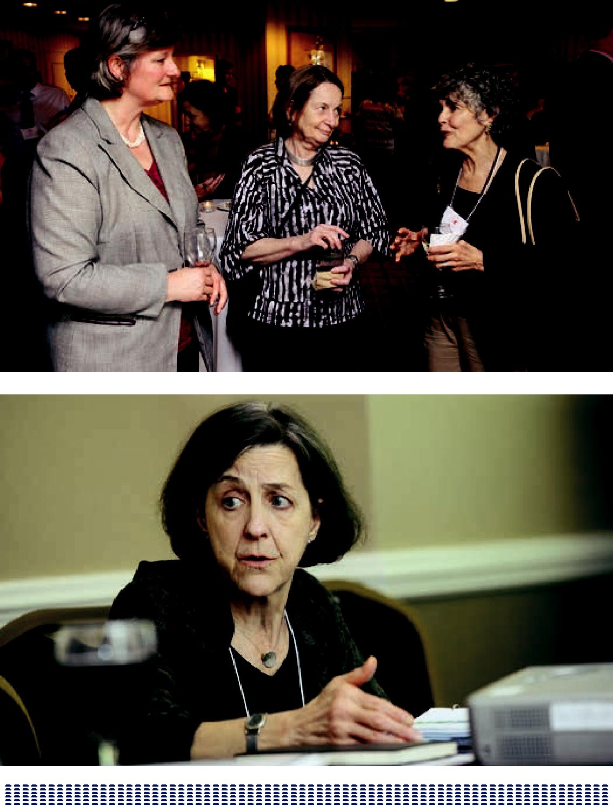

146

PANEL DISCUSSIONS ON IPE IN CLINICAL PRACTICE

INTRODUCTION FROM

GERALDINE “POLLY” BEDNASH, PHD, RN, FAAN

DR. POLLY BEDNASH: Thank you, George. It’s wonderful to be here and to see the energy exhibited by this group. The last day and a half have been exciting as we have seen renewed commitment to the IPE efforts and made connections with multiple individuals who are experimenting with new ways to bring IPE to full fruition. The reception we had that first night was an important part of the

networking and exchange and gave us the chance to share our work and excitement about it.

Yesterday the presentation by Scott Reeves gave us an important framework for how we conceptualize the various stages, evolutions, or foci for IPE: the micro, meso, and macro components of IPE. Don Berwick gave us an overview of health care

and how health care delivery is changing. His message was clear that reform and change were inevitable, whether the legislative mandates go away as a result of the Supreme Court’s review or not. System reform and health care delivery change will occur because of the experimentation that’s taking place in health care and the need to address the fundamental challenges in health care delivery today. Our challenge here is to understand the need to educate new health professionals who understand and embrace the realities of a reformed health care delivery system. Our new professionals will require the ability to develop and model new ways of interacting with others in that reformed or changed system.

Now the long history of IPE goes back further than we want to admit, with some of the writing and discussions emerging as early as the 1900s. As health professions educators, we have also experienced fits and starts of energy and commitment

to IPE that have blossomed and then faded away. But I think that this conference is evidence that we are experiencing a more energized and growing sense of

accomplishment around IPE. We’re beginning to understand that IPE is required for overcoming the challenges faced in health care delivery today and in the future.

147

Yesterday one of the participants in a breakout session challenged this new energy and accused those of us here of having drunk the Kool-Aid of IPE. In other words, she was challenging us about whether or not we’re able to look at IPE with a jaundiced eye, to really test whether or not IPE is effective or if it has any impact on health care delivery, how our graduates practice, or the outcomes of care in

an interprofessional environment. Would our commitment to IPE result in a new dynamic about how health professionals interact with each other to focus on delivery of the best care? Moreover, are we even evaluating the impact of our efforts in IPE—how we do it, what works best, and how it changes learners’ views of their colleagues? But most important, what is our commitment to evaluating the potential of IPE to impact care delivery, to look at the outcomes associated with care?

So these are the fundamentally most important issues for us. Where’s the proof of concept, we are asked.

At the same time, as educators, we are frequently asked by our practice colleagues to do a better job in preparing students who come to the practice setting, with more competence around team-based care, and the ability to collaborate with their peers in those settings to deliver better care together.

So, this morning we have asked representatives of the practice world to come in and speak with us about how they are actually supporting or implementing team-based care to improve care delivery. Many of us who are educators have struggled to find places where interprofessional practice actually occurs. That’s one of the big challenges we talked about yesterday. We are asked to prepare graduates for team-based practice but can’t find the models that are in place.

Our hope for this morning’s conversation is to learn about the best that interprofessional practice can achieve, how it is actualized in the systems represented by these individuals, and how our students can integrate into these best practices to learn in the real world of IPE. Perhaps what’s more important here is our hope that the lived experience of interprofessional practice will provide us some assurance that our efforts to engage in IPE actually will have an impact on the care that’s delivered. That is, provide some proof of the concept.

The first panel this morning will be moderated by Malcolm Cox with the learning practice team from the Primary Care Center of Excellence at the Yale-New Haven VA. The second panel will be moderated by George Bo-Linn with representatives from several different delivery systems: Geisinger, Kaiser, and the University of

148

Minnesota. Let’s hope that they can help us look at the proof of concept of IPE: does it have an impact, is it operationalized in interprofessional practice in those practice settings, and where is that proof of concept.

149

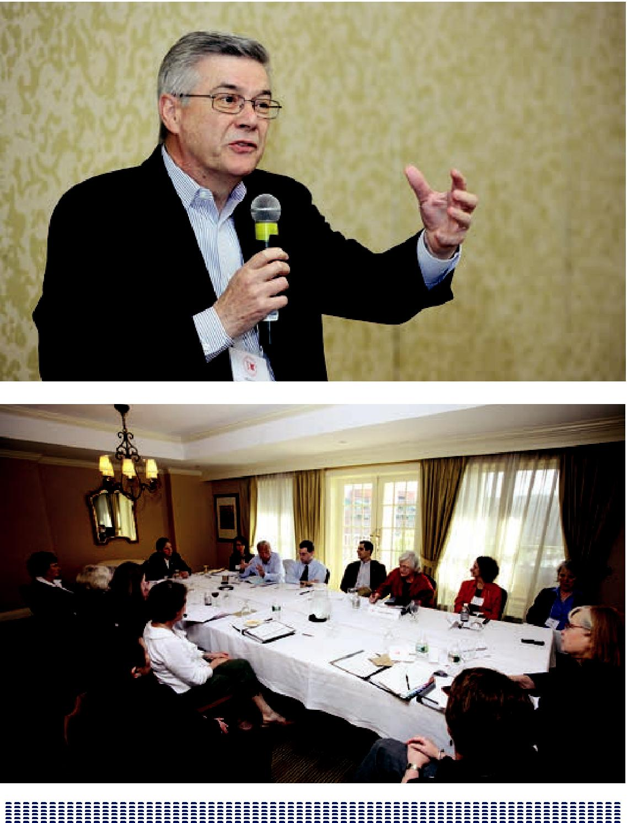

150

IPE IN THE VA

MODERATED BY MALCOLM COX, MD

Participants:

Judith Bowen, MD; VA Office of Academic Affiliations

Rebecca Brienza, MD, MPH; VA Connecticut Health Care System

Jill Edwards, APRN B.C, MSN; VA Connecticut Health Care

Theodore Long, MD; Yale University Internal Medicine Residency Program Elena Speroff, APRN B.C, MSN; VA Connecticut Health Care System

Workplace Learning

Malcolm Cox, Chief Academic Affiliations Officer at the US Department of Veterans Affairs, picked up on this theme by noting that workplace learning is learning that takes place as part of everyday thinking and acting in authentic clinical care delivery settings. This learning is structured around caring for patients, is unscripted, and inherently collaborative. By embedding trainees from any profession in the clinical workplace where teams are engaged in the work of delivering quality care, learning from experience is possible. In addition, leadership of the team has to move from individual to individual, being determined not by professional background or expectation but by the needs of the patient and the nature of the specific care episode.

Dr. Cox went on to posit that at the “heart” of every clinical workplace (microsystem) are two essential and inseparable components: caring and learning. The more effectively one cares for the patient, the more one learns from the experience; and the more one learns, the more effectively one is able to care for the patient. This positively reinforcing feedback loop is the seminal component of patient-centered care. Clinical workplaces are greatly influenced by the organization, culture, and resources of the institution (mesosystem) in which they are embedded, and in turn individual institutions are subject to the vagaries of the larger health care system (macrosystem). Of particular note is the strong interconnectedness of education and practice redesign; one without the other degrades both caring and learning.

151

Interprofessional Primary Care Practice

With these considerations in mind, Dr. Cox noted that the VA has established five Centers of Excellence in Primary Care Education: the San Francisco VA Medical Center, in collaboration with the UCSF Schools of Medicine and Nursing; the VA Puget Sound Healthcare System, in collaboration with the University of Washington Schools of Medicine and Nursing; the Boise VA Medical Center, in collaboration with the Gonzaga School of Nursing, the University of Washington School of Medicine, and the Idaho State School of Pharmacy; the Louis Stokes VA Medical Center in Cleveland, in collaboration with Case Western Reserve University School of Nursing and the Cleveland Clinic Foundation; and the VA Connecticut Healthcare System,

in collaboration with Fairfield University School of Nursing, and the Yale University Schools of Medicine and Nursing.

The goal of these Centers is to transform the primary care workforce where health care begins—in the systems of teaching and training. To do so, they focus on four interrelated educational objectives: patient-centeredness (shared decision making), sustained relationships (continuity of care and learning), interprofessional collaboration (team-based practice), and continuous performance improvement (at the level of the individual provider, the practice, and the health care institution or system). Although this initiative is directed at learners, the entire enterprise is embedded in primary care practice redesign, and more specifically in the VA’s

national effort to organize its primary care delivery system in “Patient-Aligned Care Teams” (PACTS), which are interprofessional by design. Dr. Cox noted that this effort shares many characteristics of the patient-centered medical home movement in the private sector.

To qualify as a Center of Excellence there must be:

- Two core groups of trainees: internal or family medicine residents on the one hand and nurse practitioner students on the other. Presently, the medical residents are all from internal medicine training programs. Either baccalaureate-prepared nurses entering a nurse practitioner training program (nurse practitioner students) or post-masters nurse practitioners in a fellowship program (nurse practitioner fellows) fulfill the latter requirement.

- Dual sponsorship by a school of medicine or academic medical center and a school of nursing. Other health professional schools can join but their participation is not required. Currently, some of the Centers include clinical

₁₅₂ pharmacy and psychology trainees.

- Integrated interprofessional teams, with both medical and nursing trainees having a 30% time commitment to the Center. The models vary from Center to Center but time spent in practice (caring for patients) must predominate.

Each of the Centers receives approximately $1 million annually in operating costs, including faculty time, administrative support, and data management support. In addition, Centers are provided with additional training positions over and above their general allocation if justified on the basis of the particular training model deployed. Most Centers transferred some medical resident positions from other training programs to the Center, but also needed additional positions. New positions were allocated to the Centers to support their nurse trainee complements.

VA Connecticut Center of Excellence

Dr. Cox introduced Rebecca Brienza and Jill Edwards, co-directors of the VA Connecticut Health Care System Center of Excellence in Primary Care Education, who reviewed some of the key features of their program. Internal medicine residents, nurse practitioner fellows and students, medical students, and physician assistant students all function as active members of the primary care team, but the post-masters nurse practitioner fellows and medical residents provide the core staffing. Promotion of shared decision making, motivational interviewing, facilitation skills, interprofessional collaborative team exercises (ice breakers, role play, simulation), performance improvement and patient safety projects, a health policy/leadership series led by trainees, subspecialty roundtables, and journal clubs all have important roles in a jointly developed and delivered curriculum.

The curriculum is workplace oriented with limited didactics, and includes all trainees working together. All of the learning is clinically based. Peer-to-peer teaching is emphasized and trainees are expected to take the lead on particular components of the curriculum. As an example, several learners embraced and developed a health leadership and policy curriculum that has been accepted for both local and national presentation.

To build and sustain close peer relationships, trainees spend significant amounts of time working together in the care of patients. The adult post-graduate nurse fellowship is a 12-month full-time training program offering nurse practitioners an additional “bridge” of intensive clinical skill building for effective collaborative practice. Internal medicine residents have concentrated ambulatory experiences, with two 2-month “immersion blocks” each year over the course of their three years of training. During these immersion blocks, residents have no inpatient

153

responsibilities, working entirely as part of the primary care team. When a resident moves on to other rotations, primary care team “partners” (other medical residents and nurse practitioner fellows) assume the care of that patient panel until the primary provider returns.

A Room of Their Own

Dr. Berwick in his earlier presentation struck a chord among the VA panelists when he discussed the Nuka program in Anchorage, especially his slide of the Nuka team working together in their “pod.” At the VA Connecticut Health System Center

of Excellence, a converted conference room has become the program’s learning space, its “Nuka.” The trainees call it their Clubhouse, a place where they can work, talk, relax, and get to know one another. Without such informal space, professional barriers are difficult to breach, and collaborative learning and caring just won’t happen.

The Takeaway

Nurse practitioners graduating from such programs seek positions in which they can utilize their skills in interprofessional practice. In many ways they see it as a duty to carry forward what they’ve learned in an interprofessional, team-based practice environment. It is very difficult, having trained collaboratively, not to expect collaboration to be a central component of one’s career going forward.

Medical students and residents likewise acquire the skills that enable them to become caring doctors regardless of their ultimate specialty choice. In the

classroom, in huddles, and in seeing patients, they learn with their colleagues about facilitation, collaboration, and distributed leadership. They witness and participate in team-based care, most for the first time in their training, and learn to value the capabilities that other team members bring to the table.

For many residents, this is their first opportunity to develop longitudinal relationships with patients. Instead of the usual half-day a week of “continuity clinic,” with the continuity fragmented by inpatient and other coverage responsibilities, the Centers of Excellence foster the development of real relationships with patients, allowing

for residents to take “ownership” of their patients while also providing efficient and effective team coverage during away rotations. Residents become a part of their patients’ lives, not just a part of their medical care. The experience is transformative for everyone involved, trainees, faculty and staff alike.

154

Elena Speroff, a nurse practitioner fellow, put it this way: “What we’re doing with our team is very difficult to put into words. The best way to illustrate how we all interact may be a patient’s story. Ruthie is our medical assistant, and is responsible for bringing the patient out of the waiting room. Patient care starts right then and there with Ruthie, who says ‘I’m Ruthie, I’m your medical assistant and you are going to be seeing so and so today and also the team nurse.’ Ruthie then introduces the team so the patient knows that s/he will be cared for by an interprofessional team. That particular day, Ruthie introduced us to Mr. C, who was new to the VA. Over

the past five years he had been seeing a private endocrinologist. His hemoglobin A1C was elevated and the endocrinologist had been trying to get him to start insulin for all of those five years. Instead of insulin, Mr. C was on four oral agents. Over the course of a few visits, we all agreed that Mr. C would benefit from insulin. He started taking insulin and his A1C went down nicely after several months of carefully monitored therapy. What’s important is that Mr. C said that he agreed to switch to insulin because he felt like the entire team was invested in his health, and that the recommendation to start insulin was coming from more than just a single provider and more than a single professional. We hear this a lot from our patients, a common question being: ‘why didn’t you start this teamwork a long time ago?’ I’ve had patients that have been coming to the VA for 40 years, and they notice a huge difference in the caliber of their care. They also notice that we enjoy our jobs. And I feel that our patient care is much better than what they’ve received previously.”

Ted Long, an internal medical resident, emphasized what he will take away from this experience in terms of skills learned from being in a collaborative learning and caring setting together with nurse practitioner trainees. “I think I’m now more effective than I would have been otherwise. The interprofessional training enabled me to learn from my colleagues in a more efficient way, and the facilitation and leadership training built into the curriculum was essential. The skills that my team

learned for outpatient medicine are universal, and will be equally relevant whatever career path I follow.”

Ms. Speroff added: “Near the end of my fellowship I’ve started some job interviews, but know I can’t move on from this program and leave everything I’ve learned behind. I’m really looking forward to bringing all these skills to my next job.

That said I’ve been looking for a position where I can be active in the training of residents. I also think that the quality improvement projects, the facilitation skills, all that other training, should be greatly valued. In a recent job interview in an OB/GYN practice, I spent half the time talking about how a 90-day wait for an annual exam was unacceptable, and questioning what the practice’s quality improvement people

155

were doing about it. This is a conversation I never would have had a year ago at a job interview.”

Dr. Bednash summed up by emphasizing the transformative nature of such training experiences, adding that: “Elena’s example of what she’s looking for in her next employment opportunity is a fabulous representation of the proof of concept of the benefits of interprofessional education, and its ability to change patients’ and providers’ expectations, to change how care is delivered, and eventually to change the outcomes of that care.”

156

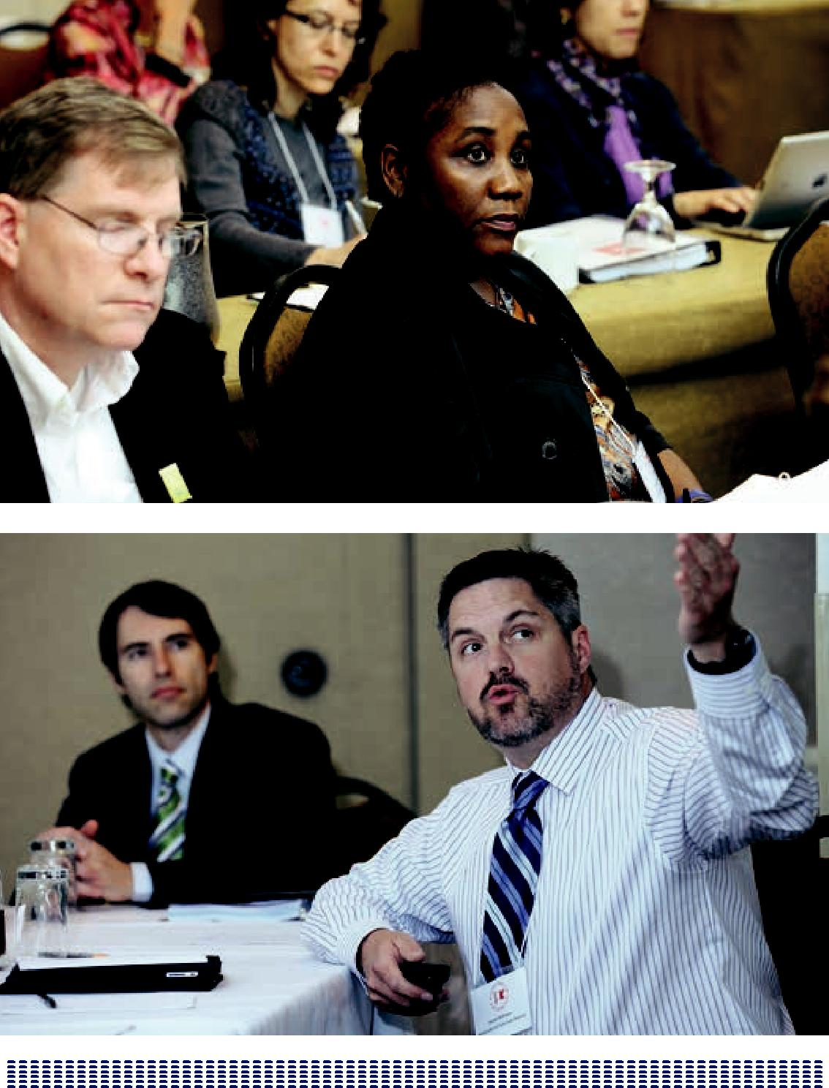

157

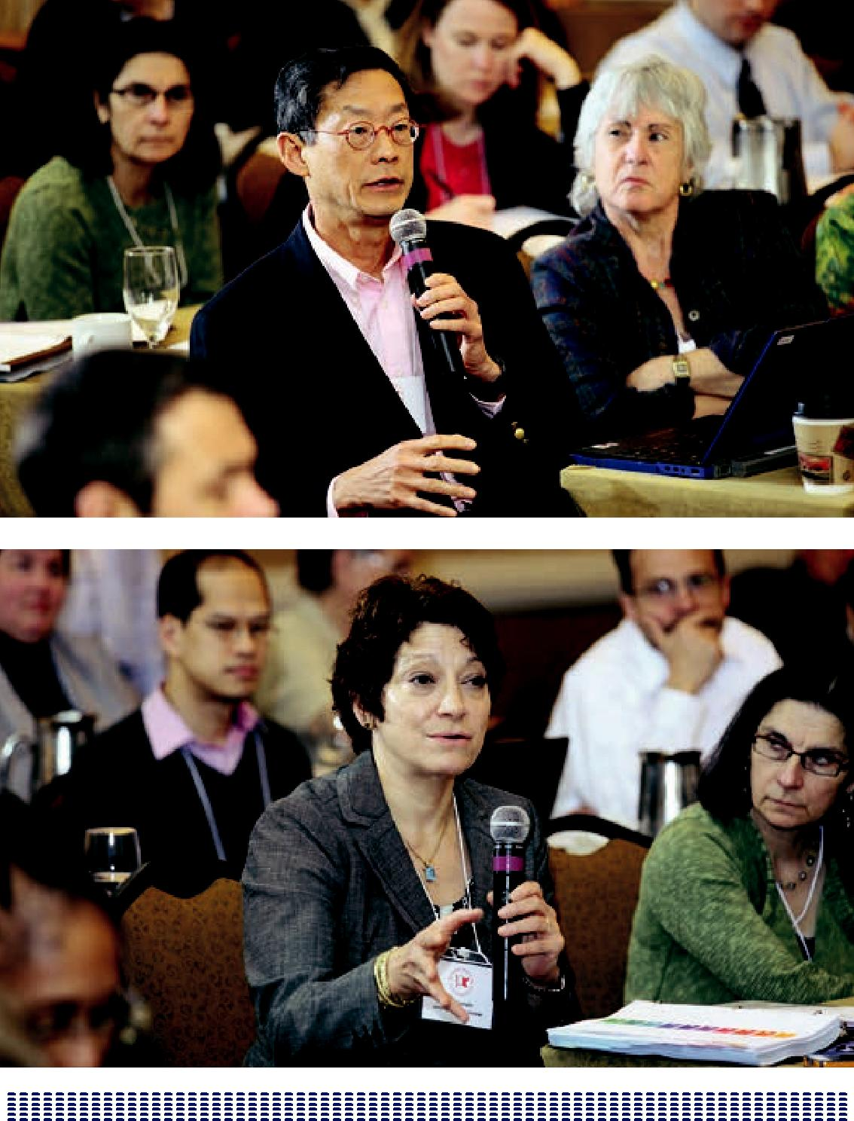

158

EDUCATION AND DELIVERY SYSTEM LINKS

INTRODUCTION AND MODERATED BY

GEORGE BO-LINN, MD

DR. GEORGE BO-LINN: Thank you and Polly for that marvelous introduction. This is a group of very independent individuals, and I certainly hope that all of you take advantage of this opportunity to ask questions for us to share with you not only our perspectives but your perspectives. This is not a panel discussion in which we will unilaterally provide you wisdom. It is…I hope there is some wisdom, but for us to learn from you and from us to learn from each other so please do not be shy about bringing up issues because this is something that’s extraordinarily important. First let me thank the prior panel and particularly Malcolm for giving us that insightful slide that illustrates the relationship between education reform and practice redesign with the patient in the center. I’d like all of us to keep that in mind as we talk about the linkages. The title of this panel is education and delivery system linkage to promote interprofessional education, and so we have a quite distinguished panel. Their bios are in the back of the book so I won’t repeat that. We have Linda and Frank and Marilyn, all from somewhat different perspectives but deep experience. Firstly, before we begin however I think it would be helpful for us to just get an idea of all of us and where we are at this moment in terms of the education and delivery system. Those of you who believe that you are representative or basically in the education system as compared to those in the delivery system, who believe that they’re in the educational system predominantly, would you raise your hands just

to get an idea? Okay, and those of you who believe that you’re predominantly in the delivery system would you please raise your hand? I think that was illustrative. [note: almost everyone in the audience sees themselves as in the education system.] Those who believe that you are predominantly in one or the other systems, are

you realizing that the two are becoming interconnected and interdependent? For those few of you identified as in health care delivery, we are particularly interested in understanding the realities of the delivery system so please don’t be shy in contributing to today’s discussion. Secondly those in the educational system and those in the delivery system, both groups, would you just raise your hand on one

159

of these two and I realize that this is not electronic polling so there may be some kind of herd instinct that’s going on, but just close your eyes then. We’re going to ask about agility. Those of you believe that the education represents agility, please raise your hand? [note: few hands raised] Those of you who believe the delivery system is one that has demonstrated agility raise your hand. [note: several hands raised] Finally those of you either in educational or delivery system, how would you describe the system in terms of being responsive to a business case; we heard a lot from Don Berwick about the necessity to reduce costs. Educational system amenable and responsive to the business case, those of you who believe that please raise your hand. [note: almost no hands raised] We’ll have a conversation later, Polly. Those

of you who believe that the delivery system is amenable and responsive to the business case raise your hand. [Note: many hands raised] Well it’s an informal poll, completely unscientific but I’m going to take that as real data. In this room we have great wisdom, and in this room we already have different perspectives of education delivery system which we can I believe fully exploit in order to bring about finally after 40 or 50 years or perhaps a hundred and plus years some true understanding of an implementation of interprofessional education and collaborative practice. As I move onto the panel members I’d ask you to keep certain key things in mind. Hold us to this, hold this panel to these considerations and we’ve heard some of them already. Is what we described generalizable? Is it scalable? Can it be replicated?

Is it generative because if it isn’t this is an intellectual exercise with little practical application. Are the stories and examples we provide generalizable? Are they scalable? Can they be replicated and is it generative? Secondly, are we including the key components that we heard from Scott yesterday, Scott Reeves? Are we clarifying or even stating definitions, measurements, and goals? Are they applicable to the Triple Aim of decreasing cost, improving the patient experience including quality, and improving the health of the population particularly the poor, underserved, and the vulnerable? If we are not, call us out because then it is not meaningful to where we are with American health care; and thirdly, if we do not speak to and address

in a convincing fashion incentives—so called “what’s in it for me?” Why should I change? If we do not address incentives call us out. We may not know, in fact I’m sure we won’t know, all the answers and that’s when we look to you to have the wisdom to help us understand how to address those components, because if we do not we will be here next year talking about what a lost opportunity we had last year. This is the hard reality of making something real, of actually creating a movement that has momentum, application, durability, and we would ask you to hold us, the panel, accountable to provide you with an educational and practical session until 11:15 and then we can get back to fantasy. We have Linda, Frank, and Marilyn. The

160

only instruction I gave them really other than sending them the inspirational email from George was I asked them from their particular viewpoint of their institution, the respective institution, what was the single most valuable perspective that their experience afforded them. From their experiences what’s the single most important lesson, and thirdly relative to the linkages what’s the single most important linkage issue that they find in bringing together the educational system and the practice reform. I held them to this single most because I find that to be a clarifying experience to say what is the single most important thing, and with that then let’s begin with Linda and then we’ll have Frank and then we’ll have Marilyn and some opening remarks and then we’ll have a conversation with all of you.

Panel Discussion and Q & A

Moderated by George Bo-Linn, MD,

Gordon and Betty Moore Foundation

Participants:

Linda M. Famiglio, MD, Geisinger Health System

Marilyn Chow, RN, DNSc, FAAN, Kaiser Permanente

Frank B. Cerra, MD, University of Minnesota

The linkage of education and delivery systems is critical to furthering the development of interprofessional education (IPE). Educators, system leaders, and IPE leaders discussed how the linkage is happening and can continue to happen.

Panelists pointed out that IPE has a need to focus on linkages that are:

- generalizable

- scalable

- replicable

- generative

Otherwise, IPE is merely an intellectual exercise with little practical application. IPE leaders are looking for the stories and examples that are generalizable, scalable, replicable and generative:

- Do those programs include the key components as outlined by Scott Reeves?

161

- Are the descriptions of these examples clarifying or even stating definitions, measurements, and goals?

- Are the examples applicable to the Triple Aim of decreasing cost, improving the patient experience including quality, and improving the health of the population, particularly the poor, underserved, and the vulnerable?

- Are the incentives clear?

This is the hard reality of making something real, of actually creating a movement that has momentum, application, and durability. The presenters spoke from their particular viewpoint of their institution and the single most valuable perspective that their experience afforded them. They also discussed the single most important linkage issue in bringing together the educational system and the practice reform.

An Example from Linda Famiglio, MD

Dr. Linda Famiglio, the first presenter, is a child neurologist and practices in an interprofessional team. Her IPE team, which has an RN, an office assistant, a physician assistant, and an MD, practices in a particular setting about two or three times a month, and this team experience is by far the most satisfying part of her practice. Over the years, Dr. Famiglio has practiced in many different environments that are her first bias. Her other perspective comes from her role as the chief academic officer for a health system that serves across 40 counties, giving her a perspective of geography. This system has 900 students, of which about one third are medical students; another third, nursing students; and another third, students at many different levels. Essentially, Dr. Famiglio’s system is a “forced” IPE. The system also has 13,000 to 18,000 employees, depending on which merger is considered, and the system produces about 90,000 hours of continuing professional development that for the most part is interprofessional.

Her experience is invaluable. Dr. Famiglio has the top view at the leadership level and the ground-level view in her role on her IPE team, which gives her an understanding of what to pay attention to and what’s in the middle or missing from the middle. Not everyone can recognize that gap, so she’s also given the opportunity to survey the landscape and do an environmental scan for any kind of

gaps that the system might have allowing a system-wide view—something that Dr. Famiglio established. Dr. Famiglio reported that the single most important lesson she’s learned with regard to linkages between professional schools and delivery systems to promote IPE is that breaking the fragmented siloed rotational model

162

of clinical assignments that Malcolm Reeves and the VA model broke through that really allow IPE practitioners to integrate education where health care delivery is happening. These linkages also make possible longitudinal learning and myriad opportunities for IPE.

Dr. Famiglio and her colleagues capitalized on the clinical campus model that came out of the physician education literature and discussion in the 1970s, which was geared toward dealing with workforce issues as well as the need for some universal access: both which still come up today. By breaking through the rotational aspects of either a medical student, a physician assistant student, or even a nurse practitioner student, the system has made headway. The idea of abandoning those segmented activities and allowing people the time and longitudinal space to be

together allows IPE practitioners to bring together these activities longitudinally. The activities revolve around the clinical campus for all different types of learners rather than around the educational process—similar to Clayton Christenson’s work on the innovator’s prescription of disrupting everything in order to move forward. This might be considered a model of the in-house training where systems only train for what is really needed, which might be viewed negatively, but Dr. Famiglio is of the school that the potential outweighs even that scary possibility.

To reiterate Rita Charon’s comments, Dr. Famiglio emphasized the importance of words. The language used is important, and the language used in the early 2000s is near embarrassing. In the earliest year when Dr. Famiglio’s system was writing vision statements and mission statements, the plan was to grow physician training, but that dropped. It became implicit that the next step was about the educational system, quality and safety, and outcomes, and then the subsequent step about integrating education into health care delivery. She did not go back and rewrite these statements. The statements did not articulate physicians, but rather professionals who would provide the reliable integration.

Clearly articulating and communicating is really essential. IPE sounds hard and sometimes intangible, but in no way does it have to be such. It’s sometimes not transformational. But the concrete consideration of goals, roles, and work plans makes IPE possible. And Dr. Famiglio believes that the infrastructure has to be constructed to support interprofessional committees and teams. Another question posed to us is the single most important issue that could be addressed by those linkages and briefly why. Quality as a goal is not new. Take for example the work of Abigail Geisinger from the early 1900s, whose statements help Dr. Famiglio’s team focus on goals within her organization. And teams aren’t new. Take for example

163

Harold Foss, Geisinger’s founding surgeon, who worked closely with his nurse, who probably also served as his assistant. And Dr. Foss’s administrator anesthesiologist wasn’t an anesthesiologist at all but rather an ocean-faring Russian navigator who did some cross-training and gave ether for Dr. Foss at Candle, Alaska, when Dr. Foss was doing some of his preliminary work. So quality is not new and teams aren’t either; rather the idea of bringing the processes across professions together while making a value statement is. The single most important issues these linkages can address is the transition of care, which is achieved by creating longitudinal experiences, being interprofessional whenever possible, and teaching team-based programs.

This work is actually a business case as demonstrated by the budget season in central Pennsylvania. At the time of the conference, the budget was neutral, and Geisinger lacked any large grants to cover the IPE costs at that point. Traditionally a student’s residence required a foundation of excellent medical knowledge coupled with developed patient care skills, but such is no longer the case. Rather it’s about interpersonal team skills that enable the organizations of teams to deliver the care.

An Example from Frank Cerra, MD

Dr. Cerra spoke to the conference attendees from the point of view of a career physician administrator who’s no longer in a senior administrative position. (The system’s current vice president is Aaron Friedman, who is also Dean of the medical school and a conference attendee.) Dr. Cerra instead spoke from the point of view of a health care professional who is now spending his time in large part reading through the archives of his university to understand why the history of the formation of the school’s Academic Health Center (AHC). What were the forces? What were the reasons and what drove it? The answers come down to something that will be echoed in this conference. The concept for the establishment of the AHC supported by the faculty of the entire university, the statewide committee, Minnesota’s legislature, and the Board of Regents at the University of Minnesota was very simple. The University’s group of health care– related schools needed to come together to promote IPE and practice—and most importantly, to meet the workforce needs of the state of Minnesota—period. Powerful—and here is the AHC 50 years later. The second contextual component was something from the managed care state. As much good as there was that came out of managed care, there were also some real problems at the time when the educational model and the clinical practice model were the same.

164

When managed care came into Minnesota in the 1980s, it took control of the care, delivery, model, and the process of care. Managed care pulled care away from academia and we let them do so. Academia then gets interested in the Medicare money, the NIH money, and formed research institutions with all the attending benefits. But education didn’t modify the model for how students ultimately should practice. Now in the past 10 to 15 years, the state of Minnesota has realized that those two pieces need to come back together, which is Malcolm’s point, just in a different way.

Dr. Cerra then discussed lessons, perspectives, and linkages using some different words but really the same model Malcolm talked about. IPE has academia, the process of care in the practice community, and what might be referred to as the nexus that joins them. Cerra then imparted his principle learning. As it rises up from the masses, successful IPE requires leadership at the Vice President, Dean, and faculty levels that prioritizes IPE strategically. And IPE has to be in the AHC’s or school’s vision and plan and in alignment with performance goals, incentives, and rewards. Adequate resources must be provided. An example of the strategic plan is that Minnesota now is able to grant tenure for IPE and research. Such policies are critical to furthering IPE.

How about on the delivery system? The phenomenon that’s happening in Minnesota, probably the most rapidly integrating health system area in the country, is all about consolidation and integration. In the United States, fully 60% of the physician providers are employed by systems that are a very different evolving model. Cerra in particular has learned where learned interprofessional practice works and where it doesn’t work.

The same leadership approach in both academia and in clinical practice arenas will bring about major cultural transformative changes, but the nexus between the two is the most poorly developed aspect. The entire continuum needs to happen in the nexus as these models come together in effective partnerships committed to achieving the Triple Aim. All leaders need to demonstrate that IPE makes a

difference by using the current tools in outcome criteria. So leaders need to consider the components of this nexus such as educational content, practice content, performance criteria, resourcing, evaluation, quality improvement, and outcomes in a shared decision-making system.

At Minnesota, a great deal is transpiring through Aaron’s chair of the community University Board where the CEOs or senior leadership of insurance companies,

165

health systems, and large companies like General Mills interact. These Board members are actually now pushing the AHC to get involved in the nexus of education, which reflects Board work that’s gone on over a period of years since managed care arrived. And what managed care is saying is that Minnesota’s practitioners don’t meet their needs. They may be great at differential diagnosis and medical decision making, but they don’t meet managed care’s needs and managed care in turn then has to retrain them. Minnesota has strong community support for interprofessional programming to make the links to what the health systems know they need to make health homes and accountable care systems work.

From Cerra’s point of view, what happens with the Accountable Care Act is important, but most of this act has already been codified in the Minnesota Healthcare Reform Law of 2008, and Minnesota is well on its way to implementing the mandates on a statewide basis.

Cerra’s recommendation is to focus on the nexus and show the difference IPE makes in real outcomes that matter and hold the Triple Aim to that.

An Example from Marilyn Chow, RN, DNSc, FAAN

Dr. Chow’s role as the Vice President for patient care services at Kaiser Permanente is basically translated as the chief nurse for Kaiser Permanente program-wide. As background, Kaiser Permanente has about 9,000,000 members and as Kaiser’s CEO George Halvorson, who came from Minnesota, frames that number as larger than 40 states. Kaiser has over 170,000 employees, of which 48,000 are nurses and about 17,000 are physicians. Kaiser is in nine states including the District of Columbia and has the largest electronic health record outside of the VA.

In her role, Dr. Chow is more involved in strategy and less in the direct operations. She sees the work at the top while remaining focused on the point of care and delivery. Her position affords Dr. Chow the opportunity to see what it takes to drive change and to drive quality and safety across a large organization that always tries to push the edge. Dr. Chow emphasized that a sea change like IPE is all about leadership. Leadership that considers what is required to move change—to drive and create a movement of change? How to balance standardization versus creativity. And Kaiser tries to push the envelope for the Triple Aim through Kaiser’s strong partnership with the Institute for Healthcare Improvement.

166

The single most important lesson Dr. Chow learned in her own education about the continuum of learning and the experiences that educational institutions create that would help create leaders was the focus that she, like her fellow students, could be a change agent. In her master’s program, the nurse practitioner movement was just beginning. They had to create it and had to learn it. In her master’s program, Dr. Chow learned from her faculty member, who didn’t know how to do the nurse practitioner program but was an expert in pediatric practice. So they learned

together along with their physician. So from the very beginning of training, they had to learn together about how to make the program work. Interestingly, they created residencies and programs that were very similar to what has been described at the conference in terms of learning together. And for them, it was learning together because they were creating a new role, a new way of practicing.

As a result of that work, they applied for and received a grant to create the pediatric nurse practitioner program as co-directors. From the start, the concept was a completely interprofessional program. And as a faculty member and co-director, Dr. Chow carried the caseload. I knew what was happening on the patient side. And the nurse practitioners even called her at home in the night or whenever they needed help. That way, there wasn’t a separation between the educational and the clinical or the care delivery, and the faculty understood what it was to live in that practice environment. For Dr. Chow, learning together is the single most important linkage.

The third piece is related to what could and should be addressed by these linkages. What was so important was how they developed the continuum. Education needs to understand the imperatives of both the service side and the care delivery side. There are a thousand initiatives being pushed through because of regulatory issues, reimbursement issues and/or care issues, and Kaiser is trying to solve them. And students are welcomed to be a part of helping Kaiser solve these problems. (Note the Geisinger poster session that indicates a clear integration of students.)

Kaiser hopes to be able to reimagine an integrated continuum of learning. Educators are not the only part of this scenario; equally important is the development of joint partnerships.

Q & A

DR. BO-LINN: In terms of the delivery system perspective, how often does each panelist meet with his/her academic partners who have students in your settings to give them feedback on the types of students, the competencies, the opportunities

167

and the challenges that you see, and feedback on how they’re performing in the system?

DR. FAMIGLIO: Our clinical campus has about 30 medical students. The number of nursing students is growing because we’re starting a new BSN program. The number of nurse practitioners students ranges from 50 to 70.Our number of physician assistance students in the campus program is low (in the 20 range), but all of those institutions are happy if we can meet their basic needs of presenting curriculum and having the evaluations completed. This year, the new dean at Temple, Dr. Kaiser, is doing some strategic planning around education, and one of the action points was to take Geisinger’s curriculum and use it in the other setting.

DR. CHOW: Kaiser has several thousand registered nursing students that go through its system annually as well as hundreds of medical students, and probably several hundred academic affiliations. After this conference, I’m hoping to coordinate better with Kaiser’s graduate medical education. Kaiser does not have a chief academic officer as Geisinger does. It would be interesting to explore that possibility to see how Kaiser could better integrate that piece enabling affiliation to happen at a facility level as opposed to a system level. It would be interesting to come up with combinations for large systems that are a variation of what the VA has established and Geisinger has established. Kaiser can do a great deal more to better educate the education side in terms of what Kaiser’s system needs and what the issues are.

DR. CERRA: The best way I can answer that is by describing the characteristics, because counting the number of encounters is probably not enough numbers. At last count, there are about five and a half thousand health professional students in the Minnesota Academic Health Center who rotate in over 1,500 sites throughout the state of Minnesota. Many of those are interprofessional sites by virtue of the fact that the schools rotate to the same place. Organized IPE generally happens around the AHC platform that ties the state together in a statewide zone defense, but most of that happens locally at two levels. One is at the school level where the feedback comes in about the students, and the other at the level of the instructor, i.e., instructor feedback.

The other tie is the Minnesota Regent’s rule that an educator or trainer can’t work with a student in any setting unless the educator or trainer is a faculty of the university. So all of Minnesota’s community-based faculty are adjunct faculty and, ironically, a process for that has yet to be set in place. There’s more of an effort to

do quality control onsite. And Minnesota still needs a centralized system for student

168

rotations and experiential feedback that in reality happens through the schools and the instructor.

Whether you’re a delivery system person or an education person, turn to this question. How often do you meet with your partner: once a quarter, twice a year, once a year, have not yet met, have not yet met, less than once a quarter?

DR. FAMIGLIO: More than quarterly, but it’s not the numbers but rather the quality.

DR. PAULA MILONE-NUZZO: I’m at Penn State University and our hospital, Hershey Medical Center, is 90 miles away. The separation means we have to collaborate, so

I meet monthly with the vice president for nursing and together we deal with issues as they arise. More importantly, we try to think strategically about the future and how we as partners can make nursing better at both institutions, not only our school of nursing but in the hospital. We also look at how we can leverage our resources to improve nursing practice, health care delivery, outcomes, IPE, the team—all those matters that are of concern to us. We try to reserve at least some of those meetings for strategic thinking, because you can get lost “in the weeds” and lose sight of the strategic thinking that needs to happen among the partnerships.

DR. SUZANNE YARBROUGH: We have a rather large undergraduate nursing program and have students at perhaps 17 different health care facilities for their experiences. In our city, though, we’ve had some collaborations where the health care organizations and the schools—all of the schools in the city—come together on a regular and recurring basis. We do meet with our educational or our clinical partners on a regular basis to the point that we’ve even been asked to participate in their strategic planning for their nursing programs and been invited to be at the table as they do their work each year. The interesting thing to me though as I’m listening to this conversation is that yes, we in nursing are doing those things and having those collaborations, but we weren’t invited to the table in terms of the whole hospital or the whole health care organization’s strategic plan, and I’m not sure why. We do work together as a university but I’m not sure where those linkages are in terms of the interprofessional collaborations.

Another participant commented that one of the things nursing has really taught the field of IPE is the very tight linkages between the schools and the practice environments that sometimes can actually be an impediment to innovations. Sometimes IPE is too close to the medical school from the physician side.

169

DR. CERRA: There’s something that’s been going on in Minnesota for some time called the Metro Minnesota Council on Graduate Medical Education (MMCGME) that involves all the graduate medical education programs in the greater Twin Cities (which essentially means the state). At MMCGME, people come together and discuss what’s happening on the rotations for residents and resident assignments,

but more importantly its primary focus is graduate medical education funding and its primary attendees are finance people. We got cranked down as it became apparent that the resident fellow workforce was in jeopardy, and that certain hospitals for instance that rely on cardiology residents to be used as direct delivery providers in rotation systems (nights and weekends) couldn’t get what they needed. Most of the programs are sponsored through the medical school so the tone of the conversation began to change, and so MMCGME is progressively evolving into a group that is now beginning to focus on the future workforce needs and how those will be paid for. I’ll predict this: I believe within 10 years residents and fellows will be paying tuition, and there will be relationships with health systems where residents and fellows will make payments based on how many of what kind of provider that

they need.

This nexus is a critical survival piece.

DR. AARON FRIEDMAN: Two comments. One: when the CEOs of practices and payers begin to tell us we’re not preparing people for what we need, it was an interesting conversation because they said it just that way: “you are not preparing people for what we need.”

The conversation evolved to how are we going to do this together because part of the preparation is occurring in your site, and that is now making for a much, much richer conversation about a partnership that goes from the time we start a nursing student or a medical student or a dental student in that school to the time that they actually wind up in practice.

I would argue in fact that that is an outcome measure, and that some of the things that we should do is not just process measure, but we should actually use that kind of relationship to demonstrate that the trainee is better prepared.

I realize the pipeline is long and that’s probably one of the reasons we don’t have much outcome information, but nonetheless there’s a very direct link between the point that was being made about the systems need and what are we doing

170

to prepare them, and the other comment is about MMCGME, a program that has moved from how to assure the benefit packages at seven different locations look the same so that schools are not competing against each other to what to do about this workforce.

In our system—and I heard different systems have very different situations—in our system we prepare 70% of the physicians for the state of Minnesota, 85% of the dentists, and 90% of the pharmacists. We’re intertwined in a relationship that cannot result in anything but a much deeper view and that gets away from the transition view to a much more integrated view.

DR. JEANETTE MLADENOVIC: OHSU also serves as the institution for the state and really carries the nursing program for the state and 70% of the decisions. But one aspect is unusual and one that I have found conducive to building the next integration of medical education into practice is the alignment of our missions.

I sit at the table for all the schools along with the hospital and the clinical practice plan. When discussions take place about expanding, participants immediately review the ideas put forward according to the missions these will serve. As we all know in this new ACO world, we have to work together in determining which educational programs are most suitable for advancing interprofessional practice whether in our rule communities or not.

Such a review makes sure that all resources flow efficiently and that decisions are not just about the school of medicine or the school of nursing, but rather all schools involved. Having all parties aligned with the missions, making sure that our programs serve the state and that the funds flow to support those missions is what allows us to continue to develop interprofessionally—especially since Oregon is an independent nurse practice state with a lot of opportunities for the further development of IPE.

DR. FAMIGLIO: The breakout group on resident affairs was most helpful, as the group was composed of the double AMC recognizing there were some leaders who were trying to align goals.

We as well as many teaching hospitals might focus mistakenly on the group that brings us money, which is graduate medical education, but which is just as con-strained as other programs. And effective changes involve the entire pipeline from the employee at one end to the preprofessional at the other. IPE will change drasti-

171

cally when a continued relationship is in place, much like what is discussed in the VA program: a continued relationship that allows for positive results from a longitudinal-ly committed clinical campus.

Such a relationship turns around from the issue of draining resources for orienting a new group of people who come by monthly to having a group of people who are on board for two years. In our case, one year for the nurse practitioner fellows and

our physician assistant residents similar to the VA system. These longer time periods changes your energy, and your work focus moves from doing HR kinds of chores such as distributing and checking up on badges to finding out whether they know how to do discharge planning as a team. That’s the change that we made into a clin-ical campus program from all different types of learners and we’re trying to continue to expand.

DR. BO-LINN: From didactic to experience, from experience to interpersonal relationships, we are in fact not only change agents but also agents of translation.

DR. CERRA: Many of us in public institutions have a declining amount of public money to support education. Most of us have seen 20% to 25% cuts of state level funding. Federal funding (with the exception of research funding) is also shrinking.

We’re increasingly reliant on clinical revenue for our ability to function. This is particularly true in medical schools and is becoming truer in colleges of pharmacy, nursing, and dentistry as they rely on clinical practice to support their education programs. This trend—a kick from reimbursement systems—is problematic. At the beginning of my career, everything was unbundled including fees, and then everything became bundled.

Now the system is moving to a different kind of bundling where, for example, Minnesota’s AHC is paid on over 20% of the contracts for providers in the state of Minnesota a global fee, period. Sometimes the payment is for an episode of care, or sometimes based on a population, but the fee is what is received for that care delivery. As the funding source changes for the schools it supports, the change erodes the ability to be innovative and creative in education. This situation reminds me of what I lived through in managed care when we were told very clearly that no part of the premium was to be allocated to research or education. We were simply reimbursed at competitive community rate. I’m not saying this was wrong but that the change just kind of happened. We’re in a financial dilemma and we need to figure out how to bring about a solution.

172

Again, my contention is that we’re going to see different kinds of tuitions as well as an increasing reliance on relationships with health systems to bridge that financial gap. And we need to figure out how this will all work.

DR. BO-LINN: For those of you predominantly in education, be sure to write down these four aspects of business that all count:

- market share

- topline revenue

- decreased expense

- improved productivity.

Being able to speak these words meaningfully from the educator viewpoint will prepare all of us for the financial conversations which are happening now and which will continue to happen.

DR. BEDNASH: That’s an interesting set of terms and I raise my hand about the business case for education, because I think any dean of a nursing program today understands the need to deal with the issue of the business case.

I recently spoke with the dean from the University of Kentucky who had been told by her president that she needed to cut $1,000,000 out of her budget for next year but couldn’t decrease enrollment. I told her when she figured out just how to do this, she should write her solution, because everyone will want to know how to do just that because they’ve got to understand market share.

We all have to understand the business issues. I think there are commonalities across both sectors of education and business that we’re not recognizing. Educators need to make changes and make them differently. We all need to approach these examinations of the bottom line from a perspective of mutual accountabilities. So I wonder if you as individuals living in the world of the delivery of care could talk to us about what you believe your half of those mutual accountabilities are?

DR. CHOW: That’s a great question. We’re coming to common ground in acknowledging the problem as mutual and so I’ve started thinking what Kaiser Permanente can do differently on its end.

173

At Kaiser Permanente we have a huge performance improvement institute. We do what we call collaborating for outcomes with physician and nurse communications, trying to get them to really talk and understand their work at hand. As a sidebar, we have interesting data that show that physicians usually identify themselves across the board as more collaborative and nurses think they are more collaborative. Kaiser has so much that it’s teaching but if schools could provide an integrated educational plan Kaiser could rely on, the programs Kaiser is putting in place would be more effective.

DR. BO-LINN: Would Kaiser pay the schools?

DR. CHOW: This question has come up in California. Kaiser hasn’t paid the schools, but whether we would have to be considered under the situation of Kaiser’s huge infrastructure for education that occurs at a facility level, at a regional level, and then at a national level with many programs. If Kaiser could offset the schools’ costs, Kaiser would succeed in decreasing its own costs. That’s part of the business case and could be doable.

DR. BO-LINN: Remember the delivery system training is not just the cost of training, but also the cost of the clinician coming out of clinical duties, so-called productivity, and the productivity measures fall. The ability to flex falls. All these factors result in an understanding of the financial aspect that prepares educators and system leaders for meaningful conversations of mutual accountability and the exchange of services.

DR. CERRA: So here’s my push to the systems, which reminds me of the early nineties when we were working to reduce the cost of renal transplantations for the payers in Minnesota. We would drop the cost 15% in a year, and the systems would cut our reimbursement 15% for the year and so on and so on. So it’s the same question: what has caused this cut in health care delivery and who benefits?

Is it the people that pay the premiums or do the savings go under the coffers of the insurance company or in the coffers of the company that’s self-insured?

It comes down to a question for me—if it were clearly demonstrable that these retraining costs—and I’m including everything there from productivity to how we do business—do you think there’s a shot at an integrated payer actually saying: “You know we’re willing to invest those in this nexus and what would be the quid pro quo’s for that?”

174

DR. FAMIGLIO: The answer would be similar to what I’m going to do with your clinical learners. It’s yes if I really can control some of those parameters, but that means I then have to have accountability and responsibility for some of those tuition dollars that happen at third- and fourth-year levels, which I don’t.

In other words, you really need to have an integrated education system. You know we’ve talked in some of our breakout groups about the “sweet spot” in education: are you dealing with something clinical either manufactured in a simulation setting or for many of us in a real clinical setting? So if that’s the sweet spot, why can’t we find a way to actually bring these things together? That can’t happen if I’m having to support the cost of the rest of the infrastructure that’s not participating in it. But a bundle around quality and around quality indicators is required. For example, being certain that nine out of ten of those indicators are actually met for the diabetes patient and that you really did some payment around quality, and you had your learners work interprofessionally. In our teams, the nurse manager is probably

the most important or in some cases, the pharmacist but surely not the physician most of the time. And if you actually use that type of system, you would get more advanced training for that type of care delivery. Not everyone that we’re training out of medical school is going into that type of practice so we have to differentiate to

a certain extent from those in medicine and nursing and other professions who are going to go into that kind of practice.

DR. CHOW: This interchange points out the fact that we’ve got to have different kinds of conversations so that we understand not just the lived experience but what the dynamics of that nexus would be that would allow you to be able to say yes we can support what you’re doing, and this is how you will then show us that we’re

being benefited by it so that we can build the RBU, the business case—whatever you want to call it—but those are critical conversations that I don’t think are occurring.

DR. BO-LINN: Of all of you how many have easy access to a Chief Financial Officer (CFO)? As most of you may not, I’ll provide a working definition of a CFO who can really help you. A competent CFO is one who understands not only the current but also the future reimbursement system, and who second, knows how to do a spreadsheet for varying scenarios of expenses and revenues. Thirdly, a competent CFO has easy access and influence with the other members of the C-suite, e.g., CEO, COO, CMO, CIO. If you find those three attributes, glom onto that person and have conversations. And be sure that you and s/he understand current reimbursement as well as future reimbursement. The regulations will be written

in 2014.

175

The crosswalk right now is ACO. Understand ACOs and understand bundled payments. I will tell you that a conversation with a health care delivery system that includes someone who can speak some of those languages and words is immediately brought forward in terms of credibility.

I now ask each of our panelists in the remaining four minutes, the one action step you recommend the audience do once back at the office.

Recommended First Action Steps

DR. FAMIGLIO: Think big, start small, and act quickly. With that in mind, choose the delivery system with which you can begin a conversation, a different dialogue.

DR. CERRA: Added to that, retain and grow your passion to make these changes happen. Just go do it in spite of the bumps and valleys in the road.

DR. CHOW: Listen to the videotape or MP3 file of Malcolm Cox’s talk and the residents’ comments to hear about the value of innovatively integrating education into the key spots in health care delivery. Changing the practice and putting learners in that spot is most likely to energize people to reach their desired goals.

176

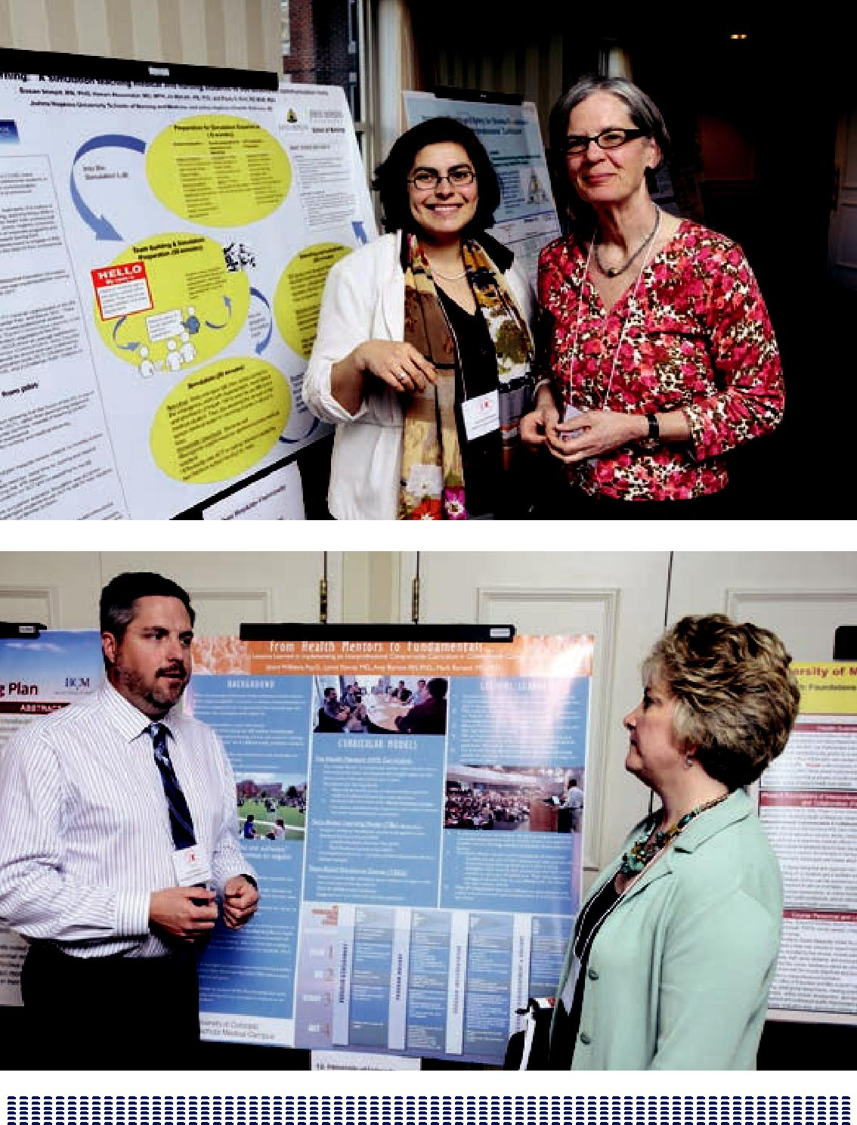

177

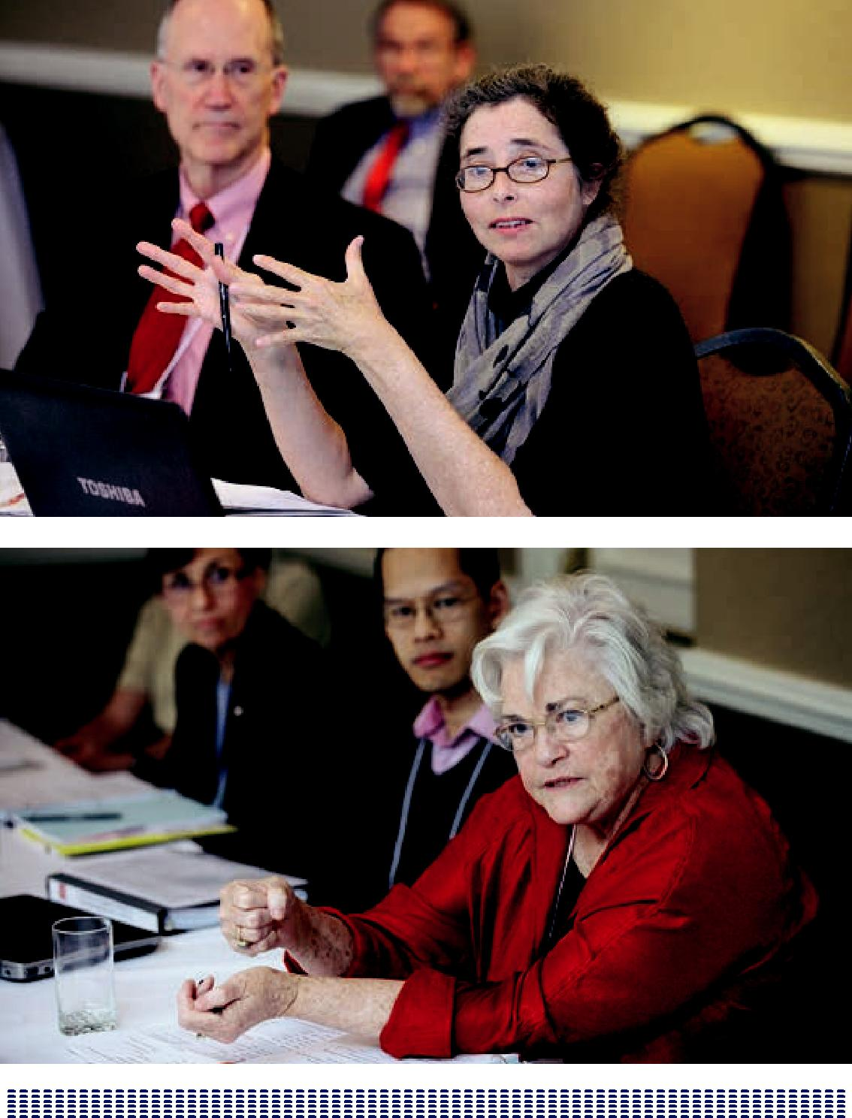

178

IMPRESSIONS LEARNED AND NEXT STEPS PANEL

INTRODUCTION AND MODERATED BY

DAVID IRBY, PHD

Thank you, George. I am excited about being here. Every conversation, every session, every group meeting, and every meal has been an opportunity to learn more about IPE. I am amazed at the amount of progress that has been made in two years since the Macy/Carnegie Conference was held in Palo Alto.

Each of our panelists will have 10 minutes to share their impressions of what they heard, lessons learned, and future directions. We have asked them not to be reporters but to share their wisdom. Before they do so, I would like to comment on four things that I have observed: the importance of leadership and funding, the importance of common values and identify formation, the significance of faculty development, and some opportunities for inquiry and discovery.

First, we have seen the importance of leadership, vision, investment, and reform. What my predecessor Abraham Flexner was able to do so ably was to write with brutal honesty about medical education and to direct millions of dollars from the Rockefeller Foundation to transform medical education. In a similar manner, we are all here because of the vision and the investment of the Macy Foundation in providing many seed grants to trigger innovation in IPE. We have George Thibault to thank for his vision and the generosity of the Macy Foundation.

We also heard about the leadership, vision, and innovation at the VA. Through Malcolm Cox’s leadership and persistence, the VA has funded some important innovations in IPE and workplace redesign. These will continue to be experiments that have the potential to change health care delivery and health professions education nationally. Leadership, vision and funding make all the difference. Please join me in a round of applause for Malcolm and George.

179

My second point has to do with identify formation, which came up in group after group. One’s identify is formed, in part, by the values enacted by the group of which you are a part. Don Berwick reminded us of the importance and the power of strong values. Specifically, he challenged us to focus on placing the patient first, serving the most vulnerable, and committing to continuous quality improvement, and cost reduction. We can be united across health professions in our affirmation of these core values. But, these core values are often sacrificed on the altar of stereotypes about other health professionals. I am reminded that research on excellent teachers reveals that they create learning experiences that trigger preconceptions and stereotypes in order to make them visible enough to examine, confront, and change. We need to create learning opportunities that enable examination of our core values and our preconceptions in order to grow a broader sense of professional identity across the health professions.

I recently read the book The Power of Habit by Charles Duhigg. He tells the story of a troubled young man who came from a broken home, had major anger issues, was thrown out of school, and was fired from multiple jobs. Finally, he went to work for Starbucks where he received training in new habits of communication with

difficult customers, and it changed his life. Starbucks gave him practice in using new scripts that enabled positive communication in difficult situations. Learning these new habits turned his life around. This is exactly what identity formation is about— helping our students learn new habits of communication, negotiation, and problem solving across professional boundaries in often difficult situations. These new scripts become part of who they are, empowering relationships of trust, respect, and collaboration.

My third thought has to do with faculty development and pedagogical content knowledge (PCK). Our Carnegie mentor, Lee Schulman, coined this phrase. He asserts that great teaching is achieved not by knowledge of content, knowledge of learners, knowledge of curriculum or knowledge of pedagogy alone but the integration of all of these forms of knowledge. PCK is the ability to teach particular learners at their level of development the key content needed for them to advance

to the next level of understanding. PCK is what we must share with our faculty, whom we expect to teach IPE in instructionally powerful ways but who may not currently be able to do so. Both content and pedagogy must be learned together.

Faculty are the most costly component of the whole enterprise, and it has been interesting to see how various universities have attempted to reduce that cost through the use of technology, online learning, and team-based learning. In some

180

cases, this has reduced the number of faculty members needed to facilitate small group instruction from 50 to two or three. We need to learn more about how to use our faculty most effectively and efficiently.

Finally, it was interesting to see how discontinuity degrades both education and patient care. The VA examples of workplace redesign showed how keeping people together longitudinally for an extended period of time can improve learning and care.

Regarding future directions for discovery, we need more research in order to determine what is the appropriate dose of IPE, where it should occur in the curriculum, and how much longitudinal clinical immersion is required?

Understanding answers to these questions will advance the work and direct future innovation.

At the conference, three different models of how to teach IPE were presented. The first model is to directly focus on and teach interprofessional competencies, such as communication skills, team management, and understanding of the roles and responsibilities of the various professions. This is the direct approach and occurs primarily in the classroom. The second model is to teach common core content in a more efficient way by putting all health professions through the same instruction. Examples include ethics, quality improvement and patient safety, and disaster management. This often occurs in the classroom, where IPE is a byproduct of learning together. The third model is clinical immersion and learning in the workplace, which can happen in a variety of ways. The VA, among others, offers an excellent example. We heard also about the importance of putting together educational reform and practice redesign, which in my opinion is the direction of the future. We need to look at each of these three models of how to teach IPE and evaluate them carefully as we move forward.

In conclusion, we have talked about the importance of leadership, vision and funding; the relevance of identity formation; the significance of faculty development; and opportunities for discovery. I would like to close with a quote from our distinguished colleague, Rita Sharon, who at the beginning of the conference challenged us “to be creative and engage in the work of discovery because we have no way of knowing how good it can get.” Indeed, we have no idea about how good it can be!

Now, let me turn it over to our distinguished panel. Patricia Benner is professor of

181

nursing at UCSF, author of numerous works on nursing expertise, and co-author of the Carnegie book Educating Nurses; Linda Headrick is Senior Associate Dean for Education and Professor of Medicine at the University of Missouri, Columbia where she has implemented an innovative curriculum on quality improvement and patient safety; Mattie Schmitt is Professor Emerita of the University of Rochester, and has worked for over 30 years on interprofessional collaborative practice; and Molly Cooke is professor of medicine, director of the Academy of Medical Educators, and co-author of the Carnegie book Educating Physicians.

Panel Discussion and Q & A

Participants:

Patricia Benner, RN, PhD, FAAN; University of California San Francisco Molly Cooke, MD; University of California San Francisco

Linda Headrick, MD; University of Missouri

Madeline Schmitt, PhD, RN, FAAN, FNAP; University of Rochester

THE FOUR SENIOR FACULT Y

Molly Cooke, MD

My practice has really always been interprofessional from my resident clinic, which actually worked quite well at San Francisco General Hospital lo these many years ago, where I worked particularly closely with nurses and social workers. I from there went to the HIV practice at San Francisco General, which was highly collaborative and highly interprofessional, but I am not a true believer in interprofessional patient care or IPE per se. I’ll come back to that point toward the end, but on the way I think that part of my skepticism frankly has come from some quite unsuccessful, even painful, experiences trying to make people work together in interprofessional kind of format. That has led me to think about what I’ve heard over the past couple of days and try and reconcile it with my experience. So that’s what I’m going to do next.

In the HIV practice at San Francisco General, this was not an IPE undertaking per se. It was organized around the patients and what they needed. There were pharmacy students, medical students, medical residents in the setting as well as nurses and social workers. I think people learned a lot about interprofessional collaboration

182

in that setting. Certainly I did, and a feature of that practice actually came up in breakout three that I sat in on earlier today when we had a piece of conversation that wondered whether the wholesome issue was the “education” part of IPE or the “interprofessional” part of a well-functioning collaborative environment in which some people might be learners and other people might be more mature

practitioners. That was certainly the case in this HIV setting in which I learned a lot of my skills.

A project that I was involved in that did not work particularly well was an intentional IPE extramurally funded project that we undertook at Mount Zion Hospital focused on the care of diabetic patients.

The more completely the project or the site is implementing Patient Aligned Care Team (PACT) the better it seems to work as an educational experience for interprofessional learners. This may have a lot to do with whom the primary

beneficiary is intended to be and is experienced as being by the participants. Is this an experience in which the learner is intended to be the primary beneficiary, or is this an experience in which the patients being cared for by an IPE team is the primary beneficiary? There may be an important world of difference between

those two kinds of experiences and that has to do with the real world context of the learning experience.

A paucity of theory characterizes innovation in medical education in general. IPE practitioners tend to be creative people full of good ideas who are often more energized by their creativity than by a very strong sense of a theoretical underpinning or even a particularly informed understanding of previous related

work. IPE practitioners should try and correct the tendency to be a bit a-theoretical. There is a lot of relevant theory, particularly in the set of sociocultural realms of learning.

Learners who have experienced IPE say they leave their programs for ordinary jobs that connect to the concept of professional identity formation. But it’s not enough to produce that effect for 100% of the learners all the time. That’s because those who are most passionate about education are often the most naïve about the flow of funding and how financing works in the world of education. IPE is at a point where that naivety is dangerous. Educators need to understand finance and financial forecasts such as the prediction that 10 years from now GME (graduate medical education) may well have no funding.

183

IPE faces a number of major issues that are all related: scalability, dissemination, and sustainability. They’re different aspects of the same fundamental problem and relate back at least in part to the financial naivety that has too long been a part of the field. Some of these really impressive innovations are taking place at the VA in association with major academic institutions rather than the university clinical programs of major universities. These are disruptive innovations, and least likely to happen in settings where people are the most confident that all is in steady shape.

IPE can also look to the extraordinary work that’s being done at Geisinger and Kaiser Permanente and look for new partners—even partners that may seem on occasion to be strange bedfellows—and even look to academic colleagues. Often those who are imbued with a kind of “we try harder” spirit are able to bring about most creative change.

For their own sake, leaders also need to revisit why they are striving to create IPE environments and what is the moral foundation for this work, hopefully which is making the care of the patients better. IPE’s innovations need to be put to the test. That’s the test that we need to be putting our innovations to: is interprofessional care the right thing for every patient. It may not be. IPE should be relaxed about the prospect of patient settings that don’t need to be interprofessional at all and cultivate an ability to discriminate between situations where interprofessional care and IPE add real value and those where they are but extra work, added cost, and extra complexity.

Patricia Benner, RN, PhD, FAAN

One of my “a ha” moments at this conference was the repeated theme that the patient has to be on the team and that patient care—improving the quality, the safety, the experience, and lowering the cost—is essential. Perhaps IPE leaders have been very profession-centric and have indulged often themselves with oppositional thinking. Now, all are engaged in clinical reasoning about the patient for the good of the patient.

What happens when the rhetoric becomes so political and so detached from the notions of good that it’s hard to have an authentic conversation? Frankly,

professional goods are often related to adversarialism, competitive individualism, and status gain. No one profession has a corner on all the knowledge or all the skills. Knowing what is important but knowing how and when is also important. In professional education, educators haven’t valued as much learning to use

184

knowledge as they have valued knowledge acquisition. It seems every profession has dug itself into the hole of a practice education gap where very complex practice institutions are now learning organizations. The field is a position of playing catch up. Providers and hospitals have no need for more differential diagnoses or more complex decision-making.

IPE needs to switch its model of professionalism to civic professionalism. The United States can’t have a democracy without having good professional classes who are engaged for the good of the society; for being responsible and behaving well in meeting the needs of the underserved and providing education and providing health. IPE has to resist the language of business case only or consumerism. Even Madison Avenue wouldn’t have come up with a product line called cancer. Suffice

it to say that nobody wants to buy that product line. IPE needs to mindful of an inauthenticity that occurs when the field borrows language inappropriately.

William May wrote an article that conveys how much we build in adversarialism into professional education. Educators are supposed to always think critically, but as professionals they need to have a way to act and a place to stand. That place to stand is, of course, the patient-centered care. All professions have the same goal for the well being of the patient. But what if IPE was all about teaching each one of the professions the multiple perspectives that the other profession brings to the patient care situation? So instead of imagining every perspective can be integrated into one monolithic framework, recognize that multiple frames of reference are

needed instead. Educators need to understand the family, the life world, and have a language for caring for the suffering.

Left to our own devices of being professional-centric, we get caught up in a kind of bad moralism-sentimentalism where we’re talking about the patient but not standing alongside the patient. So we have to seize the opportunity with IPE to hold on to these central values of well being, lowering cost, and improving quality, which is what IPE is all about. We don’t have to engage in power struggles, status inequity and/or status mongering. We can be authentic about the care of the patient. One of the take-home lessons from the IPE groups was that students like that IPE is about the patient. Their training is not just about processes, about decontextualized learning or even about communication—but rather the good of the patient. That’s an important kind of transformative approach in education.

It’s easy to ask what’s in the dose of IPE or how much, but the more important question might be what to do with the dose and what to include in it. What effective

185

ingredients does the dose have, and what does it accomplish and how can it be more synergistic? Nursing for example desperately needs to develop a more longitudinal view. When HIPAA came in, we suddenly had experts in HIPAA because students could in their program have about 12 different HIPAA trainings, and so HIPPAA loomed large in their professional careers. There is no reason why the clinical can’t be rearranged to allow for more longitudinal experience.

The systems in which care is delivered are so complex that just switching students around to multiple sites doesn’t really provide an in-depth learning experience. If health care is going to do well with dispersion and the scalability, IPE will need to become the new paradigm of focus on the patient. IPE is going to have to go for a shared identity with more mutual trust and more focus on caring across time about particular patients, families, and communities—and keeping track of those changes.

On the research front, IPE needs to look more carefully at evaluations and outcomes and at the same time remember that the rethinking of professionalism is new to IPE. What does it mean to become this new kind of professional who focuses on quality improvement, and on the patient and safety? This is a complete reversal of years of the profession being focused inward. IPE leaders have a lot to learn from each other. The field can certainly regain some of the moral ground and some of the wisdom with a shift in focus to learning from one another and using one another’s capacities to deliver better care to the patient.

Linda Headrick, MD

First, I’m going to reflect on the past by talk about a theme that I heard clearly in this meeting and that’s already been mentioned a couple of times. Then, I’m going to talk about the future and give a bit of a challenge for the future. Perhaps the next Macy meeting on IPE can be about that, which I think we should be working on next.

It was personally very meaningful to me to have Don Berwick address this group, as he is the reason I became involved in IPE. In 1992 and 1993 (the early days of the Institute for Healthcare Improvement), I was a junior faculty member interested in quality and safety, which were both relatively new concepts in health care. The IHI was interested in education for quality and safety, just as they were equally interested in making changes in health care organizations. So they reached out and found me in medicine, a junior faculty member interested in medical education and quality with the emphasis on medical education. They also found several nurse leaders at Vanderbilt including Linda Norman who is also in attendance at this

186

conference. And they recruited professionals interested in health administration, education, and quality. My very first grant as a junior faculty member was through the IHI regarding an aspect of medical education and quality that in the first place some thought was quality improvement in health care. We were already thinking about how to train people in quality improvement as part of their core professional preparation.

We were excited about these early conversations and wanted to do more, but Dr. Berwick as well as other IHI leaders said they would not invest in independent work but rather in collaborations. Not only did we have to figure out how to teach about this new field, and about quality improvement, but we also had to figure out how to do all this in an interprofessional way with nursing, health administration, and medicine in particular being the focus at that time. I was reluctant as IPE was not my first agenda. But we realized quickly, of course, that quality is an interprofessional team sport. As soon as you want to improve any aspect of patient care, the endeavors better involve all the others involved in order to achieve an effective and sustainable outcome.

In those early days, we asked very basic questions such as how do we do this education at all, and how can we do it in an interprofessional way? We recruited four sites that assembled teams of faculty and medicine, health administration, and nursing. Case Western Reserve University and Cleveland State University was one of the four, and some of that work, I’m pleased to say, is still going on in Cleveland.

Those teams worked together in their own place determining what might work in IPE and in quality and safety. The teams then convened and learned from each other. One of the things we learned very early and which has been echoed at this meeting, and that is the most engaging and enduring in many ways is that education occurs when benefits abound for patients.

When we had students involved in a theoretical study about quality improvement or observing other teams and learning about what those teams were doing, they

were short on attention. They felt like they could add something to the improvement of care that was going on in their communities, and indeed they did. There was

all kinds of evidence that showed that even young, fairly inexperienced students when put together in teams and matched with professionals in hospitals, in clinics, in urban environments, and/or in rural environments, could meaningfully contribute to the improvement of care, and at the same time carry away transformative lessons that changed who they were and the way they regarded themselves as health professionals.

187

The other take-away message we learned as part of that experience and which Patricia Benner has mentioned so eloquently is the power of placing the patient at the center for interprofessional work. We saw the interprofessional issues, if you will, melt away as we came together around the patient, around the care we were trying to improve, and found that we needed each other to achieve what we wanted to achieve. And had we not put the patient at the center, we would not have learned how to respect each other and work together. And this dynamic has been echoed in other sessions throughout this conference.

Malcolm Cox’s slide showing the patient in the center and caring and learning reinforcing around the patient is core to IPE—and where IPE needs to focus its endeavors. We need to figure out how to build a best practice that explicitly integrates learning and learners at all levels in both the delivery and improvement of care. We’ve seen some examples of that at this meeting. Case in point: the VA example presented involved fairly advanced learners. But consider the more junior people. Is it possible to include the medical students and the nursing students in those new practice environments?

At Colorado, the work has started at Children’s Hospital with senior medical students (as a core part of their senior acting internship experience) and senior nursing students working together on improvement in a meaningful way as part of their regular core experiences. At Missouri, nursing and medical students also work together in their core required internal medicine clerkship and in the core required medical nursing experience to understand about falls risk, and to teach patients about falls risk in a way that patients regard as most helpful. These students will carry these kinds of lessons with them the rest of their lives. And we need to build on and expand these types of experiences.

We need to design learners in both the care and learning because if we design a best practice without including the learners and then try to add them in later, that’s not going to work. These are complex systems that need to be clear about the aim, and if they’re designed originally with the aim only involving finished professionals involved and not the learner’s aim as well, the programs are not going to function very well and will be costly. The challenge is how to concurrently achieve both care and learning centered on the patient.

Three aspects will help with this and all three have been described throughout this meeting. One is partnerships between practice and education leaders. The second is to have those partners working with shared practice and learning measures.

188

The third aspect is how to design practice settings that explicitly includes the learner in both the delivery and improvement of care. The only way we’re going to figure that out is by testing, measuring the results, reflecting on them and trying again. These are the three components on which to focus: the practice and education and leaders and partnership, shared practice and learning measurement, and experience and reflection that lead to improvements. I hope that some of us will go home with that challenge.

Madeline Schmitt, PhD, RN, FAAN, FNAP

I’m realizing that where this all started for me is almost 50 years ago. Others are sharing personal stories, so I thought I would start with my personal story that begins when I was an undergraduate nursing student, and had a short-term clinic assignment in an old-fashioned hospital outpatient clinic. I connected with an 18-year-old young man who in those days had what was called brittle diabetes and who was under the care of a physician in that clinic.

So what did I do as a nursing student? There wasn’t much by way of deliverables in that clinic. I didn’t need to do a lot of things nurses typically do at bedside, so instead I sat down and I started talking with this young man. I learned a lot about who he was, what mattered to him, and how he was managing or not managing to live with his diabetes. His physician who in turn called me into the examining room observed my conversations with the patient. He told he had been observing and

asked what I had been doing. I explained to him what I was doing—and remember I was a junior nursing student. He listened to what I said, and then proposed that we make a deal that before he calls in this young man, that I come in and tell him what I had learned. And would I then see the patient with him.

I’ve been reflecting on this experience in relation to the messages we’ve been hearing about what IPE is. My experience was in a practice setting and across professions. And in retrospect, how profound for an attending physician to reach out to a junior nursing student. But what united the two of us was care about that patient. And there was a partnership between my educational mentor and that physician. What I didn’t know at the time and learned later was my nursing mentor was Josephine Craytor, who was one of the national pioneers in oncology nursing. At the time, she was working on a Master’s degree on team-delivered care, and was rounding with medical oncologists, surgical oncologists, and radiation oncologists in collaborative care.

189

That was in 1963, and now for the longitudinal part. My mentor saw this episode as a successful learning experience for me as well as a win-win situation for the patient and others involved. As a next step, she asked if I would like her to create a special learning experience for me in my senior year. And so I spent a semester in that clinic working with that patient and the same physician. I was asked to write a reflective paper on my experience that was reviewed and critiqued by both the physician in and my nursing mentor. I still have that paper. So for me, that episode was a profound experience, and I never thought about care in any other way from that point on. And as the years passed, I had numerous opportunities to go back and reinforce that learning in many ways. I started with that story because I realize now how much of what we’ve been talking about was captured in that seminal experience.

And here are my general impressions about the conference in context of the progress we’ve made here together.

We heard the big picture about practice change and challenges related to the what and how from Don Berwick, and we heard from Scott Reeves about the science of IPE, where we are and what our challenges are in that arena and what the next steps are in moving that agenda. As I’ve reflected on these, I perceived a gap between the big picture that Don Berwick painted on the practice side and Scott Reeves’ review and challenge to us on the science of IPE. The conference in between then and this morning in our breakouts was a lot of drill down. We used pedagogy, but I think the appropriate word is andragogy, a word I learned from Dewitt Baldwin Jr. It was an exercise for all of us in the drill down into the andragogy from many perspectives: all those themes that got organized in our breakout sessions.

So I will bring us back to a bigger picture and think about examples of how practice is changing toward more teamwork and team-based care and address the myriad safety and quality challenges and the system transformations that we’ve heard about.

We’ve made a progression here. We started with the big pictures on both sides. We did some drill downs. We’re now back to the challenges that lie ahead for us as educators committed to the interprofessional agenda.

So lessons learned. In the drill downs, we learned about progress on the andragogy side and that we have still a lot of work to do. We’re making progress, as Scott Reeves summarized so well. At the micro level, we have some best practices

190

emerging. We’re thinking about:

- staged learning

- better assessment

- faculty development and rewards

- the organizational infrastructure allowing all this to come together.

We know we’re at the Kano-1 level where we’re working on fixing deficits, but trying harder is not good enough. We have to move up the ladder to Kano-2 and Kano-3. We are in a time of majestic change. Berwick basically said the other half of the picture is up to us to figure out. And he laid out a path that I thought was very profound for us in raising up what that education side looks like. Don Berwick also talked about health care as a human right.

So when we were thinking about our charge as focusing in on the drill down related to team-based competencies, we immediately said, well, we are married to patient centeredness. Without that focus, we shouldn’t be in the business of teaching IPE in practice. And we agreed that we all need to learn how to practice from an evidence base, but what does that mean for teamwork? It means we need to constantly review the evidence for what it means to work well together and integrate that into improving the way we work. Informatics gives us a whole set of new communication opportunities, and quality improvement is about constantly looking at and improving what we do together.

One of the gaps between the big picture on the practice side and the technical approaches to the pedagogy is what we’re teaching. What is the content? This was the question we were trying to address when we worked on the core competencies. What is it that we need to be teaching? We had the benefit of other competency frameworks that had been developed.

I think back to my story. I felt mutually respected and valued as a student; a junior nursing student, when I was asked to share what I was learning. So we have to start from that base, the values base as well as the other core competencies and the values and ethics. A great deal can be learned about interprofessional ethics.

Talking to each other about our roles and responsibilities is complicated. It’s contextual. What staff nurses described as that fundamental part of their role is very

191

different than what nurses might describe their role in many other settings or in other kinds of situations.

Then the third one. We have communication, roles and responsibilities, the teamwork and team-based competencies. There is a difference between teamwork competencies, which we need all the time because we work together all the time, and team-based care. I spent most of my career studying team-based collaborative models and team delivery; team-based delivery is not an easy delivery mode. You need additional skills beyond those fundamental teamwork skills to work in effective teams. So you get a sense in the core competencies report of what we felt was fundamental content, and we also understood that that learning needed to occur across the lifetime of our work together from prelicensure all the way through to all the continuing education that we do.

Now for what I consider our challenges to be. One is a transformed educational system for health care and what that would look like. What would it mean for us to really transform our educational systems?

We’ve learned that our systems of education need to be more integrated across the learning continuum. We have very few continuing education voices at this conference, but the continuing education leaders are very interested in joining this dialogue and working on a continuum of learning.

Second, we hear that education needs to partner with practice. What does that mean on the education side? More silos to move across. Is there going to be a conversation between education and practice about how we can create better clinical learning? As of now, practice deals with physician placements, medical student placements, nursing placements, and social work placements all separately. What would it be like on the education side if we figured that conversation out among ourselves first and went as a group of interprofessional educators to clinical practice settings and said in concert what we want our learners to learn together? That’s the challenge I see for us as educators. We come to practice partners with one voice about what we want learners to experience in clinical training, and we single out sites where we know they can learn. We want our learner to learn like I did: in the setting where care is delivered. And we know already from the education side that the clinical setting provides the most powerful learning.

As Molly emphasized, it’s dangerous for educators not to understand the realities of practice. So how do we do that as educators? How do we stay in touch with the

192

realities of practice? In a lot of places, there are big silos between education and practice. And many educators I know don’t do much practice anymore and don’t pay attention to a lot of the realities in practice.

I was reflecting on my own experience at Rochester because I grew up in a very collaborative environment and spent 34 years full-time as a faculty member there. We were privileged to have Lee Ford as our dean for 16 years. For those of you who don’t know, Lee Ford and Henry Silver cocreated the nurse practitioner model, and Lee’s focus was on faculty practice. In the early days, we were charged with the expectations: the Triple Aim in a different way. We were educators but stayed embedded in practice, and engaged in research. In our model, nursing chiefs interfaced with medical chiefs in pediatrics, medicine, and so forth.

So faculty practice was one way by which we stayed in touch with the realities of practice. Some colleagues volunteer and take care of the poor and underserved as a way to stay connected to the realities of practice in a significantly profound way. Another way is by mentoring students in student-run clinics. But the question remains for us on the education side as to how we stay in touch with the realities of practice so we are still able to create meaningful learning experiences.

What are our cost issues in education, and where are those wedges Don Berwick referenced? It’s not one answer but rather a series of answers. And one of those answers might be the efficiencies gained by recognizing that much of the content taught in silos could be taught together more efficiently.

Several years ago, a study on geriatrics content reviewed curricula across the professions and discovered that 65% to 70% of what was taught about geriatrics was the same across the interprofessional spectrum but was all being taught in silos. So think where the cost wedges are for us, and what that kind of common learning can bring to cost containment and how we might rethink how we share education costs across the education practice continuum. We’ve got a challenge on the education side to look in our own houses first for those cost-saving wedges.

Another challenge for us as educators is to consider would it look like to do patient-centered health professions education. Can we have this discussion in a much more public way—public discourse about what transformation in health professions

education looks like, and in that public discourse and in a more unified voice can we add to the voices who are pushing the practice changes? Can we align ourselves in that way so that as we’re transforming our educational enterprise together we

193

are adding our voices to the push to get to a different place in how we take care of people?

DR. IRBY: Common themes were the value of putting the patient first, providing students with authentic experiences with patients, and creating best practices in the clinical setting. All of this relates back to Malcolm Cox’s slide that places patients at the center and surrounds them with care and learning. We have seen three different models of IPE at this conference (IPE competencies, core content, and clinical practice redesign). What if we were to take seriously placing the patient first, how would we push those models going into the future? What difference would that make to each of those? Linda, let me start with you because you have wrestled with this across the continuum and have tried to address this. Which of these models have you used and found helpful?

The three models being 1) IPE by itself for itself, 2) common core content that you connect with IPE, and 3) education and clinical practice redesign.

DR. HEADRICK: That’s a provocative question.

Provocative comes to mind because of conversations I’ve had with those from primarily an IPE point of view and those who come to the conversation from primarily a quality improvement point of view. In the early conversations where those communities were coming together, there was a little bit of a “tug and pull”: where the quality improvement persons were questioning the IPE persons as to the point of their efforts. The IPE persons said if the focus isn’t on the teamwork and the needed collaboration, then something is going to be missed. I think the answer is to have both: the quality improvement requires the IPE. IPE requires a focus—a meaningful, authentic reason for doing the work—but if you don’t reflect on that which could be quality improvement or other aspects of care, you’re going to miss the opportunity to create better health care.

The practice redesign piece seems to be the one we know least about and which we need to work on next. We need to find places in which we can integrate learning and care together in the context of where care actually takes place, whether in

a family medicine primary care clinic, an internal medicine inpatient unit, or an emergency room.

DR. BENNER: I think we need all three approaches. The challenge is going to be to integrate education and service without going back to a situation where education is

194

only “on the job” training or at the mercy of the demands in the profession. Frankly, medical education is running into that situation now with residencies where the organizational work demands that we supersede education. We have to be careful in our strategic integration that we serve both the patient as well as the education needs of those being trained.

DR. SCHMITT: Both quality improvement and patient safety are essential, but the way that happened initially was interprofessional but with no reflection on learning how our work together made that happen. And to be noted is that the Affordable Care Act has created opportunities for dialogue in areas other than patient safety.

The greatest challenge is the system redesign, found myself asking a couple of questions about that. I’ve actually studied models outside the VA, but they’re discrete models sitting within larger systems that don’t necessarily support or embrace the fundamental ideas behind those models. We’ve learned over and over on the practice side that in geriatrics, in hospice and palliative care, that critical care teamwork matters a great deal in outcomes. But why has it taken us so long for IPE leaders to raise that to the system level? That’s a big culture change question, and one that requires a different level of leadership. Fortunately, the field has system leaders who are addressing this question and who have spurred a massive culture change wherein these smaller models now fit the larger structure. On the education side, the dialogue between education and practice is a different level of thinking showing the impact of interprofessional teamwork together at the large system level. So I agree with Linda that one of our big next challenges is to understand what really comprises transformative changes in the system.

DR. IRBY: Building on that, Don Berwick reminds us that this sort of metaconversation is actually happening nationally in regards to health care reform. Berwick asked where were the advocates and voices in this public dialogue about what’s working, what’s important, and what’s transformative. Though we’ve heard examples here, it’s difficult to identify a public forum within which we can advocate and initiate change.

DR. BENNER: The kind of advocacy we’re trying to achieve in health care is one that focuses on the goods. At the same time, it’s encouraging that so many different health care groups want reform from within health care. I belong to the group that’s working on more compassion in patient care. And suddenly we’re in this situation where indeed we are spending enough money. If we were doing it well and doing

195

it right, we could deliver a high level of health care. So something has gone awry in the multiple motives that have come in and distorted the conversation.

So how do we clear up those multiple motives so that we’re not spending so much in administrative costs to deliver care, that we’re not so focused on the unionism part of the professions, and that we’re really focused on recovering the goods that are in the civic tradition of professionalism?

And without a focus on the civic tradition, we’re going to have a kind of empty managerialism. That’s not the direction we want to go. We don’t have a lot of time to transform the systems, but we need to do it now. I feel encouraged by the conversations I’ve heard. I felt encouraged here with the shared vision for making the health care system better and making it more humane and more cost effective. When our health care system is causing bankruptcy we know we’re in trouble. We can’t continue the way we’re going, and if we wait for the change to come from without, we’re not going to like the changes that we get. We must become real activists and advocate.

DR. SCHMITT: There are two different kinds of answers to your question, and in raising that question, you’re moving us up to another level of policy discussions. I have two reflections. One is that IPE has returned in a big way. And I’m glad I’m

still alive to see this come back. So many potential partners are emerging in the IPE arena that forces us to sort out each of our roles in moving the IPE agenda forward. We each have expertise in the different locations from which we are to do our piece of that agenda. The second reflection is how do to engage beyond the education and practice partnerships that we’ve heard about. Where are the voices of IPE and the education practice partnerships that are so important in the profound dialogue that’s going on in the policy and financing world? How do we move the vision for the transformation that needs to occur?

DR. HEADRICK: We need to find all the groups that are trying to work on this and join those.

DR. SCHMITT: I know the tipping point. Those of us who have been here before now feel the energy and the companionship of so many people, but unless we can have those conversations at the highest levels, the momentum will wane, in spite of the fact that this time there more voices are championing the cause and pedagogies are better. The stakes are high.

196

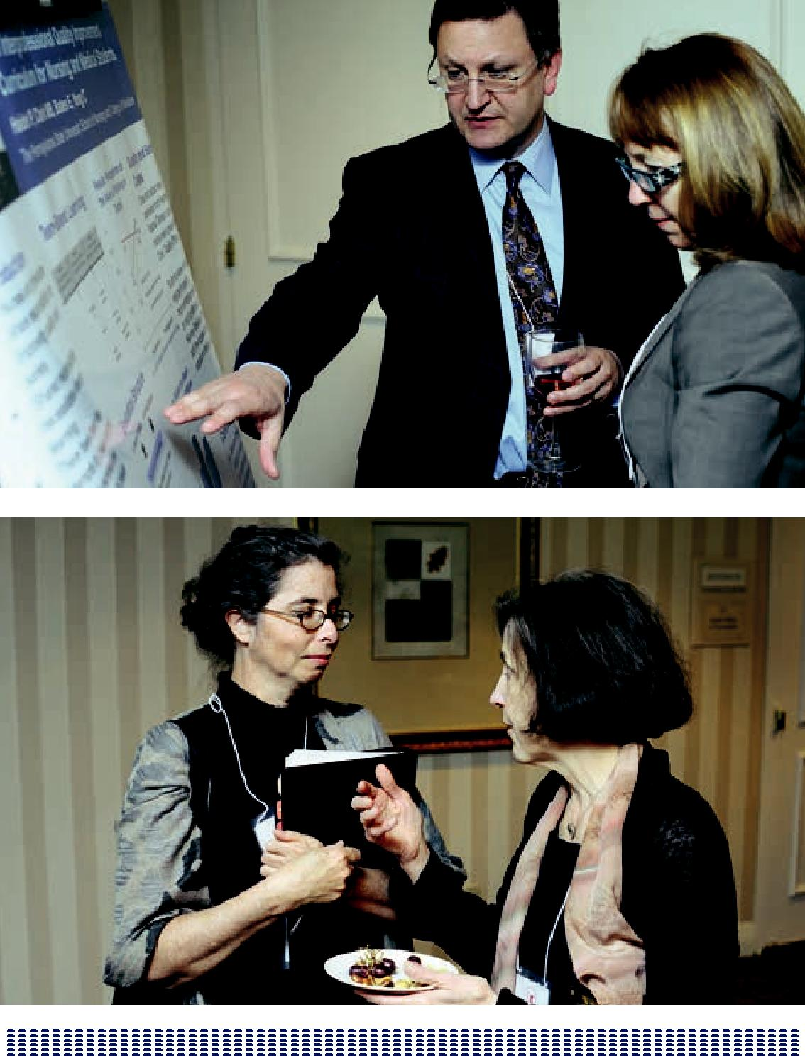

197

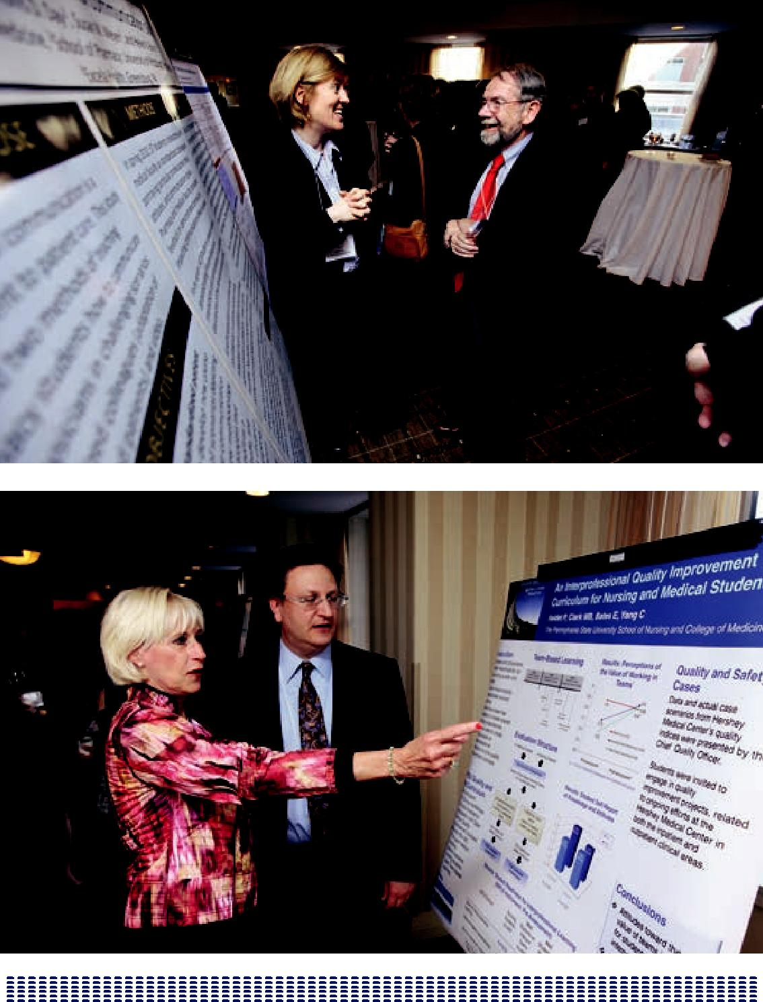

198

SUMMARY REMARKS

GEORGE E. THIBAULT, MD

You, the conference attendees, are at the vanguard of a very important movement.

The meeting has demonstrated that much has been much accomplished that is real, tangible, and authentic, but there is so much more to do. We have really only just begun, and the hardest parts are ahead.

Based on what I have heard, there are three things that will make up our collective work agenda going forward. The first is that we have got to make some choices. Letting a thousand flowers bloom works for a while, but it is time to begin to select what is scalable, reproducible, and generalizable in IPE and bring it to scale. Each of us needs to go back home, look critically at what we are doing and make those critical choices.

Second, we have got to get out of our own educational silos. We have broken down some of them by talking to each other, and this meeting has been a wonderful model for the kind of work that you have been doing. But we are still just talking to each other. This meeting was by design a meeting of educators; we have not been as good at having these conversations beyond our immediate educational groups. It is time to get out of our comfort zone and have these conversations with those leading our health care delivery systems. The VA gave us a wonderful example of what a system can do to bring together education reform and delivery reform. We can say that the VA system is special, and that it may be possible to make such changes in the VA and not elsewhere. But the VA can be a model.

The panel “Education/Delivery System Links to Promote IPE,” acknowledged the gulf that exists between the education and the practice worlds. I have been encouraged to hear that the conference has already sparked at least one

conversation between an education system and a delivery system. Let us commit to getting dozens of those conversations going about the common purposes and common goals that we share.

199

That brings me to the third part of our agenda. It was very clear to me in listening to Don Berwick that we have not done a good enough job of articulating the goals of IPE. Does the larger world of educators, delivery system leaders and policy makers know that IPE is really about the Triple Aim? It is about better patient care, better health, and lower cost. Even in our conversations among ourselves, we have not made that clear. We have sometimes acted as if IPE is an end in itself—to feel better about ourselves and to feel better about each other. That will not suffice.

All of us must be clearer about our message. Why are we doing IPE? We are doing this to make patient care better.

We are going home feeling good and having been energized by the people we have met and the discussions we have had. We have been validated and we have learned. This is important work that we are engaged in, and we have come a long way.

Now each of us must take responsibility for the tasks ahead. We can begin to look critically at what we are doing and make choices. We can begin those local conversations to bridge that gap between education and care delivery. We can be clearer in everything we say and do—the purpose of IPE is to improve the care of

patients. This is by no means time to rest on our laurels. The really hard work has just begun. As Mattie Schmitt has reminded us, we have seen the IPE movements come and go before. We know so much more now and IPE is so much more needed; we cannot let that happen this time.

Thank you all for sharing your work and your thoughts. I look forward to our ongoing work together.

200

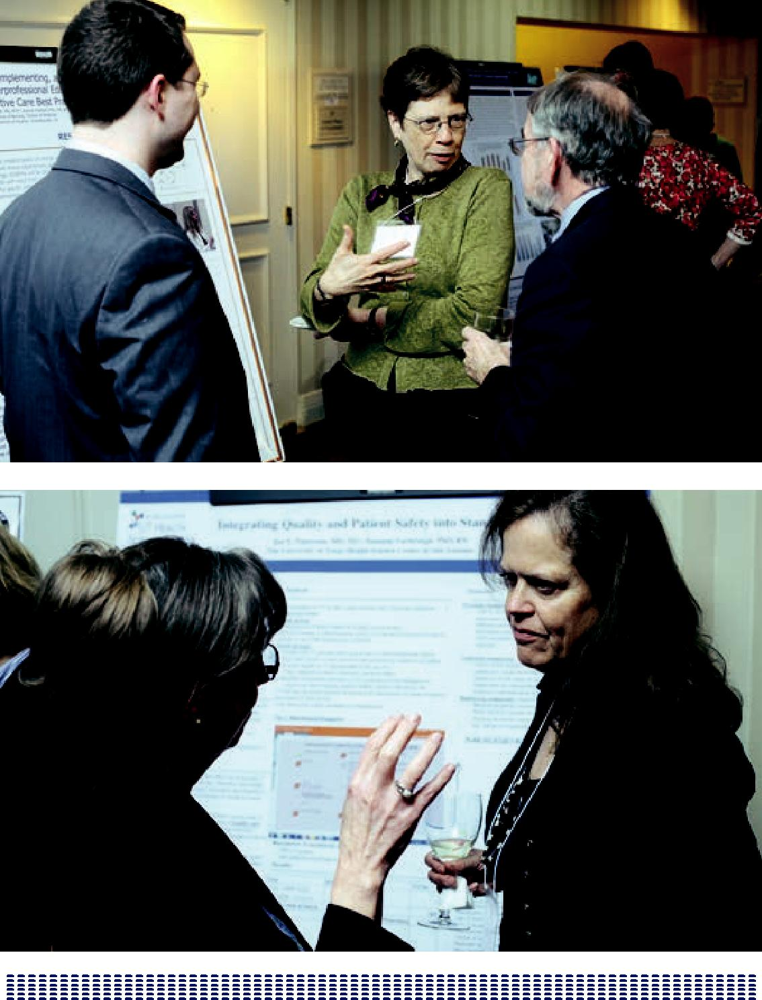

201

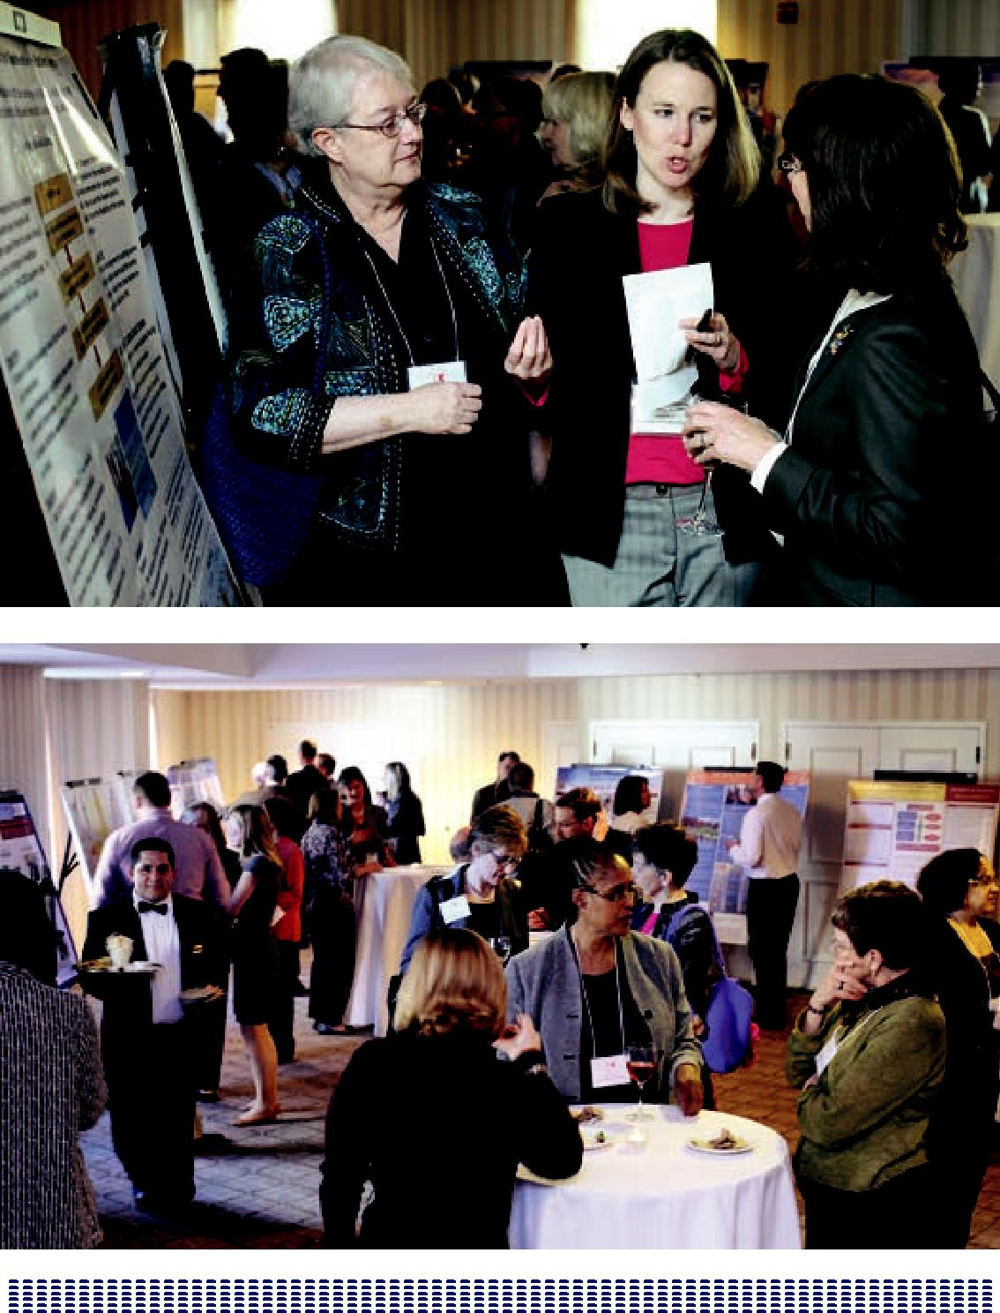

202

BIOGRAPHIES OF SPEAKERS AND FACULTY

Geraldine Bednash, PhD, RN, FAAN

Chief Executive Officer and Executive Director

American Association of Colleges of Nursing (AACN)

Since 1989, Dr. Bednash has served as Chief Executive Officer and Executive Director of the AACN, which is comprised of more than 700 member schools of nursing at public and private institutions nationwide and is the only national organization dedicated exclusively to furthering nursing education in America’s

universities and four-year colleges. In her role as CEO, Dr. Bednash oversees the educational, research, governmental affairs, publications, and other programs of the AACN.

Dr. Bednash currently serves as the chair of the Nursing Alliance for Quality Care, as a member of the Sullivan Alliance to Transform the Health Professions, and

as a member of the Quality Alliance Steering Committee. Additionally, she has been appointed to the Secretary’s Academic Affiliations Council of the Veteran’s Administration. Dr. Bednash has served on multiple boards and commissions including the board of the Friends of the National Library of Medicine and the advisory board for the National Coalition of Ethnic Minority Nursing Associations scholars development project, and the advisory board for the National Center for the Analysis of Health Care Data. Her publications and research presentations

cover a range of critical issues in nursing education, research, clinical practice, and legislative policy.

203

Patricia Benner, RN, PhD, FAAN

Professor Emerita School of Nursing

University of California, San Francisco (UCSF)

Dr. Patricia Benner is a professor emerita at the University of California School of Nursing. She is a noted nursing educator and author of From Novice to Expert: Excellence and Power in Nursing Practice, which has been translated into eight languages. She has directed over 50 doctoral dissertations. She pioneered the use of Interpretive Phenomenology in Nursing. She is the director of this Carnegie Foundation for the Advancement of Teaching National Nursing Education Study,

Educating Nurses: A Call for Radical Transformation, which is the first such study in 40 years. Additionally, she collaborated with the Carnegie Preparation for

the Professions studies of clergy, engineering, law, and medicine. Dr. Benner is designated as a Living Legend of the American Academy of Nursing. She was elected an honorary fellow of the Royal College of Nursing. Her work has influence beyond nursing in the areas of clinical practice and clinical ethics. She has received two honorary doctorates. She is the first author of Expertise in Nursing Practice: Caring, Ethics and Clinical Judgment (2010) with Christine Tanner and Catherine Chesla, and she has coauthored 12 other notable books including a 2nd Edition of Clinical Wisdom and Interventions in Acute and Critical Care: A Thinking-In-Action Approach.

Donald M. Berwick, MD, MPP, FRCP

Senior Fellow, Center for American Progress

Former Administrator of the Centers for Medicare and Medicaid Services

Dr. Berwick is the former President and Chief Executive Officer of the Institute for Healthcare Improvement (IHI), an organization that he co-founded and led for over 20 years and is one of the nation’s leading authorities on health care quality and improvement. In July 2010, President Obama appointed Dr. Berwick to the

position of Administrator of the Centers for Medicare and Medicaid Services (CMS), a position he held until December 2011. Dr. Berwick also served in a previous administration as a member of President Clinton’s Advisory Commission on Consumer Protection and Quality in the Healthcare Industry.

A pediatrician by training, Dr. Berwick served as Clinical Professor of Pediatrics and Health Care Policy at the Harvard Medical School, as Professor of Health Policy and Management at the Harvard School of Public Health, and as a member of the staffs of Boston’s Children’s Hospital Medical Center, Massachusetts General Hospital,

204

and the Brigham and Women’s Hospital. He has also served as vice chair of the US Preventive Services Task Force, as the first “Independent Member” of the Board of Trustees of the American Hospital Association, and as chair of the National Advisory Council of the Agency for Healthcare Research and Quality. Dr. Berwick is the author or co-author of over 160 scientific articles and four books.

An elected member of the Institute of Medicine (IOM), Dr. Berwick served two terms on the IOM’s governing Council and was a member of the IOM’s Global Health Board. He is a recipient of numerous awards, including the 1999 Joint Commission’s Ernest Amory Codman Award, the 2002 American Hospital Association’s Award of Honor, the 2006 John M. Eisenberg Patient Safety and Quality Award for Individual Achievement from the National Quality Forum and the Joint Commission on Accreditation of Healthcare Organizations, the 2007 William B. Graham Prize for Health Services Research, and the 2007 Heinz Award for Public Policy from the Heinz Family Foundation. In 2005, Dr. Berwick was appointed “Honorary Knight Commander of the British Empire” by the Queen of England, the highest honor awarded by the UK to non-British subjects, in recognition of his work with the British National Health Service.

George Wong Bo-Linn, MD, MHA, FACP

Chief Program Officer

Gordon and Betty Moore Foundation

Dr. Bo-Linn is the Chief Program Officer, San Francisco Bay Area (hospitals, nursing, science education, land conservation) for the Gordon and Betty Moore Foundation, one of the largest foundations in the United States. The program works with over 75 health care institutions including the Betty Irene Moore School of Nursing at University of California, Davis.

Dr. Bo-Linn was Senior Vice President and Chief Medical Officer of Catholic Healthcare West (now Dignity Health), one of the nation’s largest health systems. Dr. Bo-Linn completed his internal medicine training at the Johns Hopkins Hospital, a fellowship in gastroenterology at the University of Texas at Dallas, and a Master’s Degree in Healthcare Administration from the Carlson Business School at the University of Minnesota.

205

Judith L. Bowen, MD, FACP

Professor of Medicine

Oregon Health & Science University (OHSU)

Dr. Bowen is Professor of Medicine at the Oregon Health & Science University (OHSU) School of Medicine in Portland, Oregon, and serves as an Education Consultant for the Office of Academic Affiliations at the Veterans Health Administration Centers of Excellence in Primary Care Education. Dr. Bowen’s leadership roles in medical education have included chair of the education committee for the Association of Program Directors in Internal Medicine (APDIM) and director of APDIM pre-courses; APDIM Council member; APDIM representative to the national faculty development program for teaching in ambulatory settings; internal medicine residency program director for Virginia Mason Hospital and associate residency program director for primary care internal medicine for Oregon Health & Science University Department of Medicine.

Dr. Bowen was the director of the Society of General Internal Medicine’s PCMH Education Summit that addressed preparation of internal medicine physicians for leading teams and practicing in patient-centered medical home practices. Dr. Bowen developed and implemented a “teaching scholars program” for chief residents, fellows, and faculty in the Department of Medicine at OHSU. She also teaches

an interprofessional course for clinician-educators as part of OHSU’s Clinical and Translational Science Award. Dr. Bowen has received numerous teaching awards including the regional Society of General Internal Medicine (SGIM) Clinician-Teacher Award of Excellence and the national SGIM award for Scholarship in Medical Education: Scholarship in Educational Methods and Teaching; and the Dema

C. Daley Founder’s Award from the Association of Program Directors in Internal Medicine. In 2006, she was elected to the American Osteopathic Association.

Frederick Chen, MD, MPH

Senior Advisor

Bureau of Health Professions

Health Resources and Services Administration

Dr. Chen is Associate Professor in the Department of Family Medicine at the University of Washington School of Medicine and Chief of Family Medicine at Harborview Medical Center. He attended medical school at the University of California, San Francisco and received his MPH in epidemiology from the University of California, Berkeley.

206

After completing his residency in family medicine at the University of Washington, and during his tenure as a Robert Wood Johnson Clinical Scholar, Dr. Chen developed his research interest in health policy and medical education. He pursued that as a Kerr White Scholar at the US Agency for Healthcare Research and Quality and as an Atlantic Fellow in public health policy at University College in London. At the University of Washington, he has served as one of the lead faculty for the

medical school’s Underserved Pathway, as medical director for the Washington State Patient-Centered Medical Home Collaborative, and as an investigator in the WWAMI Rural Health Research Center. Dr. Chen currently chairs the medical school’s required course in health policy and serves as senior advisor to HRSA’s Bureau of Health Professions.

Molly Cooke, MD, FACP

Director of Education, Global Health Sciences

Professor of Medicine

University of California, San Francisco

Dr. Cooke is Professor of Medicine and the inaugural director of education for Global Health Sciences across the five schools (Medicine, Dentistry, Pharmacy, Nursing and the Graduate Division) at the University of California, San Francisco. Appointed in July 2012, her charge is to develop a portfolio of high-impact educational programs for UCSF students, residents, fellows, post-docs, and faculty members and to devise innovative and high-value ways to share UCSF’s expertise in discovery science, health care delivery, professional education, and basic science with international partners.

Dr. Cooke has been active in medical education program development and educational research throughout her career. A distinguished teacher, Dr. Cooke has twice received the Kaiser Family Foundation Teaching Award as well as a UCSF Academic Senate Award for Distinction in Teaching. In 2006, she was awarded the American Osteopathic Association/Robert J. Glaser Distinguished Teacher Award by the Association of American Medical Colleges (AAMC); in 2010, she received the Career Achievement Award in Education from the Society for General Internal Medicine. As a Senior Scholar of the Carnegie Foundation for the Advancement of Teaching, she co-directed a national study of medical education. This work culminated in the text, Educating Physicians: A Call for Reform of Medical School

and Residency, by Molly Cooke, David M. Irby, and Bridget C. O’Brien, published in June 2010 by Jossey-Bass/Wiley.

207

Dr. Cooke has used education and faculty development to address the health problems of underserved populations throughout her career. A founding faculty member of the internal medicine residency at San Francisco General Hospital–UCSF, she developed graduate medical education curricula focused on the care of the urban underserved, including community health and advocacy. She is the School

of Medicine’s liaison to UCSF’s regional campus in Fresno and, in that capacity and as a member of the San Joaquin Valley PRIME advisory board, is addressing health inequities in California’s Central Valley. She provided the educational expertise

for IDCAP, Infectious Disease Capacity Building Evaluation, a three-year project exploring cost-effective ways to build capacity among mid-level providers in sub-Saharan Africa funded by the Bill and Melinda Gates Foundation. She serves on the Training Advisory Committee of the University of Zimbabwe Medical Education Partnership Initiative (MEPI); the US partner institutions are the University of Colorado and Stanford University.

Dr. Cooke is a practicing internist with a special interest in HIV and other complex chronic illnesses. She has advised the American Medical Association, the American College of Physicians (ACP), and the AAMC on clinical care and ethical and policy issues in the HIV epidemic, and was a founding co-director of the AIDS Task Force of the Society for General Internal Medicine. She testified before both National Commissions on AIDS (1988 and 1990). She was a Department of Health and Human Services Primary Care Health Policy Fellow in 2004 and has been repeatedly selected by her peers as one of “America’s Best Doctors.” Governor of the Northern California chapter of the American College of Physicians from 2004 to 2009, she currently serves as a Regent and President-elect of the College. She will become President in April 2013.

Dr. Cooke is a graduate of Stanford University. She received her medical degree from Stanford University School of Medicine. She did her residency training at UCSF, where she also served as chief resident in medicine and did a Henry J. Kaiser Family Foundation Fellowship focusing on ethics.

Malcolm Cox, MD

Chief Academic Affiliations Officer

Department of Veterans Affairs (VA)

Dr. Cox is the Chief Academic Affiliations Officer for the Department of Veterans Affairs (VA), where he oversees the largest health professions education program in the United States. Previously, he was Chief of Medicine at the Philadelphia

208

VA Medical Center, Associate Dean for Clinical Education at the University of Pennsylvania, and Dean for Medical Education at Harvard Medical School.

During the past six years, Dr. Cox has led a major expansion of VA’s medical, nursing, and associated health training programs and an intensive re-evaluation of VA’s educational infrastructure and affiliation relationships. At the same time, he has repositioned the VA’s Office of Academic Affiliations as a major voice in health

professions workforce reform and educational innovation. Dr. Cox currently serves on the VA National Academic Affiliations Council, the Strategic Directions Committee of the National Leadership Council of the Veterans Health Administration, the National Advisory Committee of the Robert Wood Johnson Foundation Clinical Scholars Program, the National Board of Medical Examiners, the Accreditation Council

for Graduate Medical Education, and the Global Forum on Innovation in Health Professions Education of the Institute of Medicine.

Leslie W. Hall, MD, FACP

Senior Associate Dean for Clinical Affairs

University of Missouri – Columbia

Dr. Hall is the Senior Associate Dean for Clinical Affairs at the University of Missouri’s Columbia School of Medicine and the Chief Medical Officer for University of Missouri Health Care. He also has served as the Director of the Office of Clinical Effectiveness, overseeing quality improvement and patient safety initiatives throughout the University of Missouri Health Care. During the past few years, Dr. Hall has led several curricular innovations in the areas of quality improvement, patient safety, and teamwork in health care. Dr. Hall serves as co-chair of the Academy

for Healthcare Improvement Professional Education Resource Committee and has served as a physician advisor for Quality and Safety Education in Nursing. Dr. Hall is currently a co-principal investigator of a Macy Foundation grant to develop faculty to facilitate the teaching of interprofessional team-based care.

Linda Headrick, MD, MS, FACP

Helen Mae Spiese Distinguished Faculty Scholar,

Senior Associate Dean for Education, and Professor of Medicine University of Missouri – Columbia

Dr. Headrick is the Helen Mae Spiese Distinguished Faculty Scholar, Senior Associate Dean for Education, and Professor of Medicine at the School of Medicine at the University of Missouri in Columbia, Missouri. She leads a dean’s office team that

209

supports all aspects of medical education, from pre-admissions through continuing medical education. In that role, Dr. Headrick has enhanced the medical school’s internationally recognized curriculum by emphasizing quality improvement and teamwork.

In 2009 and 2010, Dr. Headrick was the faculty lead for “Retooling for Quality and Safety,” an Institute for Healthcare Improvement (IHI) initiative supported by the Macy Foundation. “Retooling for Quality and Safety” engaged six competitively selected School of Medicine and School of Nursing partners in implementing innovative methods to integrate health care improvement and patient safety content into required curricula. Currently, Dr. Headrick is the chair of the Associate for American Medical College’s Teaching for Quality (Te4Q) initiative, with the goal of ensuring education in quality and patient safety (including interprofessional education) for the next generation of physicians.

David M. Irby, PhD

Professor of Medicine

University of California, San Francisco (UCSF)

Dr. Irby is professor of medicine and until recently the vice dean for education and director of the Office of Medical Education in the School of Medicine at UCSF. He is a former senior scholar at The Carnegie Foundation for the Advancement of Teaching, where he co-directed a national study on the professional preparation of physicians, Educating Physicians: A Call for Reform of Medical School and Residency.

Recognized for his research on clinical teaching and leadership in medical education, Dr. Irby has received awards from the Karolinska Institutet, the Association of American Medical Colleges, the American Educational Research Association, the National Board of Medical Examiners, Harvard Medical School, Graceland University, and Vanderbilt University School of Medicine.

Maryjoan D. Ladden, PhD, RN, FAAN

Senior Program Officer

Robert Wood Johnson Foundation

Dr. Ladden, a nurse practitioner, is a Senior Program Officer at the Robert Wood Johnson Foundation working on the Human Capital Team. Prior to joining the Foundation, she served as interim Chief Programs Officer of the American Nurses

210

Association (ANA), providing strategic direction, integration and coordination for ANA programs, and Assistant Professor in the Department of Ambulatory Care and Prevention at Harvard Medical School.

Her current work focuses on improving health care quality, safety, and health professional collaboration. Dr. Ladden received her BS in Nursing from the University of Connecticut, MS as a nurse practitioner from the University of Rochester, and her PhD from Boston College School of Nursing.

Christopher A. Langston, PhD

Program Director

The John A. Hartford Foundation

Dr. Langston is Program Director at The John A. Hartford Foundation of New York, where he is responsible for the Foundation’s grant making in support of enhancing the nation’s capacity to care for its older citizens. The Hartford Foundation works to increase the geriatric care expertise of professionals in the fields of medicine, nursing, and social work and to develop and test innovative models of care that will provide improved care to older adults.

Dr. Langston re-joined the Hartford Foundation after two years at The Atlantic Philanthropies, where he worked as a program executive on the US Aging Team in the Human Capital Development subprogram in aging and health. While at Atlantic, he worked with the National Council on Aging in a nationwide partnership with

the Federal Administration on Aging to support the adoption for health promotion of the Chronic Disease Self-Management Program and other evidence-based programs. Dr. Langston also helped to develop initial grant support in forming the Direct Care Alliance, a new organization for paraprofessional workers to advance quality care for older adults and quality jobs for workers in long-term care.

Before joining Atlantic in 2005, Dr. Langston was at the Hartford Foundation, rising to Senior Program Officer. In this capacity, he had responsibility for a variety of health education and quality improvement demonstrations related to health care for older persons. These included a 40-school initiative to incorporate geriatric care into the medical school curriculum through the Association of American Medical Colleges (AAMC) and project IMPACT, the largest randomized controlled trial of depression treatment among older adults.

211

Jeanette Mladenovic, MD, MBA, MACP

Provost & Vice President for Academic Affairs

Oregon Health & Science University (OHSU)

Dr. Mladenovic is an experienced academic administrator having held positions as Chair or Chief of the Department of Medicine, Dean for education, faculty and

hospital affiliations, and Director of research education and career development. An American Osteopathic Association graduate of the University of Washington School of Medicine, she completed residency training at Johns Hopkins Hospital and Stanford University, and chief residency and hematology fellowship at the University of Washington. She has held faculty positions at the University of Minnesota, University of Colorado, the State University of New York, and the University of Miami, having won several teaching awards throughout her career.

For 18 years, Dr. Mladenovic directed an NIH-funded laboratory focused on hematopoietic stem cell differentiation. Her clinical activities have included hospital medicine and the care of patients with myeloproliferative diseases. Most recently, she was a dean at the University of Miami Miller School where she oversaw programs for three institutions and was responsible for the strategic planning and implementation of a new regional campus in Palm Beach.

Nationally, Dr. Mladenovic has served as a member of the Board of Directors of the American Board of Internal Medicine, its Executive Committee, and has

chaired the Examination Committees in Internal Medicine. She has also been active as a member of the American Board of Medical Specialties, the Association of Professors of Medicine and its Board, the American Society of Hematology, and the Accreditation Council for Graduate Medical Education. She has authored more than 90 papers and edited four books.

Scott Reeves, PhD, MSc, PGCE

Founding Director

Center for Innovation in Interprofessional Healthcare Education University of California, San Francisco

Dr. Reeves is the Founding Director of the Center for Innovation in Interprofessional Education and Professor of Social and Behavioral Sciences at the University of California, San Francisco. A social scientist by training, Dr. Reeves has been involved with health professions education and health services research for nearly 20 years. His main focus is the development of conceptual, empirical and theoretical

212

knowledge to inform the design and implementation of interprofessional education and practice. To date, Dr. Reeves has received over $15 million in research grants.

Dr. Reeves is the Editor-in-Chief of the Journal of Interprofessional Care. He has also edited for the BMJ Group as well as for the Journal of Continuing Education for the Health Professions. Presently, he is working as a co-editor at Radcliffe Press for a series of interprofessional textbooks. He has also over 200 publications, including 100 peer-reviewed papers, as well as numerous chapters, books, monographs, commentaries and editorials.

A native of the United Kingdom, Dr. Reeves previously worked as the inaugural Director of Research in the Centre for Faculty Development at St. Michael’s Hospital in Canada. He has also served in appointments at the Wilson Centre for Research in Education in the University Health Network, at the Department of Psychiatry in the University of Toronto, and as the inaugural Evaluation Director for the Canadian Interprofessional Health Collaborative. Dr. Reeves currently holds honorary faculty positions in a number of institutions around the world, including: the Medical Case Centre, Karolinska Institutet in Stockholm, Sweden; Keenan Research Centre, Li Ka Shing Knowledge Institute in Canada; and Institute of Health Sciences Education in Queen Mary University of London, UK.

Dr. Reeves has served on a number of national and international committees, including the Global Forum on Innovation in Health Professional Education, Institute of Medicine; the Lifelong Learning Initiative, the American Association of Colleges of Nursing and the Association of American Medical Colleges; Primary Care Interprofessional Teamwork Initiative, Canadian Health Services Research Foundation; and Health Force Ontario, Ministry of Health and Long Term Care, Canada.

Dr. Reeves has received a number of awards including the Interprofessional Education Mentorship Award from the National Health Sciences Student Association, the Ted Freedman Innovation in Education Award from the Ontario Hospital Association, and the Mentorship Award from the Wilson Centre for Research in Education at the University Health Network, Toronto.

213

Madeline H. Schmitt, PhD, RN, FAAN

Professor Emerita

University of Rochester

Dr. Schmitt, Professor Emerita, is a nurse-sociologist who until her retirement was Professor and Independence Foundation Chair in Nursing and Interprofessional Education at the University of Rochester School of Nursing. Since the 1970s, she has focused her academic interest on interprofessional collaborative practice models and interprofessional education. She is sole or co-author of more than 100 professional publications, many focused on interprofessional collaboration topics. She was one of two US members of the WHO Task Force who co-authored the 2010 report,

Framework for Action in Interprofessional Education and Collaborative Practice.

In 2010 and 2011, Dr. Schmitt chaired the expert panel that produced the report “Core Competencies for Interprofessional Collaborative Practice” for the

Interprofessional Education Collaborative (AACN, AACOM, AACP, AAMC, ADEA, ASPH). She currently represents the American Academy of Nursing at the IOM Forum on Innovations in Health Professions Education. Dr. Schmitt is an Editor Emerita of the Journal of Interprofessional Care, and a founding Board member of the American Interprofessional Health Collaborative. She remains active in consultation, research, and publication, as well as limited teaching, with regard to interprofessional issues.

Stephen C. Schoenbaum, MD, MPH

Special Advisor to the President

Josiah Macy Jr. Foundation

Dr. Schoenbaum is Special Advisor to the President of the Macy Foundation. He has extensive experience as a clinician, epidemiologist, and manager. From 2000 to 2010, he was Executive Vice President for Programs at The Commonwealth Fund and Executive Director of its Commission on a High Performance Health System. Prior to that, he served as the medical director and then president of Harvard Pilgrim Health Care of New England, a mixed-model HMO delivery system.

Dr. Schoenbaum is currently a lecturer in the Department of Population Medicine at Harvard Medical School, a department he helped to found, and the author of over 150 professional publications. He is vice-chairman of the board of the Picker Institute; former president of the board of the American College of Physician Executives; chair, of the International Advisory Committee to the Joyce and Irving

214

Goldman Medical School, Ben Gurion University, Beer Sheva, Israel; and an honorary fellow of the Royal College of Physicians.

Molly Sutphen, MS, PhD

Research Scholar

Wabash College

Dr. Sutphen received her bachelor’s degree in physical anthropology from Brown University. She attended Duke University to study functional morphology, paleontology, and primate anatomy, completing a master’s degree. She received

her PhD in history of medicine and the health sciences from Yale University. She was a Fulbright Scholar and a Wellcome Trust Post-Doctoral Fellow in the Department of Anatomy at the University College in London. She was the recipient of the J. Elliott Royer Post-Doctoral Research Fellowship in the Department of Anthropology, History, and Social Medicine, at the University of California, San Francisco

(UCSF), where she focused her research on the evolution of international health organizations and cooperation in international health. Dr. Sutphen has also taught medical, nursing, and doctoral students at UCSF, as well as students in the Global Health Sciences program.

In 2004, Dr. Sutphen began a study on nursing education for the Carnegie Foundation for the Advancement of Teaching. The study is part of a five-year initiative on the preparation for careers in the law, the clergy, engineering, medicine, and nursing. She is a co-author of the book Educating Nurses: A Call for Radical Transformation. She is now working on a book on faculty development focusing on pedagogies and practices for reflection, leadership, and university citizenship.

215

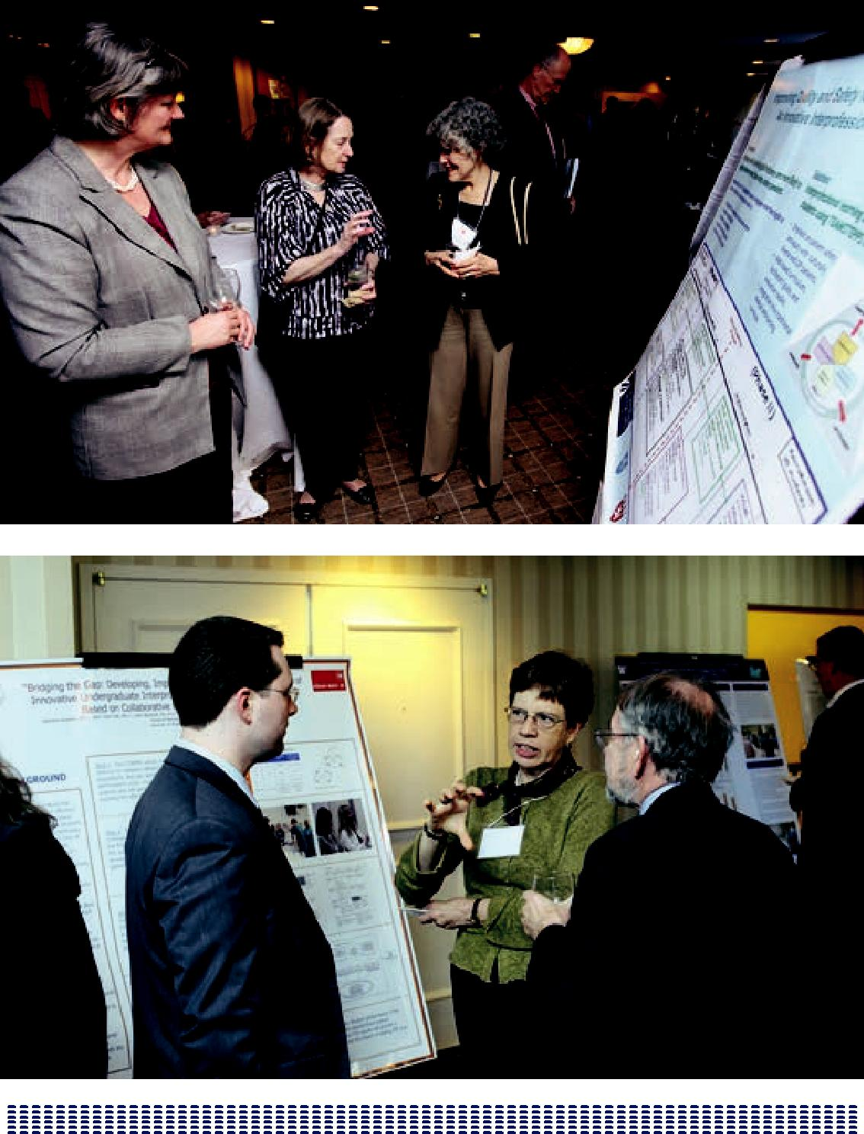

216

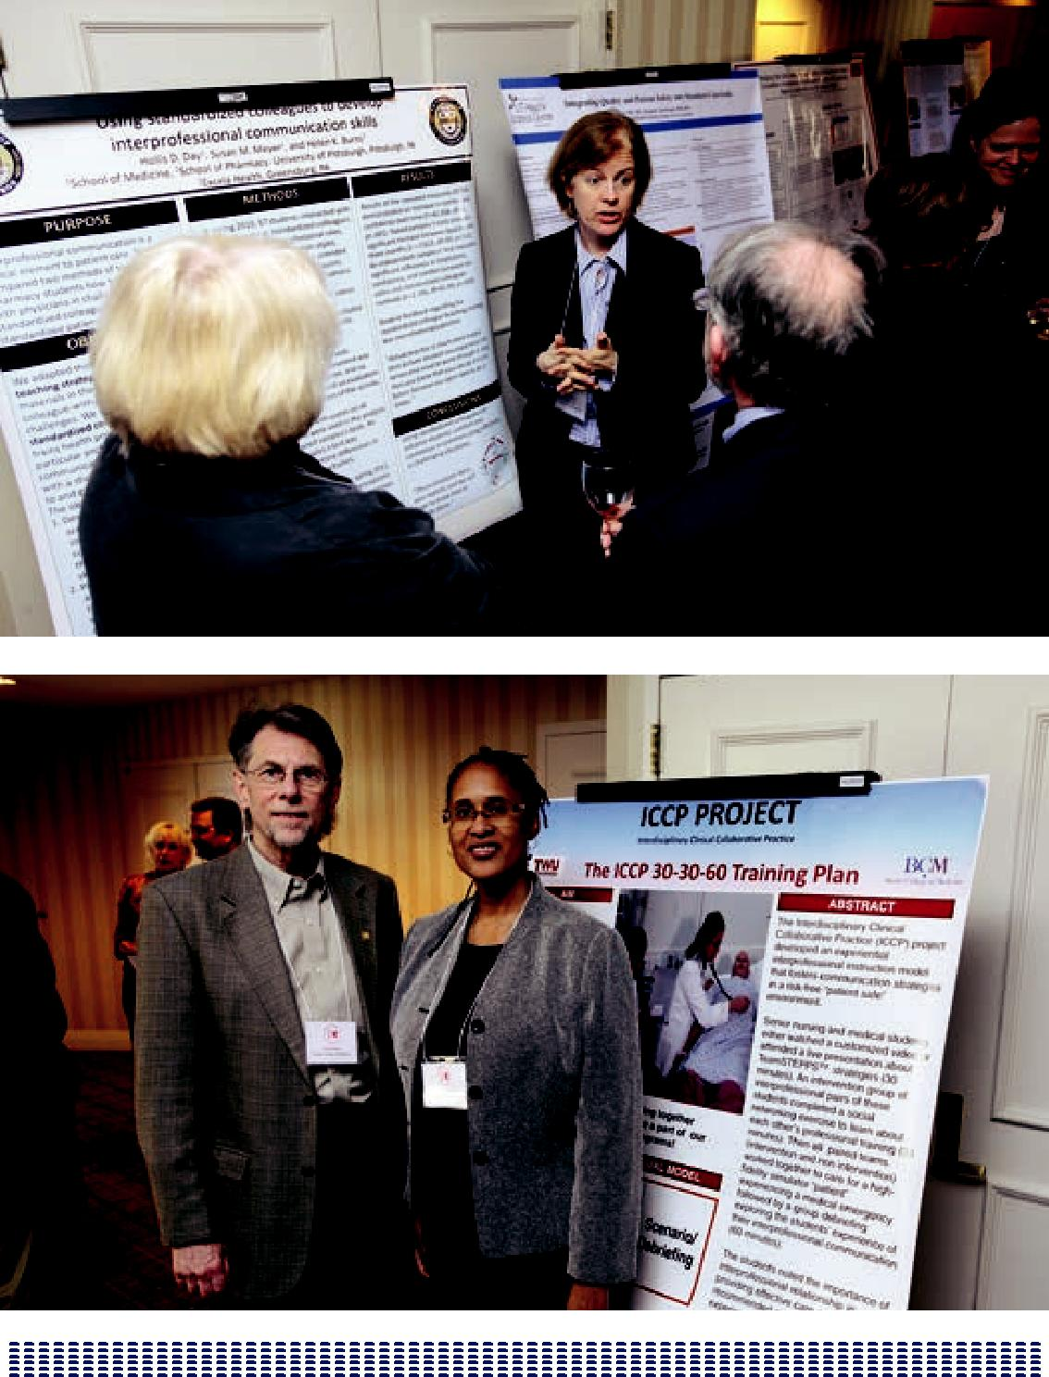

217

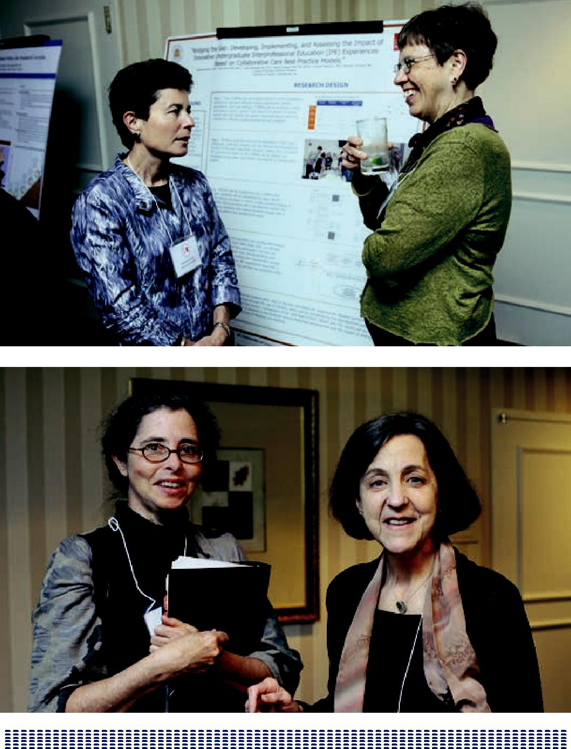

218

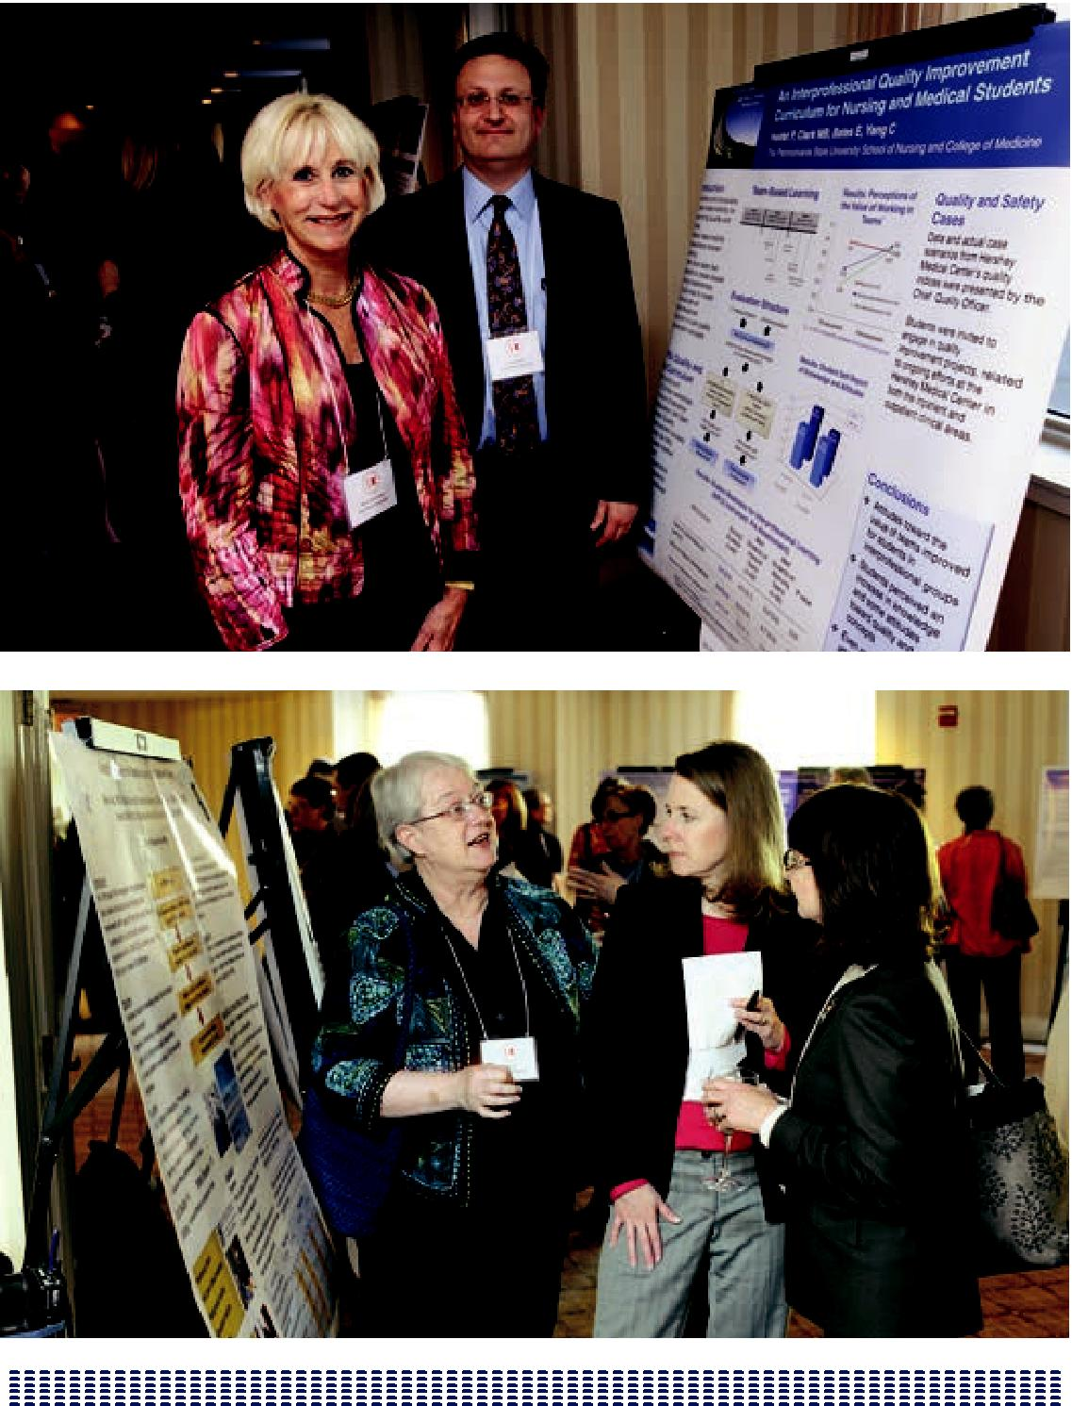

219

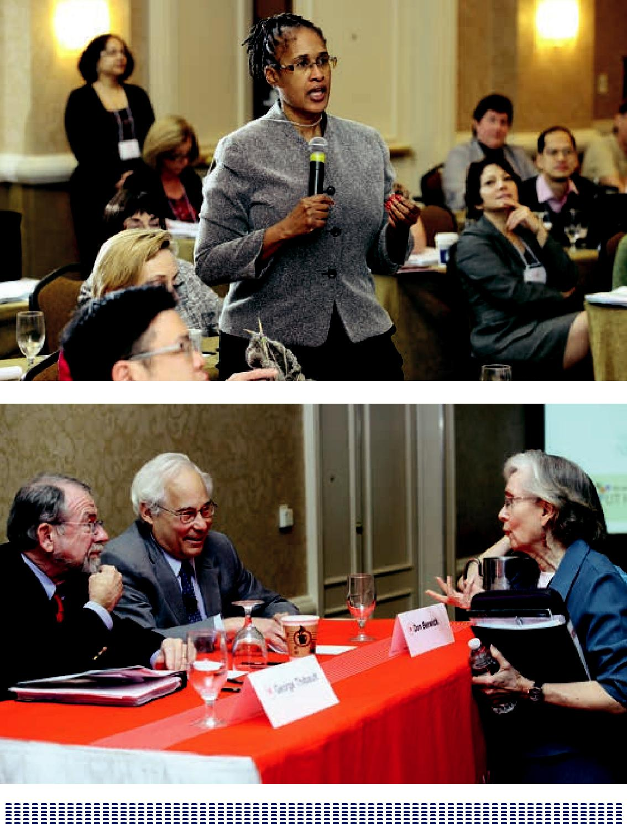

220

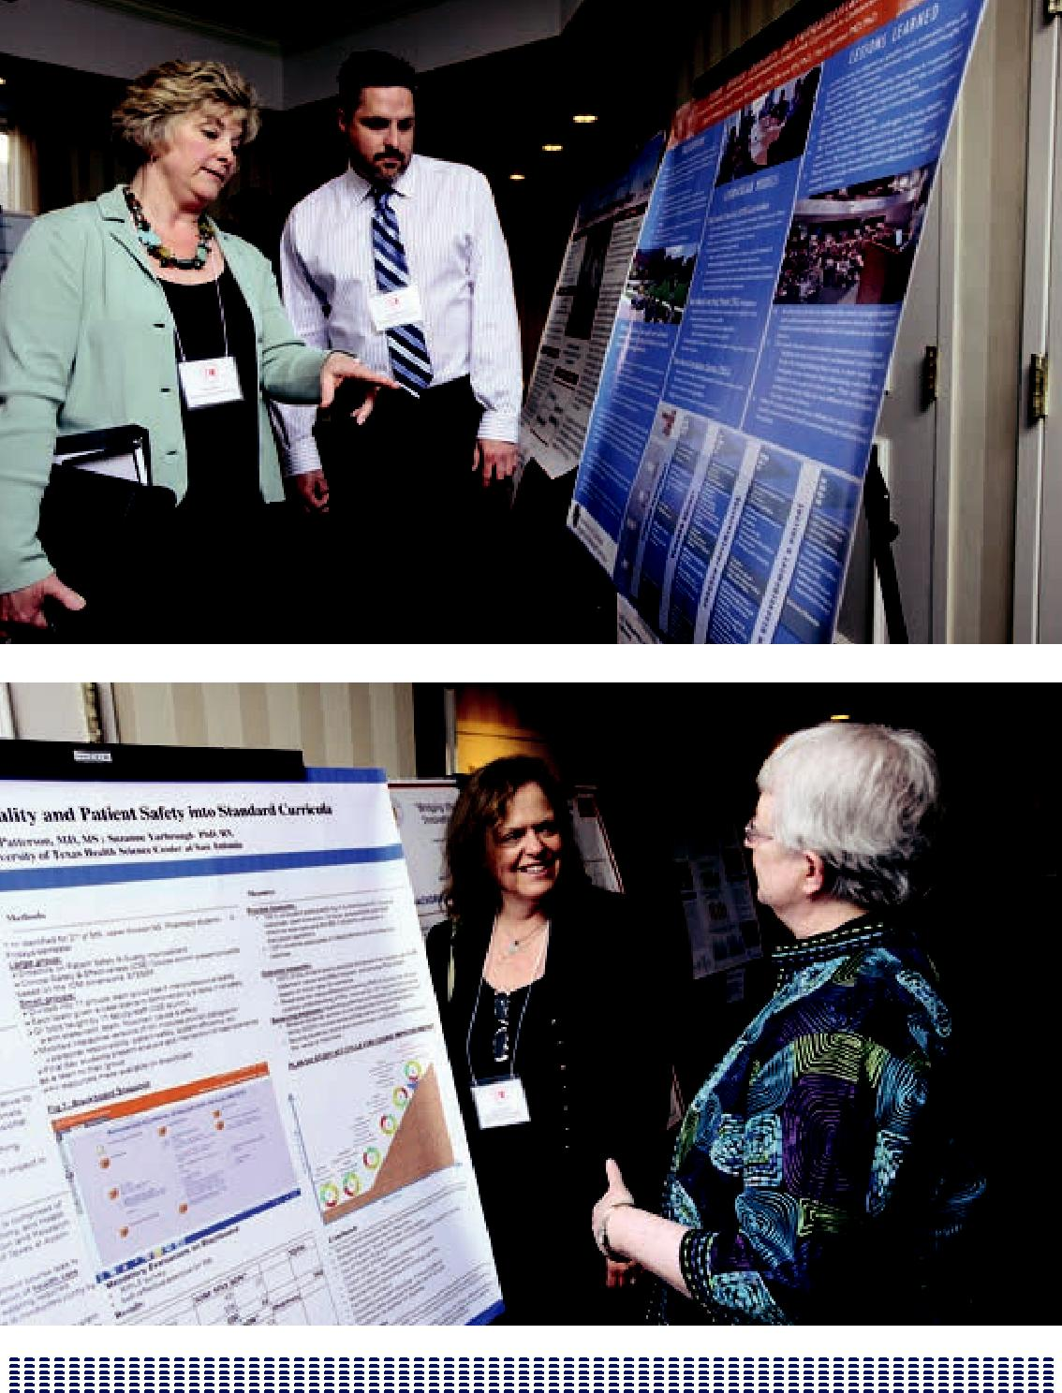

221

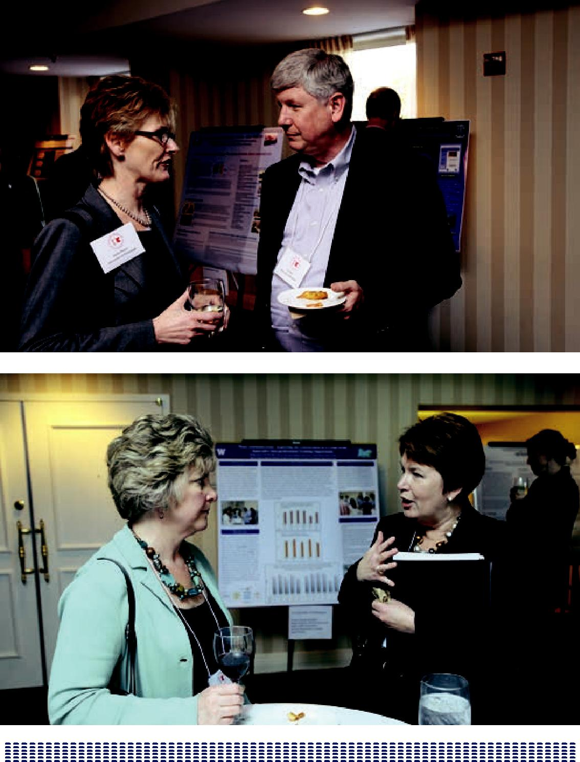

222

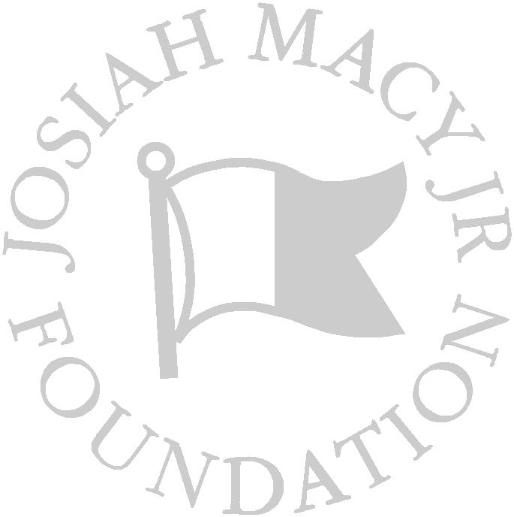

223

Copy Editor: Elise Paxson

Contributing Editor: Dottie Jeffries

Production Editor: Nicholas R. Romano

Designed by: Vixjo Design, Inc.

Photography by: Keith Weller

ISBN# 0-914362-57-7

Printed in U.S.A. with soy-based inks on paper containing post-consumer recycled content and produced using 100% wind-generated power

Josiah Macy Jr. Foundation

44 East 64th Street, New York, NY 10065 www.macyfoundation.org

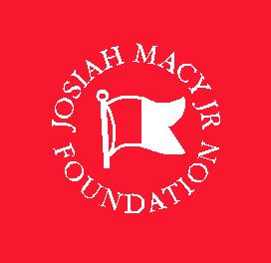

ISBN# 0-914362-57-7

